Presenting maps and data
Learning goal: Present geographical findings with maps and data.

Words to use
Word | Meaning
climate | Weather patterns over a long period
hazard | A process or event with potential to cause harm
effect | A consequence
response | An action taken because of a situation

Remember
Why include a data value in a pattern statement? It supports the description with checkable evidence.
What must a useful graph label include? The variable, units and relevant dates or categories.

How to show your learning
Present three geographical findings using a map and data display.
The map locates ___. The data show ___ at ___. This suggests ___, with the limit ___.

Evidence matters
Fictional cases are teaching examples. Historical, geographical and religious claims use the named sources. A model video demonstrates a method.
You can respond by speaking, pointing, drawing, typing or writing. A fictional personal example is welcome.
Sources: NASA Causes of climate change

Arrival choices
Previous lesson reminder:
Start with 1 and 2. Try 3 and 4 when ready. Reading and exact scribing are available.

1 Can different stated values lead to caring actions
Support: Use the reminder strip or talk it through with an adult.
My response
________________________________________________________________________

2 Which meaning fits climate
Support: Choose: Weather patterns over a long period OR A process or event with potential to cause harm.
My response
________________________________________________________________________

3 Why include a data value in a pattern statement
Support: Use the model evidence anchor dataset or read one relevant card together.
My response
________________________________________________________________________

4 What must a useful graph label include
Support: Give a reason when ready.
My response
________________________________________________________________________
Stretch: use a precise example or explain which detail supports your answer.

Evidence cards
Read, point or listen. Keep the source label with any detail you use.

A Zones and events
Broad temperature zones relate to latitude. Near the equator is generally warmer; high latitudes are generally colder. Local climate also depends on altitude and other factors. Earthquakes relate mainly to plate boundaries, not climate zones.
Source: Authored map explanation
Limit: Broad bands simplify climate; they are not a detailed climate classification.

B Human influence
Burning fossil fuels adds carbon dioxide. Greenhouse gases slow heat loss to space. Human activity is the main cause of recent global warming.
Source: NASA Causes of climate change
Limit: One local hot or cold day does not establish the global trend.

C Two responses
Reducing fossil-fuel use tackles a cause of warming. Shade, water access and cooler buildings can reduce harm during heat. These responses do different jobs.
Source: Authored examples based on climate mechanisms
Limit: Their suitability depends on the place and the needs of people there.

D Community accounts
Fictional account 1: a faith group explains caring for creation as its reason for planting shade trees. Fictional account 2: a non-religious residents’ group gives human wellbeing as its reason for a cool-room project.
Source: Two authored teaching accounts with explicitly stated values
Limit: These are not reports of real organisations and do not represent every religious or non-religious person.

Visual resource
Use this visual with the evidence cards and enquiry questions.
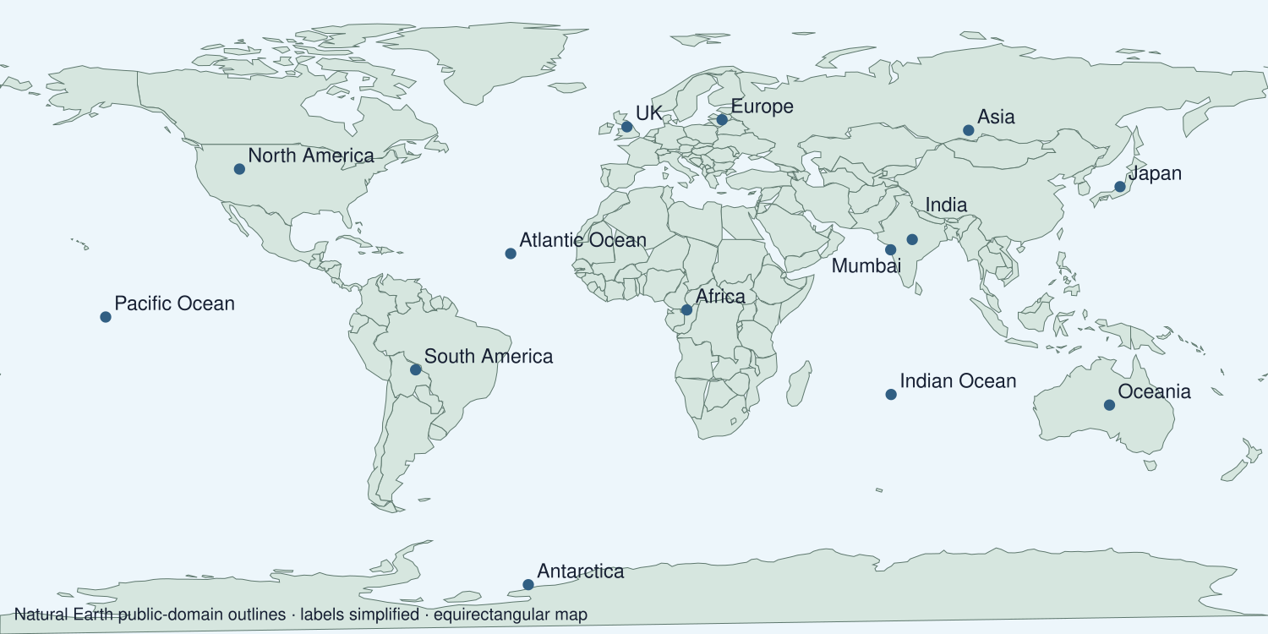
A detail I noticed and what it helps me explain
________________________________________________________________________
________________________________________________________________________
________________________________________________________________________
________________________________________________________________________

Data for the enquiry
Selected global annual temperature anomalies
Year | Anomaly °C
1980 | 0.26
1990 | 0.45
2000 | 0.39
2010 | 0.72
2020 | 1.01
2024 | 1.29

Units: °C relative to 1951–1980
Source: NASA GISTEMP v4 annual J-D column; selected values checked 19 September 2026. The full series can be revised.
Limit: Selected years simplify the record. Use the full annual series to examine variability. An anomaly is a difference from the baseline, not the absolute temperature.
My labelled graph or data notes
________________________________________________________________________
________________________________________________________________________
________________________________________________________________________
________________________________________________________________________
________________________________________________________________________
________________________________________________________________________
________________________________________________________________________
________________________________________________________________________

Shared investigation
1. Select a map and graph that answer the same question.
2. Practise a three-point explanation and a location question.
Work with a partner or adult, or use your own table. One person suggests; the other checks the evidence. Swap after one turn. Passing is allowed.
Use the evidence cards and any visual sheet. Follow the two shared steps above, then record one decision.
Our explanation
________________________________________________________________________
________________________________________________________________________
________________________________________________________________________
Support: Read one evidence card together. Highlight a useful detail. Rehearse with: The map locates ___. The data show ___ at ___. This suggests ___, with the limit ___.
Further challenge: Explain why your chosen display is suitable and another display might mislead.

Supported independent task
Complete this route only. Present geographical findings with maps and data.
1. Present three geographical findings using a map and data display.
2. Explain a pattern with a value and location.
3. Answer a location or pattern question independently and record feedback.
Support: Read one evidence card together. Highlight a useful detail. Rehearse with: The map locates ___. The data show ___ at ___. This suggests ___, with the limit ___. Complete the organiser one space at a time. The map locates ___. The data show ___ at ___. This suggests ___, with the limit ___.
My main message
________________________________________________________________________
________________________________________________________________________
My factual evidence and source
________________________________________________________________________
________________________________________________________________________
My visual or presentation choice
________________________________________________________________________
________________________________________________________________________
My reason or response to a question
________________________________________________________________________
________________________________________________________________________
An adult may read or scribe your exact response. They should not choose the answer.

Standard independent task
Complete this route only. Present geographical findings with maps and data.
1. Present three geographical findings using a map and data display.
2. Explain a pattern with a value and location.
3. Answer a location or pattern question independently and record feedback.
Support: The map locates ___. The data show ___ at ___. This suggests ___, with the limit ___.
My main message
________________________________________________________________________
________________________________________________________________________
My factual evidence and source
________________________________________________________________________
________________________________________________________________________
My visual or presentation choice
________________________________________________________________________
________________________________________________________________________
My reason or response to a question
________________________________________________________________________
________________________________________________________________________
Check the required evidence and revise one detail.

Stretch independent task
Complete this route only. Present geographical findings with maps and data.
1. Present three geographical findings using a map and data display.
2. Explain a pattern with a value and location.
3. Answer a location or pattern question independently and record feedback.
4. Explain why your chosen display is suitable and another display might mislead.
Support: Choose the evidence independently. Use the frame only if it helps.
My main message
________________________________________________________________________
________________________________________________________________________
My factual evidence and source
________________________________________________________________________
________________________________________________________________________
My visual or presentation choice
________________________________________________________________________
________________________________________________________________________
My reason or response to a question
________________________________________________________________________
________________________________________________________________________
Explain why your chosen display is suitable and another display might mislead.

Exit ticket
Choose a response mode. You may give your answers privately to an adult.

Why include a data value in a pattern statement
My response
________________________________________________________________________
________________________________________________________________________
________________________________________________________________________

What must a useful graph label include
My response
________________________________________________________________________
________________________________________________________________________
________________________________________________________________________
Support: The map locates ___. The data show ___ at ___. This suggests ___, with the limit ___.
Further challenge: Explain why your chosen display is suitable and another display might mislead.
One thing I changed or want to check
________________________________________________________________________
________________________________________________________________________

