Respecting special objects
Learning goal: Show one respectful way to handle or respond to a special religious object.

Words to use
Word | Meaning
respect | Treating people and things with care
handle | To hold or touch something with your hands
replica | A copy made for learning, not the real object
sacred | Special and holy to people of a faith

Remember
Why do readers often use a pointer with a Torah scroll? So that fingers do not touch the handwritten scroll.
Do you have to touch an object to show respect for it? No. Looking carefully is a respectful choice.

How to show your learning
Choose three respectful actions.
I can show respect by ___. This matters because ___.

Evidence matters
Fictional cases are teaching examples. Historical, geographical and religious claims use the named sources. A model video demonstrates a method.
This is learning about religion and worldviews, not worship. Nobody is asked to share a personal belief, family detail or loss.

Arrival choices
Previous lesson reminder:
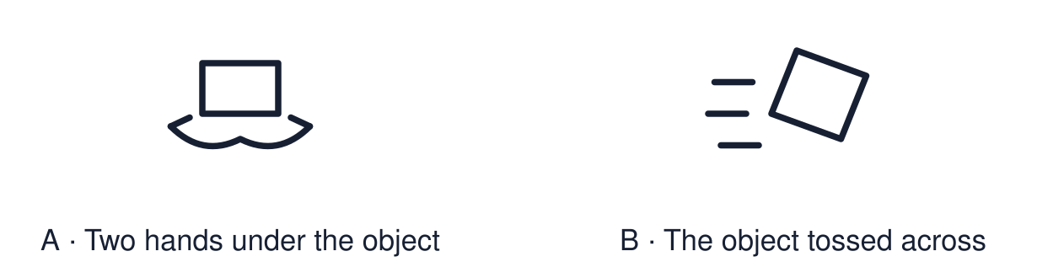
Start with 1 and 2. Try 3 and 4 when ready. Reading and exact scribing are available.

1 What is one sign that Sam is welcome at the gurdwara
Support: Use the reminder strip or talk it through with an adult.
My response
________________________________________________________________________

2 Which meaning fits respect
Support: Choose: Treating people and things with care OR To hold or touch something with your hands.
My response
________________________________________________________________________

3 Why do readers often use a pointer with a Torah scroll
Support: Use the model evidence anchor C or read one relevant card together.
My response
________________________________________________________________________

4 Do you have to touch an object to show respect for it
Support: Give a reason when ready.
My response
________________________________________________________________________
Stretch: use a precise example or explain which detail supports your answer.

Evidence cards
Read, point or listen. Keep the source label with any detail you use.

A Our handling rules
Clean hands. Wait for the adult. Use two hands. Keep the object over the table. You may choose to look and not touch.
Source: Authored classroom rules
Limit: Rules for a classroom replica are not the same as the rules believers follow.

B A holy book
Many Muslims wash before touching the Qur’an and keep it in a high, clean place. In class we use a photo or a protected copy and do not put it on the floor.
Source: Authored RE summary
Limit: Practice varies between families and communities.

C The Torah pointer
A Torah scroll is handwritten. Readers often follow the words with a pointer called a yad so that fingers do not touch the scroll.
Source: Authored RE summary
Limit: Practice varies between communities.

D Why it matters
Careful handling shows respect for the people who find the object sacred. We can respect an object without sharing the belief.
Source: Authored classroom resource
Limit: Respect can be shown in many ways, including by only looking.

Shared investigation
1. Decide whether each action shows respect.
2. Explain who the respect is for.
Work with a partner or adult, or use your own table. One person suggests; the other checks the evidence. Swap after one turn. Passing is allowed.

Move or match the cards
Cards to use
Choose to look closely and not touch
Grab the object before the adult is ready
Hold the replica with two hands over the table

Possible labels: Needs changing / Respectful
Our explanation
________________________________________________________________________
________________________________________________________________________
________________________________________________________________________
Support: Show two choices. Read one short instruction. Point, match or say a word, then add a reason when ready.
Further challenge: Explain how someone can respect an object without sharing the belief.

Supported independent task
Complete this route only. Show one respectful way to handle or respond to a special religious object.
1. Choose two respectful action cards.
2. Put them in order: first, next.
3. Point to or say why one of them matters.
Support: Show two choices. Read one short instruction. Point, match or say a word, then add a reason when ready. Complete the organiser one space at a time. I can show respect by ___. This matters because ___.
My choice or example
________________________________________________________________________
________________________________________________________________________
A detail from the card story or object
________________________________________________________________________
________________________________________________________________________
My reason
________________________________________________________________________
________________________________________________________________________
My check or next step
________________________________________________________________________
________________________________________________________________________
An adult may read or scribe your exact response. They should not choose the answer.

Standard independent task
Complete this route only. Show one respectful way to handle or respond to a special religious object.
1. Choose three respectful actions.
2. Put them in order: first, next, last.
3. Say why one action matters.
Support: I can show respect by ___. This matters because ___.
My choice or example
________________________________________________________________________
________________________________________________________________________
A detail from the card story or object
________________________________________________________________________
________________________________________________________________________
My reason
________________________________________________________________________
________________________________________________________________________
My check or next step
________________________________________________________________________
________________________________________________________________________
Check the required evidence and revise one detail.

Stretch independent task
Complete this route only. Show one respectful way to handle or respond to a special religious object.
1. Choose three respectful actions and put them in order.
2. Explain who each action shows respect for.
3. Explain how looking without touching can show respect.
Support: Choose the evidence independently. Use the frame only if it helps.
My choice or example
________________________________________________________________________
________________________________________________________________________
A detail from the card story or object
________________________________________________________________________
________________________________________________________________________
My reason
________________________________________________________________________
________________________________________________________________________
My check or next step
________________________________________________________________________
________________________________________________________________________
Explain how someone can respect an object without sharing the belief.

Exit ticket
Choose a response mode. You may give your answers privately to an adult.

Why do readers often use a pointer with a Torah scroll
My response
________________________________________________________________________
________________________________________________________________________
________________________________________________________________________

Do you have to touch an object to show respect for it
My response
________________________________________________________________________
________________________________________________________________________
________________________________________________________________________
Support: I can show respect by ___. This matters because ___.
Further challenge: Explain how someone can respect an object without sharing the belief.
One thing I changed or want to check
________________________________________________________________________
________________________________________________________________________

