Beliefs and worldviews in our community
Learning goal: Identify different beliefs and worldviews in our community.

Words to use
Word | Meaning
religion | An organised set of beliefs, practices and community
worldview | The way a person sees life and what matters
religious | Following a religion
non-religious | Not following a religion, but still holding beliefs and values

Remember
Name two different worldviews found in Britain. Any two, for example Christianity and Humanism.
Does a non-religious person have beliefs and values? Yes. Everyone has a worldview, religious or not.

How to show your learning
Place the three fictional profiles on the community map.
One worldview in our community is ___. A clue is ___.

Evidence matters
Fictional cases are teaching examples. Historical, geographical and religious claims use the named sources. A model video demonstrates a method.
This is learning about religion and worldviews, not worship. Nobody is asked to share a personal belief, family detail or loss.
Sources: Humanists UK explanation of Humanism; Sikh Coalition introduction to Sikh beliefs and practice

Arrival choices
You can begin without previous learning. Word help: religion means an organised set of beliefs, practices and community.
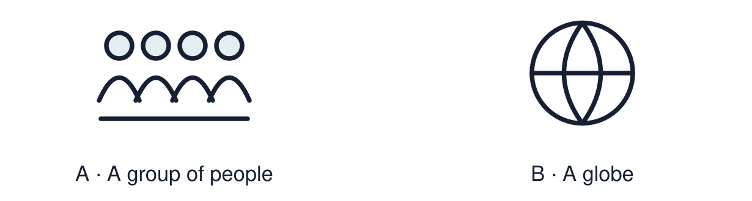
Start with 1 and 2. Try 3 and 4 when ready. Reading and exact scribing are available.

1 What does religion mean
Support: Use the reminder strip or talk it through with an adult.
My response
________________________________________________________________________

2 Which meaning fits religion
Support: Choose: An organised set of beliefs, practices and community OR The way a person sees life and what matters.
My response
________________________________________________________________________

3 Name two different worldviews found in Britain
Support: Use the model evidence anchor A,C or read one relevant card together.
My response
________________________________________________________________________

4 Does a non religious person have beliefs and values
Support: Give a reason when ready.
My response
________________________________________________________________________
Stretch: use a precise example or explain which detail supports your answer.

Evidence cards
Read, point or listen. Keep the source label with any detail you use.

A Hannah
Fictional profile: Hannah is 14 and Christian. She goes to church with her gran and prays before exams. She says her faith helps her stay calm.
Source: Authored profile
Limit: This is one person's view. Others who share the worldview may describe it differently.

B Imran
Fictional profile: Imran is 15 and Muslim. He prays, fasts in Ramadan and helps at a mosque food bank.
Source: Authored profile
Limit: This is one person's view. Others who share the worldview may describe it differently.

C Ellie
Fictional profile: Ellie is 14 and non-religious. She calls herself a Humanist. She thinks people should use reason and kindness to decide what is right.
Source: Authored profile
Limit: This is one person's view. Others who share the worldview may describe it differently.

D Worldviews in Britain
The 2021 census for England and Wales found Christianity was the most common religion, and about 37% of people said they had no religion. Islam, Hinduism, Sikhism, Judaism and Buddhism were also recorded.
Source: Authored summary of Office for National Statistics census 2021 headline results
Limit: A census counts what people tick. It cannot show how they live their beliefs.

Shared investigation
1. Match each clue to the worldview it fits.
2. Say which word in the clue helped you decide.
Work with a partner or adult, or use your own table. One person suggests; the other checks the evidence. Swap after one turn. Passing is allowed.

Move or match the cards
Cards to use
Uses reason and kindness, follows no religion
Fasts in Ramadan
Prays before exams and goes to church

Possible labels: Christian / Humanist / Muslim
Our explanation
________________________________________________________________________
________________________________________________________________________
________________________________________________________________________
Support: Read one evidence card together. Highlight a useful detail. Rehearse with: One worldview in our community is ___. A clue is ___.
Further challenge: Explain why a non-religious person still has a worldview.

Supported independent task
Complete this route only. Identify different beliefs and worldviews in our community.
1. Place two profile cards on the community map.
2. Label each with its worldview from the word bank.
3. Point to one clue for each.
Support: Read one evidence card together. Highlight a useful detail. Rehearse with: One worldview in our community is ___. A clue is ___. Complete the organiser one space at a time. One worldview in our community is ___. A clue is ___.
My choice or example
________________________________________________________________________
________________________________________________________________________
A detail from the card story or object
________________________________________________________________________
________________________________________________________________________
My reason
________________________________________________________________________
________________________________________________________________________
My check or next step
________________________________________________________________________
________________________________________________________________________
An adult may read or scribe your exact response. They should not choose the answer.

Standard independent task
Complete this route only. Identify different beliefs and worldviews in our community.
1. Place the three fictional profiles on the community map.
2. Label each worldview.
3. Add one clue from each profile.
Support: One worldview in our community is ___. A clue is ___.
My choice or example
________________________________________________________________________
________________________________________________________________________
A detail from the card story or object
________________________________________________________________________
________________________________________________________________________
My reason
________________________________________________________________________
________________________________________________________________________
My check or next step
________________________________________________________________________
________________________________________________________________________
Check the required evidence and revise one detail.

Stretch independent task
Complete this route only. Identify different beliefs and worldviews in our community.
1. Complete the map with all three profiles and clues.
2. Add one fact from the census card.
3. Explain what a census cannot tell us about belief.
Support: Choose the evidence independently. Use the frame only if it helps.
My choice or example
________________________________________________________________________
________________________________________________________________________
A detail from the card story or object
________________________________________________________________________
________________________________________________________________________
My reason
________________________________________________________________________
________________________________________________________________________
My check or next step
________________________________________________________________________
________________________________________________________________________
Explain why a non-religious person still has a worldview.

Exit ticket
Choose a response mode. You may give your answers privately to an adult.

Name two different worldviews found in Britain
My response
________________________________________________________________________
________________________________________________________________________
________________________________________________________________________

Does a non religious person have beliefs and values
My response
________________________________________________________________________
________________________________________________________________________
________________________________________________________________________
Support: One worldview in our community is ___. A clue is ___.
Further challenge: Explain why a non-religious person still has a worldview.
One thing I changed or want to check
________________________________________________________________________
________________________________________________________________________

