Diwali: festival, story and meaning
Learning goal: Explain one meaning connected to Diwali.

Words to use
Word | Meaning
Diwali | A festival of lights celebrated by many Hindus, Sikhs and Jains
diya | A small lamp, often made of clay
rangoli | A bright pattern made on the floor to welcome guests
symbol | Something that stands for an idea

Remember
Name one thing light can represent at Diwali. Good overcoming evil, hope or welcome.
Is Diwali celebrated only by Hindus? No. Many Sikhs and Jains also celebrate at this time, with their own meanings.

How to show your learning
Choose one Diwali symbol or practice.
At Diwali, ___ is a symbol of ___ because ___.

Evidence matters
Fictional cases are teaching examples. Historical, geographical and religious claims use the named sources. A model video demonstrates a method.
This is learning about religion and worldviews, not worship. Nobody is asked to share a personal belief, family detail or loss.
Sources: Hindu American Foundation Diwali; Sikh Coalition introduction to Sikh beliefs and practice

Arrival choices
Previous lesson reminder:
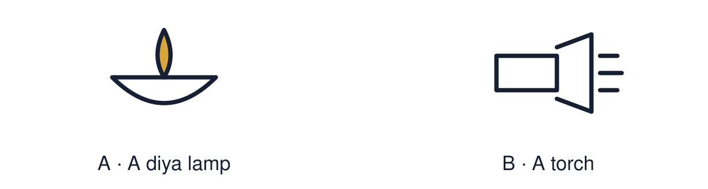
Start with 1 and 2. Try 3 and 4 when ready. Reading and exact scribing are available.

1 What value does Imran s belief lead to
Support: Use the reminder strip or talk it through with an adult.
My response
________________________________________________________________________

2 Which meaning fits Diwali
Support: Choose: A festival of lights celebrated by many Hindus, Sikhs and Jains OR A small lamp, often made of clay.
My response
________________________________________________________________________

3 Name one thing light can represent at Diwali
Support: Use the model evidence anchor A or read one relevant card together.
My response
________________________________________________________________________

4 Is Diwali celebrated only by Hindus
Support: Give a reason when ready.
My response
________________________________________________________________________
Stretch: use a precise example or explain which detail supports your answer.

Evidence cards
Read, point or listen. Keep the source label with any detail you use.

A Rama and Sita
Many Hindus tell the story of Rama and Sita at Diwali. After Rama rescues Sita from Ravana, people light lamps to guide them home. Light stands for good overcoming evil.
Source: Authored retelling; see Hindu American Foundation, Diwali
Limit: Not everyone who celebrates Diwali tells this story.

B Different communities
Many Sikhs mark Bandi Chhor Divas at the same time, remembering Guru Hargobind’s release from prison. Many Jains remember Mahavira. One festival season holds several meanings.
Source: Authored RE summary
Limit: These are short summaries of long traditions.

C Practices
Families clean and decorate homes, make rangoli, light diyas, share sweets and visit each other. Many Hindus also pray to Lakshmi.
Source: Authored summary; see Hindu American Foundation, Diwali
Limit: Families celebrate in different ways.

D Symbol and meaning
A symbol stands for an idea. Ask: what is it? What does it mean to the people who use it?
Source: Authored classroom resource
Limit: A symbol can mean different things to different people.

Shared investigation
1. Match each symbol or practice to a meaning.
2. Name the evidence card you used.
Work with a partner or adult, or use your own table. One person suggests; the other checks the evidence. Swap after one turn. Passing is allowed.

Move or match the cards
Cards to use
Sharing sweets with visitors
Rangoli by the door
Rows of lit diyas

Possible labels: Community and joy / Good overcoming evil / Welcome
Our explanation
________________________________________________________________________
________________________________________________________________________
________________________________________________________________________
Support: Read one evidence card together. Highlight a useful detail. Rehearse with: At Diwali, ___ is a symbol of ___ because ___.
Further challenge: Explain how one festival season can carry different meanings for Hindus, Sikhs and Jains.

Supported independent task
Complete this route only. Explain one meaning connected to Diwali.
1. Choose one symbol: diya or rangoli.
2. Match it to its meaning card.
3. Draw and label: symbol → meaning.
Support: Read one evidence card together. Highlight a useful detail. Rehearse with: At Diwali, ___ is a symbol of ___ because ___. Complete the organiser one space at a time. At Diwali, ___ is a symbol of ___ because ___.
My choice or example
________________________________________________________________________
________________________________________________________________________
A detail from the card story or object
________________________________________________________________________
________________________________________________________________________
My reason
________________________________________________________________________
________________________________________________________________________
My check or next step
________________________________________________________________________
________________________________________________________________________
An adult may read or scribe your exact response. They should not choose the answer.

Standard independent task
Complete this route only. Explain one meaning connected to Diwali.
1. Choose one Diwali symbol or practice.
2. Write: symbol → meaning.
3. Explain the meaning using the story or a card.
Support: At Diwali, ___ is a symbol of ___ because ___.
My choice or example
________________________________________________________________________
________________________________________________________________________
A detail from the card story or object
________________________________________________________________________
________________________________________________________________________
My reason
________________________________________________________________________
________________________________________________________________________
My check or next step
________________________________________________________________________
________________________________________________________________________
Check the required evidence and revise one detail.

Stretch independent task
Complete this route only. Explain one meaning connected to Diwali.
1. Choose two symbols and give the meaning of each.
2. Link one meaning to the Rama and Sita story.
3. Explain how Sikhs or Jains give the season another meaning.
Support: Choose the evidence independently. Use the frame only if it helps.
My choice or example
________________________________________________________________________
________________________________________________________________________
A detail from the card story or object
________________________________________________________________________
________________________________________________________________________
My reason
________________________________________________________________________
________________________________________________________________________
My check or next step
________________________________________________________________________
________________________________________________________________________
Explain how one festival season can carry different meanings for Hindus, Sikhs and Jains.

Exit ticket
Choose a response mode. You may give your answers privately to an adult.

Name one thing light can represent at Diwali
My response
________________________________________________________________________
________________________________________________________________________
________________________________________________________________________

Is Diwali celebrated only by Hindus
My response
________________________________________________________________________
________________________________________________________________________
________________________________________________________________________
Support: At Diwali, ___ is a symbol of ___ because ___.
Further challenge: Explain how one festival season can carry different meanings for Hindus, Sikhs and Jains.
One thing I changed or want to check
________________________________________________________________________
________________________________________________________________________

