Questions for a faith or belief visitor
Learning goal: Ask or answer a respectful question and record one thing learned from a faith or belief visitor.

Words to use
Word | Meaning
lived experience | What life is really like for a person
respectful question | A question that is curious and kind
open question | A question that needs more than yes or no
boundary | A limit that keeps people comfortable and safe

Remember
Give one respectful question stem. For example: “What does ___ mean to you?”
Does one visitor speak for everyone who shares their worldview? No. They speak from their own lived experience.

How to show your learning
Ask or write one respectful question.
I learned that ___. One question I still have is ___.

Evidence matters
Fictional cases are teaching examples. Historical, geographical and religious claims use the named sources. A model video demonstrates a method.
This is learning about religion and worldviews, not worship. Nobody is asked to share a personal belief, family detail or loss.
Sources: Humanists UK explanation of Humanism

Arrival choices
Previous lesson reminder:
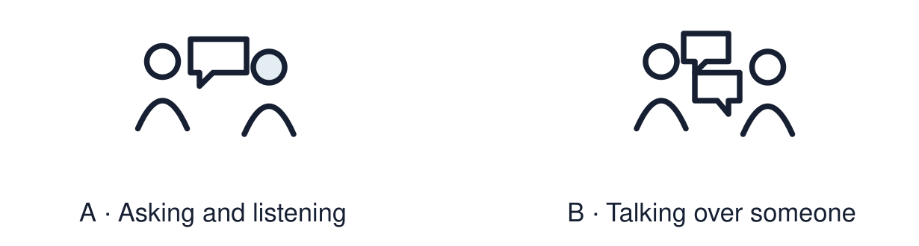
Start with 1 and 2. Try 3 and 4 when ready. Reading and exact scribing are available.

1 Give one respectful discussion phrase
Support: Use the reminder strip or talk it through with an adult.
My response
________________________________________________________________________

2 Which meaning fits lived experience
Support: Choose: What life is really like for a person OR A question that is curious and kind.
My response
________________________________________________________________________

3 Give one respectful question stem
Support: Use the model evidence anchor A or read one relevant card together.
My response
________________________________________________________________________

4 Does one visitor speak for everyone who shares their worldview
Support: Give a reason when ready.
My response
________________________________________________________________________
Stretch: use a precise example or explain which detail supports your answer.

Evidence cards
Read, point or listen. Keep the source label with any detail you use.

A Good questions
“What does a normal week look like for you?” “Which festival means most to you, and why?” Open, curious and about the person’s own experience.
Source: Authored classroom rules
Limit: A visitor speaks for themselves, not for everyone who shares their worldview.

B Questions to avoid
Questions such as “Why do you lot...?” stereotype people. Agree topics with the visitor first. The visitor can decline any question, and pupils may choose to listen. Do not ask anyone to speak for a whole worldview.
Source: Authored classroom rules
Limit: If unsure, check the question with an adult first.

C Jan Halliday: a real celebrant
Jan Halliday explains that she trained to lead Humanist naming ceremonies after her daughter asked her to lead a beach ceremony for her grandsons. She describes these as non-religious occasions that welcome a child. Families help shape each ceremony; examples include planting a tree or reading a poem. Paraphrased from Jan’s own public profile.
Source: Jan Halliday’s profile, Humanists UK: https://humanists.uk/celebrants/jan-halliday/naming-ceremonies/
Limit: This is a paraphrase of one real person’s public account. It cannot tell us what every Humanist thinks.

D Three areas
Belief: what do you believe? Practice: what do you do? Community: who do you share it with?
Source: Authored classroom resource
Limit: Not every question fits one area.

Shared investigation
1. Sort each class question: belief, practice or community.
2. Check each against the boundaries.
Work with a partner or adult, or use your own table. One person suggests; the other checks the evidence. Swap after one turn. Passing is allowed.

Move or match the cards
Cards to use
“Who do you celebrate with?”
“What do you do on a special day?”
“What do you believe happens when we die?”

Possible labels: Belief / Community / Practice
Our explanation
________________________________________________________________________
________________________________________________________________________
________________________________________________________________________
Support: Read one evidence card together. Highlight a useful detail. Rehearse with: I learned that ___. One question I still have is ___.
Further challenge: Explain why one visitor cannot speak for everyone who shares their worldview.

Supported independent task
Complete this route only. Ask or answer a respectful question and record one thing learned from a faith or belief visitor.
1. Choose one pre-written question.
2. Read card C, or have it read aloud. Find the answer in Jan’s account.
3. Record one thing learned with a word, symbol or scribe.
Support: Read one evidence card together. Highlight a useful detail. Rehearse with: I learned that ___. One question I still have is ___. Complete the organiser one space at a time. I learned that ___. One question I still have is ___.
My choice or example
________________________________________________________________________
________________________________________________________________________
A detail from the card story or object
________________________________________________________________________
________________________________________________________________________
My reason
________________________________________________________________________
________________________________________________________________________
My check or next step
________________________________________________________________________
________________________________________________________________________
An adult may read or scribe your exact response. They should not choose the answer.

Standard independent task
Complete this route only. Ask or answer a respectful question and record one thing learned from a faith or belief visitor.
1. Ask or write one respectful question.
2. Record the answer from the visitor or the source.
3. Write one thing you learned.
Support: I learned that ___. One question I still have is ___.
My choice or example
________________________________________________________________________
________________________________________________________________________
A detail from the card story or object
________________________________________________________________________
________________________________________________________________________
My reason
________________________________________________________________________
________________________________________________________________________
My check or next step
________________________________________________________________________
________________________________________________________________________
Check the required evidence and revise one detail.

Stretch independent task
Complete this route only. Ask or answer a respectful question and record one thing learned from a faith or belief visitor.
1. Write an open question answered by Jan’s account, then a follow-up question.
2. Record the supported answer. Mark a follow-up as unanswered if the source does not tell you.
3. Explain how this person’s experience may differ from others’.
Support: Choose the evidence independently. Use the frame only if it helps.
My choice or example
________________________________________________________________________
________________________________________________________________________
A detail from the card story or object
________________________________________________________________________
________________________________________________________________________
My reason
________________________________________________________________________
________________________________________________________________________
My check or next step
________________________________________________________________________
________________________________________________________________________
Explain why one visitor cannot speak for everyone who shares their worldview.

Exit ticket
Choose a response mode. You may give your answers privately to an adult.

Give one respectful question stem
My response
________________________________________________________________________
________________________________________________________________________
________________________________________________________________________

Does one visitor speak for everyone who shares their worldview
My response
________________________________________________________________________
________________________________________________________________________
________________________________________________________________________
Support: I learned that ___. One question I still have is ___.
Further challenge: Explain why one visitor cannot speak for everyone who shares their worldview.
One thing I changed or want to check
________________________________________________________________________
________________________________________________________________________

