Belief, identity and belonging in adult life
Learning goal: Explain one way a belief or worldview can influence a person's identity or choices.

Words to use
Word | Meaning
worldview | The way a person sees life and what matters
influence | To have an effect on something
values | What a person thinks is important in how to live
identity | Who a person is and how they see themselves

Remember
How does Daniel’s belief influence his choice of work? He believes everyone deserves dignity, so he chose care work.
Does a belief fully determine a person’s identity? No. It is one influence among several, and views can change.

How to show your learning
Complete the identity-influence map for one fictional person.
A worldview can influence identity by ___. For example, ___.

Evidence matters
Fictional cases are teaching examples. Historical, geographical and religious claims use the named sources. A model video demonstrates a method.
This is learning about religion and worldviews, not worship. Nobody is asked to share a personal belief, family detail or loss.
Sources: Humanists UK explanation of Humanism

Arrival choices
You can begin without previous learning. Word help: worldview means the way a person sees life and what matters.
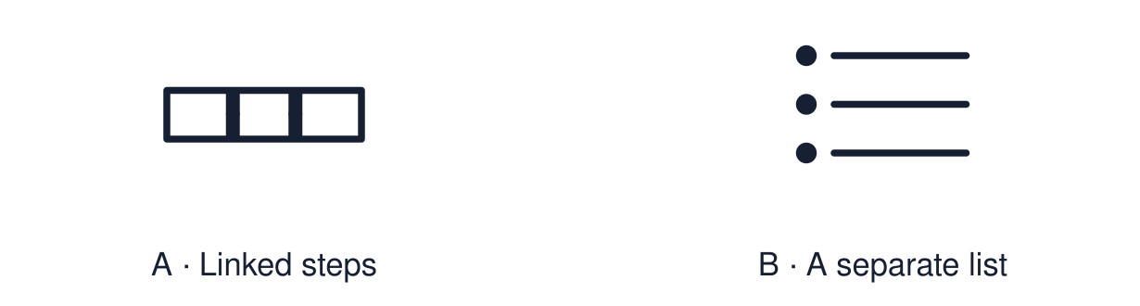
Start with 1 and 2. Try 3 and 4 when ready. Reading and exact scribing are available.

1 What does worldview mean
Support: Use the reminder strip or talk it through with an adult.
My response
________________________________________________________________________

2 Which meaning fits worldview
Support: Choose: The way a person sees life and what matters OR To have an effect on something.
My response
________________________________________________________________________

3 How does Daniel s belief influence his choice of work
Support: Use the model evidence anchor A or read one relevant card together.
My response
________________________________________________________________________

4 Does a belief fully determine a person s identity
Support: Give a reason when ready.
My response
________________________________________________________________________
Stretch: use a precise example or explain which detail supports your answer.

Evidence cards
Read, point or listen. Keep the source label with any detail you use.

A Daniel
Fictional profile: Daniel is 24, Christian and a care worker. He says, “I believe every person is made in the image of God, so everyone deserves dignity.” He chose care work over a better-paid job.
Source: Authored profile
Limit: This is one person's view. Others who share the worldview may describe it differently.

B Priya
Fictional profile: Priya is 26 and a Humanist. She says, “This is the one life we have, so I want mine to be useful.” She volunteers as a mentor and gives blood.
Source: Authored profile
Limit: This is one person's view. Others who share the worldview may describe it differently.

C Belief choice identity
A belief can lead to a choice. Repeated choices become part of how a person sees themselves and how others see them.
Source: Authored classroom resource
Limit: Real lives are less tidy than a three-step model.

D Other influences
Family, money, health, friends and place also shape adult choices. Belief is one influence, and people can change their views.
Source: Authored classroom resource
Limit: Belief does not fully determine identity.

Shared investigation
1. Label each piece of evidence: belief, choice or identity.
2. Highlight the phrase that shows influence.
Work with a partner or adult, or use your own table. One person suggests; the other checks the evidence. Swap after one turn. Passing is allowed.

Move or match the cards
Cards to use
“I want my life to be useful.”
Chose care work over a better-paid job
“Every person is made in the image of God.”

Possible labels: Belief / Choice / Identity
Our explanation
________________________________________________________________________
________________________________________________________________________
________________________________________________________________________
Support: Use the glossary and one chunk of evidence. Plan the claim and supporting detail before explaining.
Further challenge: Evaluate how far belief, compared with other influences, explains one person’s choice.

Supported independent task
Complete this route only. Explain one way a belief or worldview can influence a person's identity or choices.
1. Choose one profile and find the belief sentence.
2. Select the choice it led to from two options.
3. Say or finish: A worldview can influence identity by ___.
Support: Use the glossary and one chunk of evidence. Plan the claim and supporting detail before explaining. Complete the organiser one space at a time. A worldview can influence identity by ___. For example, ___.
Cause and supporting detail
________________________________________________________________________
________________________________________________________________________
Event or change
________________________________________________________________________
________________________________________________________________________
Consequence and supporting detail
________________________________________________________________________
________________________________________________________________________
How the links connect
________________________________________________________________________
________________________________________________________________________
An adult may read or scribe your exact response. They should not choose the answer.

Standard independent task
Complete this route only. Explain one way a belief or worldview can influence a person's identity or choices.
1. Complete the identity-influence map for one fictional person.
2. Show belief, value, choice and identity.
3. Explain one link in a full sentence.
Support: A worldview can influence identity by ___. For example, ___.
Cause and supporting detail
________________________________________________________________________
________________________________________________________________________
Event or change
________________________________________________________________________
________________________________________________________________________
Consequence and supporting detail
________________________________________________________________________
________________________________________________________________________
How the links connect
________________________________________________________________________
________________________________________________________________________
Check the required evidence and revise one detail.

Stretch independent task
Complete this route only. Explain one way a belief or worldview can influence a person's identity or choices.
1. Complete the map for both profiles.
2. Explain one link and one competing influence.
3. Judge how strong the influence of belief is, with a reason.
Support: Choose the evidence independently. Use the frame only if it helps.
Cause and supporting detail
________________________________________________________________________
________________________________________________________________________
Event or change
________________________________________________________________________
________________________________________________________________________
Consequence and supporting detail
________________________________________________________________________
________________________________________________________________________
How the links connect
________________________________________________________________________
________________________________________________________________________
Evaluate how far belief, compared with other influences, explains one person’s choice.

Exit ticket
Choose a response mode. You may give your answers privately to an adult.

How does Daniel s belief influence his choice of work
My response
________________________________________________________________________
________________________________________________________________________
________________________________________________________________________

Does a belief fully determine a person s identity
My response
________________________________________________________________________
________________________________________________________________________
________________________________________________________________________
Support: A worldview can influence identity by ___. For example, ___.
Further challenge: Evaluate how far belief, compared with other influences, explains one person’s choice.
One thing I changed or want to check
________________________________________________________________________
________________________________________________________________________

