Belief and identity assessment
Learning goal: Use evidence from the half-term to explain how beliefs and worldviews can influence identity, values or choices.

Words to use
Word | Meaning
evidence | An example or fact that supports the point
relevant | Directly connected to the question
authority | A source people trust to guide what they believe or do
next step | One thing to improve next time

Remember
What makes evidence relevant? It directly answers the question being asked.
Must every pupil write the same length of answer? No. Use your agreed access route.

How to show your learning
Write your point.
Point: ___. For example, ___. This shows ___ because ___.

Evidence matters
Fictional cases are teaching examples. Historical, geographical and religious claims use the named sources. A model video demonstrates a method.
This is learning about religion and worldviews, not worship. Nobody is asked to share a personal belief, family detail or loss.
Sources: Humanists UK explanation of Humanism

Arrival choices
Previous lesson reminder:
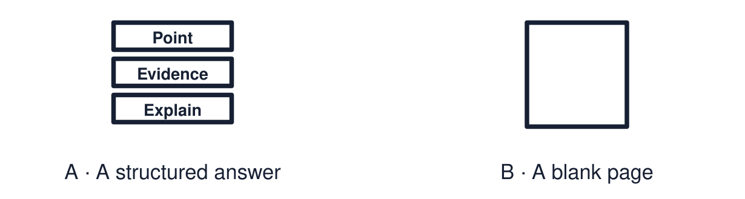
Start with 1 and 2. Try 3 and 4 when ready. Reading and exact scribing are available.

1 Give one similarity or difference between the two responses
Support: Use the reminder strip or talk it through with an adult.
My response
________________________________________________________________________

2 Which meaning fits evidence
Support: Choose: An example or fact that supports the point OR Directly connected to the question.
My response
________________________________________________________________________

3 What makes evidence relevant
Support: Use the model evidence anchor B or read one relevant card together.
My response
________________________________________________________________________

4 Must every pupil write the same length of answer
Support: Give a reason when ready.
My response
________________________________________________________________________
Stretch: use a precise example or explain which detail supports your answer.

Evidence cards
Read, point or listen. Keep the source label with any detail you use.

A The assessment question
“Explain how beliefs and worldviews can influence identity, values or choices.”
Source: Authored assessment task
Limit: Use evidence from this half-term.

B Selecting evidence
Relevant evidence answers this question. Ask: does it show a belief leading to a value, a choice or a sense of identity?
Source: Authored classroom resource
Limit: Interesting facts are not always relevant.

C Evidence bank
Daniel and care work · Priya and volunteering · Amira and the Qur’an · the mosque open day · the two remembrance sources.
Source: Authored classroom resource
Limit: Choose the evidence you can explain.

D Routes
Written: three sentences or more. Structured: complete the point, evidence, explain frame. Supported: answer aloud with a scribe or recorder.
Source: Authored classroom resource
Limit: Use your normal way of working.

Evidence cards continued
Read, point or listen. Keep the source label with any detail you use.

E1 Assessment source Daniel
Fictional profile: Daniel is 24, Christian and a care worker. He says, “I believe every person is made in the image of God, so everyone deserves dignity.” He chose care work over a better-paid job.
Source: Authored profile
Limit: This is one person's view. Others who share the worldview may describe it differently.

E2 Assessment source Priya
Fictional profile: Priya is 26 and a Humanist. She says, “This is the one life we have, so I want mine to be useful.” She volunteers as a mentor and gives blood.
Source: Authored profile
Limit: This is one person's view. Others who share the worldview may describe it differently.

Shared investigation
1. Match each piece of evidence to what it best shows.
2. Plan one answer together using the frame.
Work with a partner or adult, or use your own table. One person suggests; the other checks the evidence. Swap after one turn. Passing is allowed.

Move or match the cards
Cards to use
Amira turns to the Qur’an on honesty
Priya: “I want my life to be useful”
Daniel chose care work

Possible labels: Authority influencing values / Belief influencing a choice / Belief influencing identity
Our explanation
________________________________________________________________________
________________________________________________________________________
________________________________________________________________________
Support: Use the glossary and one chunk of evidence. Plan the claim and supporting detail before explaining.
Further challenge: Include a second worldview and compare the influence.

Supported independent task
Complete this route only. Use evidence from the half-term to explain how beliefs and worldviews can influence identity, values or choices.
1. Choose your evidence from the bank.
2. Answer aloud or with a scribe: point, then example.
3. Add one “because”.
Support: Use the glossary and one chunk of evidence. Plan the claim and supporting detail before explaining. Complete the organiser one space at a time. Point: ___. For example, ___. This shows ___ because ___.
My choice or example
________________________________________________________________________
________________________________________________________________________
A detail from the card story or object
________________________________________________________________________
________________________________________________________________________
My reason
________________________________________________________________________
________________________________________________________________________
My check or next step
________________________________________________________________________
________________________________________________________________________
An adult may read or scribe your exact response. They should not choose the answer.

Standard independent task
Complete this route only. Use evidence from the half-term to explain how beliefs and worldviews can influence identity, values or choices.
1. Write your point.
2. Add evidence from the half-term.
3. Explain using “because” or “therefore”.
Support: Point: ___. For example, ___. This shows ___ because ___.
My choice or example
________________________________________________________________________
________________________________________________________________________
A detail from the card story or object
________________________________________________________________________
________________________________________________________________________
My reason
________________________________________________________________________
________________________________________________________________________
My check or next step
________________________________________________________________________
________________________________________________________________________
Check the required evidence and revise one detail.

Stretch independent task
Complete this route only. Use evidence from the half-term to explain how beliefs and worldviews can influence identity, values or choices.
1. Write a full answer using two pieces of evidence.
2. Compare the influence in two worldviews.
3. Self-assess one strength and one next step.
Support: Choose the evidence independently. Use the frame only if it helps.
My choice or example
________________________________________________________________________
________________________________________________________________________
A detail from the card story or object
________________________________________________________________________
________________________________________________________________________
My reason
________________________________________________________________________
________________________________________________________________________
My check or next step
________________________________________________________________________
________________________________________________________________________
Include a second worldview and compare the influence.

Exit ticket
Choose a response mode. You may give your answers privately to an adult.

What makes evidence relevant
My response
________________________________________________________________________
________________________________________________________________________
________________________________________________________________________

Must every pupil write the same length of answer
My response
________________________________________________________________________
________________________________________________________________________
________________________________________________________________________
Support: Point: ___. For example, ___. This shows ___ because ___.
Further challenge: Include a second worldview and compare the influence.
One thing I changed or want to check
________________________________________________________________________
________________________________________________________________________

