Rites of passage and community
Learning goal: Describe a rite of passage and explain how it can connect a person to a community.

Words to use
Word | Meaning
rite of passage | A ceremony that marks a new stage of life
ceremony | A formal event with set words and actions
commitment | A promise to stay loyal to something
Bar or Bat Mitzvah | A Jewish ceremony marking religious adulthood

Remember
Define “rite of passage”. A ceremony that marks a new stage of life.
Are rites of passage only religious? No. There are non-religious ceremonies too.

How to show your learning
Choose one rite of passage.
At a ___, ___. This means ___. It shows belonging because ___.

Evidence matters
Fictional cases are teaching examples. Historical, geographical and religious claims use the named sources. A model video demonstrates a method.
This is learning about religion and worldviews, not worship. Nobody is asked to share a personal belief, family detail or loss.
Sources: Chabad introduction to Bar Mitzvah; Church of England confirmation

Arrival choices
Previous lesson reminder:
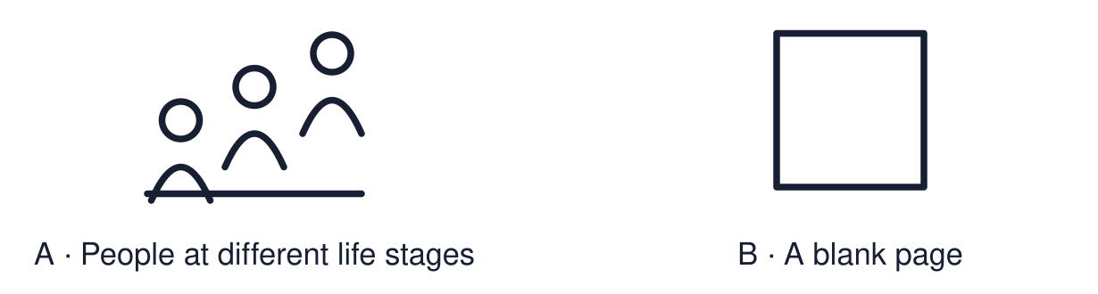
Start with 1 and 2. Try 3 and 4 when ready. Reading and exact scribing are available.

1 Give one reason pilgrimage may matter to a believer
Support: Use the reminder strip or talk it through with an adult.
My response
________________________________________________________________________

2 Which meaning fits rite of passage
Support: Choose: A ceremony that marks a new stage of life OR A formal event with set words and actions.
My response
________________________________________________________________________

3 Define rite of passage
Support: Use the model evidence anchor word or read one relevant card together.
My response
________________________________________________________________________

4 Are rites of passage only religious
Support: Give a reason when ready.
My response
________________________________________________________________________
Stretch: use a precise example or explain which detail supports your answer.

Evidence cards
Read, point or listen. Keep the source label with any detail you use.

A Bar and Bat Mitzvah
Bar or Bat Mitzvah marks becoming responsible for the commandments in Jewish life. Common ages are 13 for boys and 12 or 13 for girls, depending on the community. A synagogue celebration may include reading Torah; practices vary.
Source: Authored RE summary
Limit: Jewish communities mark this in different ways.

B Confirmation
Confirmation is an expression of Christian commitment in churches that practise it. In the Church of England it includes affirming baptismal promises and a bishop laying on hands. Other Christian traditions differ.
Source: Authored RE summary
Limit: Christian churches differ. Some do not practise confirmation.

C A Humanist naming ceremony
Some non-religious families hold a naming ceremony to welcome a child. Family and friends make promises of support. There is no religious content.
Source: Authored RE summary
Limit: Many non-religious families hold no ceremony.

D Three questions
What happens? What does it mean? How does it show belonging?
Source: Authored classroom resource
Limit: Three questions are a starting point.

Shared investigation
1. Sort each detail: Bar/Bat Mitzvah, Confirmation or both.
2. Answer the three questions for one ceremony.
Work with a partner or adult, or use your own table. One person suggests; the other checks the evidence. Swap after one turn. Passing is allowed.

Move or match the cards
Cards to use
The community witnesses a young person’s commitment
Confirming promises made at baptism
Reading from the Torah

Possible labels: Bar/Bat Mitzvah / Both / Confirmation
Our explanation
________________________________________________________________________
________________________________________________________________________
________________________________________________________________________
Support: Use the glossary and one chunk of evidence. Plan the claim and supporting detail before explaining.
Further challenge: Explain why communities mark life stages publicly and not in private.

Supported independent task
Complete this route only. Describe a rite of passage and explain how it can connect a person to a community.
1. Choose one ceremony from the case studies.
2. Match: what happens → what it means.
3. Say how it shows belonging.
Support: Use the glossary and one chunk of evidence. Plan the claim and supporting detail before explaining. Complete the organiser one space at a time. At a ___, ___. This means ___. It shows belonging because ___.
My choice or example
________________________________________________________________________
________________________________________________________________________
A detail from the card story or object
________________________________________________________________________
________________________________________________________________________
My reason
________________________________________________________________________
________________________________________________________________________
My check or next step
________________________________________________________________________
________________________________________________________________________
An adult may read or scribe your exact response. They should not choose the answer.

Standard independent task
Complete this route only. Describe a rite of passage and explain how it can connect a person to a community.
1. Choose one rite of passage.
2. Answer: what happens? What does it mean?
3. Explain how it shows belonging.
Support: At a ___, ___. This means ___. It shows belonging because ___.
My choice or example
________________________________________________________________________
________________________________________________________________________
A detail from the card story or object
________________________________________________________________________
________________________________________________________________________
My reason
________________________________________________________________________
________________________________________________________________________
My check or next step
________________________________________________________________________
________________________________________________________________________
Check the required evidence and revise one detail.

Stretch independent task
Complete this route only. Describe a rite of passage and explain how it can connect a person to a community.
1. Answer the three questions for one ceremony.
2. Compare it with a second ceremony.
3. Explain why a public ceremony strengthens commitment.
Support: Choose the evidence independently. Use the frame only if it helps.
My choice or example
________________________________________________________________________
________________________________________________________________________
A detail from the card story or object
________________________________________________________________________
________________________________________________________________________
My reason
________________________________________________________________________
________________________________________________________________________
My check or next step
________________________________________________________________________
________________________________________________________________________
Explain why communities mark life stages publicly and not in private.

Exit ticket
Choose a response mode. You may give your answers privately to an adult.

Define rite of passage
My response
________________________________________________________________________
________________________________________________________________________
________________________________________________________________________

Are rites of passage only religious
My response
________________________________________________________________________
________________________________________________________________________
________________________________________________________________________
Support: At a ___, ___. This means ___. It shows belonging because ___.
Further challenge: Explain why communities mark life stages publicly and not in private.
One thing I changed or want to check
________________________________________________________________________
________________________________________________________________________

