Moral teachings across worldviews
Learning goal: Apply a moral teaching or principle from two worldviews to an everyday dilemma.

Words to use
Word | Meaning
moral | To do with right and wrong
principle | A basic rule that guides decisions
dilemma | A situation where the right choice is not obvious
consequence | What happens as a result of an action

Remember
Which principle asks you to imagine being the other person? Both: the Golden Rule and Humanist empathy.
Does describing a teaching mean you agree with it? No. Description is separate from endorsement.

How to show your learning
Select one everyday dilemma.
Using the principle of ___, a person might ___ because ___.

Evidence matters
Fictional cases are teaching examples. Historical, geographical and religious claims use the named sources. A model video demonstrates a method.
This is learning about religion and worldviews, not worship. Nobody is asked to share a personal belief, family detail or loss.
Sources: Luke 6 Christian ethical teaching

Arrival choices
Previous lesson reminder:
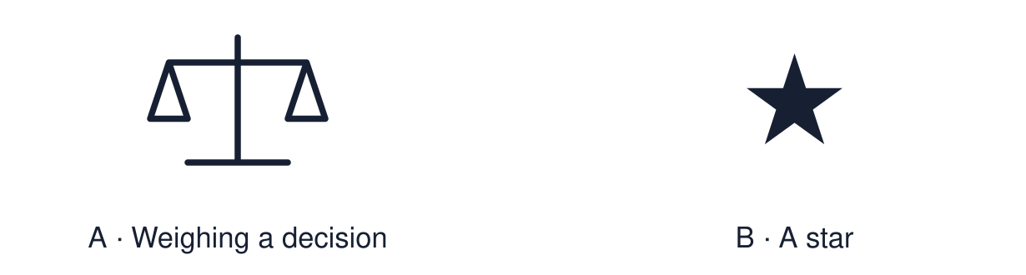
Start with 1 and 2. Try 3 and 4 when ready. Reading and exact scribing are available.

1 Define rite of passage
Support: Use the reminder strip or talk it through with an adult.
My response
________________________________________________________________________

2 Which meaning fits moral
Support: Choose: To do with right and wrong OR A basic rule that guides decisions.
My response
________________________________________________________________________

3 Which principle asks you to imagine being the other person
Support: Use the model evidence anchor A,B or read one relevant card together.
My response
________________________________________________________________________

4 Does describing a teaching mean you agree with it
Support: Give a reason when ready.
My response
________________________________________________________________________
Stretch: use a precise example or explain which detail supports your answer.

Evidence cards
Read, point or listen. Keep the source label with any detail you use.

A A Christian teaching
“Do to others as you would have them do to you.” Often called the Golden Rule.
Source: Authored summary; Luke 6:31
Limit: The Golden Rule appears in many worldviews in different words.

B A Humanist principle
Think about the consequences for everyone affected, and use empathy: how would it feel to be them?
Source: Authored summary of Humanist ethics
Limit: Humanists weigh principles differently.

C The dilemma
Fictional case: Sam finds a wallet with £40 and a bank card outside the shop. Nobody saw. Sam is short of money this week.
Source: Authored classroom case
Limit: This example does not describe every person, family or community.

D People differ
Two people who share a worldview may decide differently. Describing a teaching is not the same as agreeing with it.
Source: Authored classroom rules
Limit: We describe and apply. We do not judge people.

Shared investigation
1. Apply each principle to Sam’s dilemma.
2. Decide whether each response fits the principle.
Work with a partner or adult, or use your own table. One person suggests; the other checks the evidence. Swap after one turn. Passing is allowed.

Move or match the cards
Cards to use
Hand it in, because the owner may be worse off than Sam
Keep it, because nobody saw
Hand the wallet in, as Sam would want if it were his

Possible labels: Does not fit / Fits consequences and empathy / Fits the Golden Rule
Our explanation
________________________________________________________________________
________________________________________________________________________
________________________________________________________________________
Support: Use the glossary and one chunk of evidence. Plan the claim and supporting detail before explaining.
Further challenge: Explain why two people using the same principle could still reach different decisions.

Supported independent task
Complete this route only. Apply a moral teaching or principle from two worldviews to an everyday dilemma.
1. Listen to one everyday dilemma.
2. Choose between two responses.
3. Say which principle fits your choice.
Support: Use the glossary and one chunk of evidence. Plan the claim and supporting detail before explaining. Complete the organiser one space at a time. Using the principle of ___, a person might ___ because ___.
My choice or example
________________________________________________________________________
________________________________________________________________________
A detail from the card story or object
________________________________________________________________________
________________________________________________________________________
My reason
________________________________________________________________________
________________________________________________________________________
My check or next step
________________________________________________________________________
________________________________________________________________________
An adult may read or scribe your exact response. They should not choose the answer.

Standard independent task
Complete this route only. Apply a moral teaching or principle from two worldviews to an everyday dilemma.
1. Select one everyday dilemma.
2. Explain two possible responses.
3. Say which principle influenced each.
Support: Using the principle of ___, a person might ___ because ___.
My choice or example
________________________________________________________________________
________________________________________________________________________
A detail from the card story or object
________________________________________________________________________
________________________________________________________________________
My reason
________________________________________________________________________
________________________________________________________________________
My check or next step
________________________________________________________________________
________________________________________________________________________
Check the required evidence and revise one detail.

Stretch independent task
Complete this route only. Apply a moral teaching or principle from two worldviews to an everyday dilemma.
1. Explain two responses to one dilemma.
2. Apply a principle from each worldview.
3. Justify which response you find stronger.
Support: Choose the evidence independently. Use the frame only if it helps.
My choice or example
________________________________________________________________________
________________________________________________________________________
A detail from the card story or object
________________________________________________________________________
________________________________________________________________________
My reason
________________________________________________________________________
________________________________________________________________________
My check or next step
________________________________________________________________________
________________________________________________________________________
Explain why two people using the same principle could still reach different decisions.

Exit ticket
Choose a response mode. You may give your answers privately to an adult.

Which principle asks you to imagine being the other person
My response
________________________________________________________________________
________________________________________________________________________
________________________________________________________________________

Does describing a teaching mean you agree with it
My response
________________________________________________________________________
________________________________________________________________________
________________________________________________________________________
Support: Using the principle of ___, a person might ___ because ___.
Further challenge: Explain why two people using the same principle could still reach different decisions.
One thing I changed or want to check
________________________________________________________________________
________________________________________________________________________

