A structured “compare” response
Learning goal: Produce a structured comparison using evidence from two worldviews.

Words to use
Word | Meaning
compare | To show similarities and differences
describe | To say what something is like
however | A word that introduces a difference
viewpoint | What a person or worldview thinks about a question

Remember
Which words show that an answer is comparing? Both, however, whereas.
Are two descriptions side by side a comparison? No. A comparison links them.

How to show your learning
Answer one Autumn 2 comparison question.
Both ___. However, ___ whereas ___, because ___.

Evidence matters
Fictional cases are teaching examples. Historical, geographical and religious claims use the named sources. A model video demonstrates a method.
This is learning about religion and worldviews, not worship. Nobody is asked to share a personal belief, family detail or loss.
Sources: Chabad introduction to Bar Mitzvah; Church of England confirmation

Arrival choices
Previous lesson reminder:
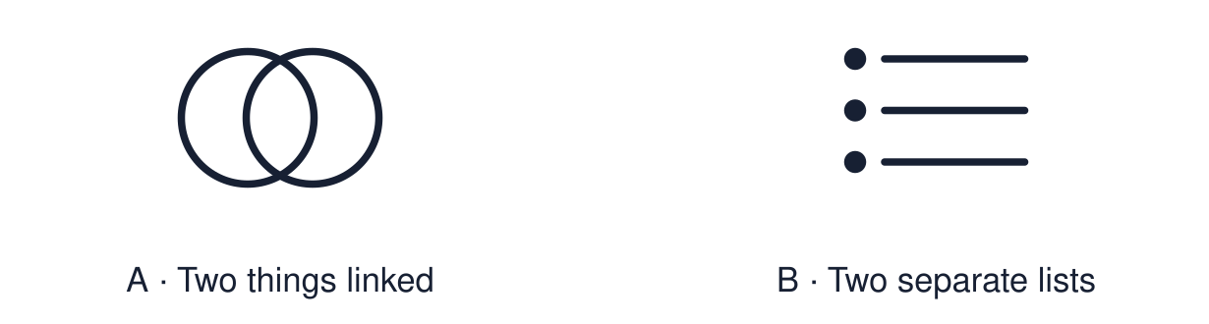
Start with 1 and 2. Try 3 and 4 when ready. Reading and exact scribing are available.

1 Give the strongest similarity between the two responses
Support: Use the reminder strip or talk it through with an adult.
My response
________________________________________________________________________

2 Which meaning fits compare
Support: Choose: To show similarities and differences OR To say what something is like.
My response
________________________________________________________________________

3 Which words show that an answer is comparing
Support: Use the model evidence anchor B or read one relevant card together.
My response
________________________________________________________________________

4 Are two descriptions side by side a comparison
Support: Give a reason when ready.
My response
________________________________________________________________________
Stretch: use a precise example or explain which detail supports your answer.

Evidence cards
Read, point or listen. Keep the source label with any detail you use.

A Describe or compare?
Describe: says what one thing is like. Compare: sets two things side by side using both, however or whereas.
Source: Authored classroom resource
Limit: Good comparisons start from accurate descriptions.

B The structure
Both… (similarity). However… / whereas… (difference). Because… (reason from evidence).
Source: Authored classroom resource
Limit: A support for clear thinking, not an exam technique.

C A weak comparison
“Christians have confirmation. Jews have Bar Mitzvah.” Two descriptions, no comparison.
Source: Authored classroom example
Limit: It is a useful starting point.

D A model comparison
Both bar or Bat Mitzvah and Christian confirmation can mark religious responsibility or commitment within a community. Their meanings and practices differ. Bar or Bat Mitzvah concerns responsibility for commandments; Church of England confirmation includes affirming baptismal promises. Customs vary.
Source: Authored classroom model
Limit: Other good answers exist.

Shared investigation
1. Improve each weak comparison using both / however / because.
2. Highlight the comparison words.
Work with a partner or adult, or use your own table. One person suggests; the other checks the evidence. Swap after one turn. Passing is allowed.

Move or match the cards
Cards to use
Prayer and reflection are different.
Muslims go to Makkah. Catholics go to Lourdes.

Rewrite one draft and explain what you changed.
Our explanation
________________________________________________________________________
________________________________________________________________________
________________________________________________________________________
Support: Use the glossary and one chunk of evidence. Plan the claim and supporting detail before explaining.
Further challenge: Add a “because” that explains the difference using a belief.

Supported independent task
Complete this route only. Produce a structured comparison using evidence from two worldviews.
1. Choose one Autumn 2 comparison question.
2. Complete the “Both ___” clause aloud or with a scribe.
3. Add one “however”.
Support: Use the glossary and one chunk of evidence. Plan the claim and supporting detail before explaining. Complete the organiser one space at a time. Both ___. However, ___ whereas ___, because ___.
My point
________________________________________________________________________
________________________________________________________________________
Evidence for my point
________________________________________________________________________
________________________________________________________________________
My explanation
________________________________________________________________________
________________________________________________________________________
My checked or improved sentence
________________________________________________________________________
________________________________________________________________________
An adult may read or scribe your exact response. They should not choose the answer.

Standard independent task
Complete this route only. Produce a structured comparison using evidence from two worldviews.
1. Answer one Autumn 2 comparison question.
2. Use both and however or whereas.
3. Add a reason using “because”.
Support: Both ___. However, ___ whereas ___, because ___.
My point
________________________________________________________________________
________________________________________________________________________
Evidence for my point
________________________________________________________________________
________________________________________________________________________
My explanation
________________________________________________________________________
________________________________________________________________________
My checked or improved sentence
________________________________________________________________________
________________________________________________________________________
Check the required evidence and revise one detail.

Stretch independent task
Complete this route only. Produce a structured comparison using evidence from two worldviews.
1. Write a full structured comparison.
2. Support each side with evidence.
3. Explain the difference using a belief.
Support: Choose the evidence independently. Use the frame only if it helps.
My point
________________________________________________________________________
________________________________________________________________________
Evidence for my point
________________________________________________________________________
________________________________________________________________________
My explanation
________________________________________________________________________
________________________________________________________________________
My checked or improved sentence
________________________________________________________________________
________________________________________________________________________
Add a “because” that explains the difference using a belief.

Exit ticket
Choose a response mode. You may give your answers privately to an adult.

Which words show that an answer is comparing
My response
________________________________________________________________________
________________________________________________________________________
________________________________________________________________________

Are two descriptions side by side a comparison
My response
________________________________________________________________________
________________________________________________________________________
________________________________________________________________________
Support: Both ___. However, ___ whereas ___, because ___.
Further challenge: Add a “because” that explains the difference using a belief.
One thing I changed or want to check
________________________________________________________________________
________________________________________________________________________

