A feeling in colour or sound
BUILD Spring 1 Week 1 Monday 4 January 2027 P5 Year A Explore
I can use a colour or sound to show a feeling.
Weekly outcome: Use colour/sound to express a feeling.
I can choose a feeling for my art.
I can try two marks or sounds.
I can show my choice in my arts log.
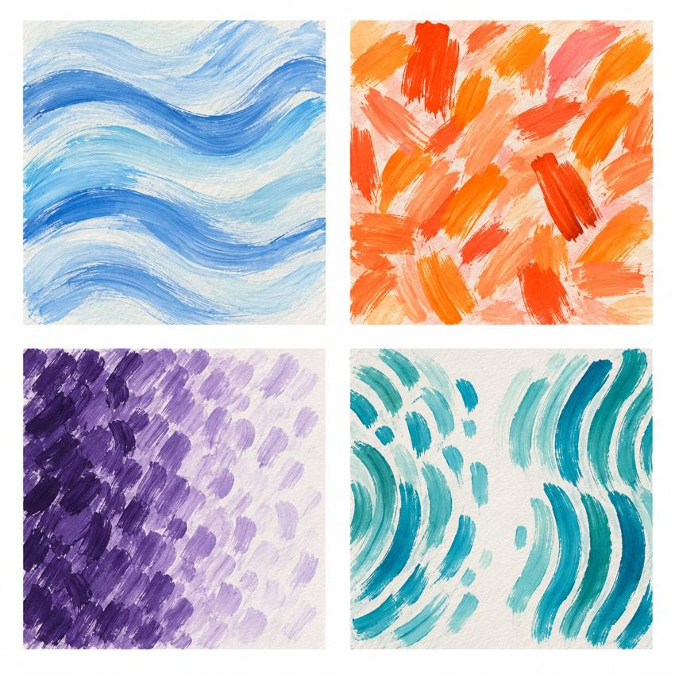
Original teacher models. These are possible readings. You may see or hear a different feeling.
Choose paint, sound or silent movement. GROW can also choose original words or drama. Work may be small. Ask for help or take a calm pause.

My task and routes
BUILD Spring 1 Week 1 Monday 4 January 2027 P5 Year A Explore

The main task
In your book or arts log, choose a feeling.
Try two tiny colour tests or two sound tests.
Keep one and make a short piece.
Say or show: I chose ___ because ___.
Keep your tests. You can ask an adult to write your words.

Supported
Pick calm or energy, or point to your own word.
Try two lines or beats with an adult.
Choose one. Direct the adult if you want.
Finish: I chose ___ because ___.

Independent
Choose a feeling and paint or sound.
Try two small versions. Keep both tests.
Make a short piece with your choice.
Add your choice and reason to your arts log.

Aspire
Use the same core task.
Change one feature, such as space, speed or a pause.
Say how the new version changes the feeling.
Keep your own reason in your arts log.

My words
My feeling or idea is ___.
My art form is paint / sound / silent movement.
My two tests were ___.
I chose ___ because ___.
Next time I will ___.

Teacher models comparison
BUILD Spring 1 Week 1 Monday 4 January 2027 P5 Year A Explore
These are original teacher examples. They are not works by named artists.
Top left: flowing blue marks. Top right: short warm marks. Bottom left: dense marks become more open. Bottom right: a motif returns after a gap.
Which marks could fit a made-up feeling? Point to a feature and give your reason. A colour or sound can mean different things to different people.
I notice ___.
This could show ___ because ___.

My arts log entry
BUILD Spring 1 Week 1 Monday 4 January 2027 P5 Year A Explore
Actual date __________ Lesson ART_BUILD_S1_W01_P1
Use your own book or this log page. You can speak, sign or point. An adult can scribe your words and read them back.
Sketch your real work, or describe your sound or movement
My feeling or idea is ___.
My art form is paint / sound / silent movement.
My two tests were ___.
I chose ___ because ___.
Next time I will ___.
Adult scribed my words: yes / no. I checked them: yes / not yet.
Staff note: actual help used and exact observed work. Record a first attempt as a first attempt.

