Making my emotion piece
BUILD Spring 1 Week 2 Tuesday 12 January 2027 P1 Year A Explore
I can make a small piece linked to a feeling.
Weekly outcome: Create art linked to an emotion (links PSHE).
I can use my plan to make a piece.
I can show a start and an end.
I can say how one choice fits my feeling.
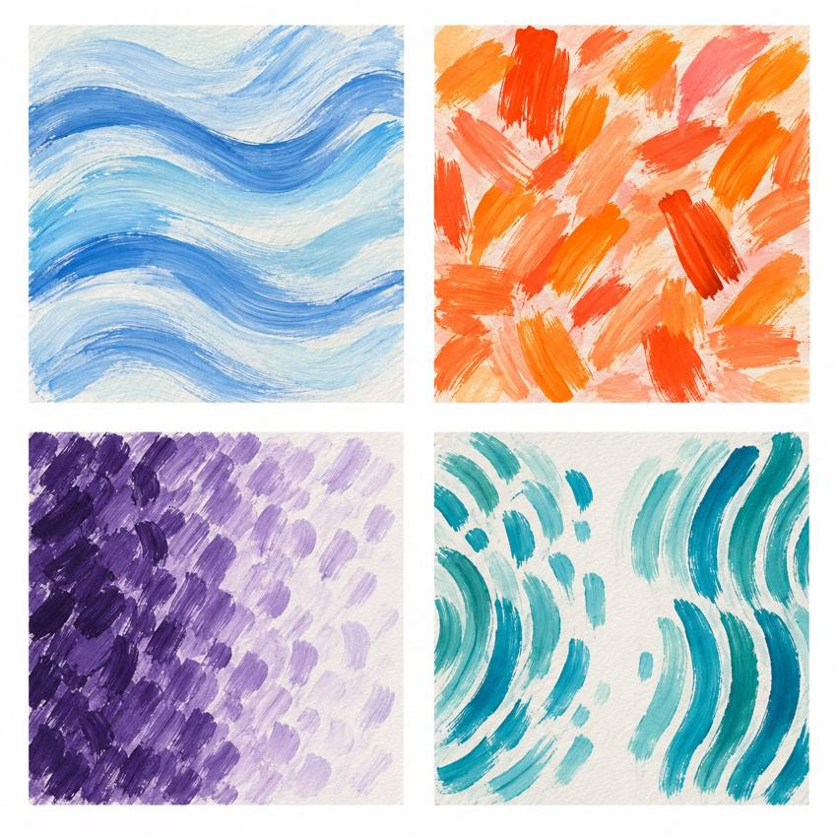
Original teacher models. These are possible readings. You may see or hear a different feeling.
Choose a quiet or silent route if helpful. Ask for help or take a calm pause. Use your own idea for an invented emotion.

My task and routes
BUILD Spring 1 Week 2 Tuesday 12 January 2027 P1 Year A Explore

The main task
In your book or arts log, find your plan.
Make your small painting, sound or silent piece.
Give it a clear start and end.
Check one part. Keep or change it and say why.
Keep your work and your own words.

Supported
Find your plan or make a short one now.
Make the first part, then the last part.
You may direct an adult.
Point to a choice. Tell or show why you kept it.

Independent
Use your plan to make a small piece.
Give it a clear start and end.
Check one part. Keep or change it for a reason.
Add your real work and words to the arts log.

Aspire
Complete your small piece and review.
Try the end in one new way.
Which end fits your feeling best? Say why.
Keep both tests and your final choice.

My words
I made ___.
My piece is about ___.
My piece starts with ___ and ends with ___.
I kept / changed ___ because ___.
My work or witness note is ___.
Next I would like to ___.

Teacher models comparison
BUILD Spring 1 Week 2 Tuesday 12 January 2027 P1 Year A Explore
These are original teacher examples. They are not works by named artists.
Look at the type of mark, colour and space. Which feature could show an invented emotion? The same colour can mean different things to different makers.
I notice ___.
My own piece could show ___ by ___.

My arts log entry
BUILD Spring 1 Week 2 Tuesday 12 January 2027 P1 Year A Explore
Actual date __________ Lesson ART_BUILD_S1_W02_P2
Use your own book or this log page. You can speak, sign or point. An adult can scribe your words and read them back.
Sketch your real work, or describe your sound or movement
I made ___.
My piece is about ___.
My piece starts with ___ and ends with ___.
I kept / changed ___ because ___.
My work or witness note is ___.
Next I would like to ___.
Adult scribed my words: yes / no. I checked them: yes / not yet.
Staff note: actual help used and exact observed work. Record a first attempt as a first attempt.

