One skill to practise
GROW Spring 1 Week 2 Monday 11 January 2027 P6 Year A Explore
I can choose one technique, keep a first try and practise it.
Weekly outcome: Develop a skill and record it in my arts log.
I can choose one technique to practise.
I can keep a real before test and set one goal.
I can record what I tried and what I noticed.
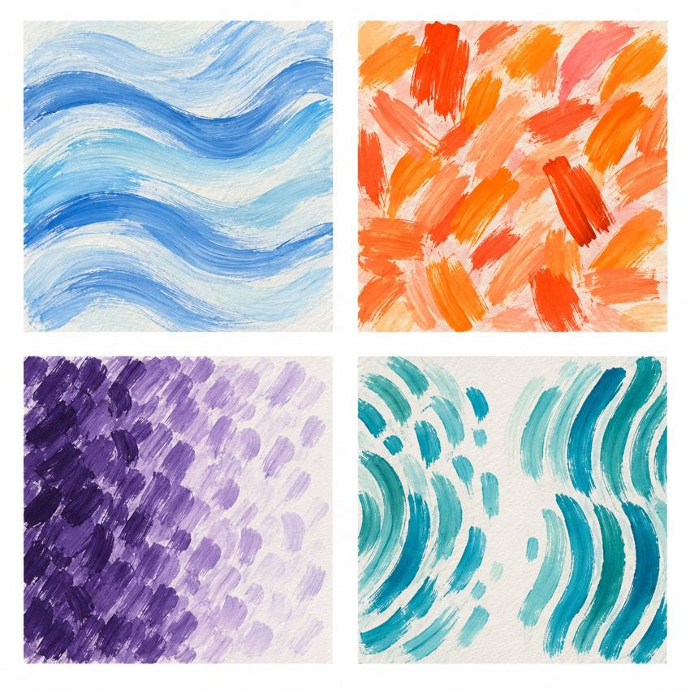
Original teacher models. These are possible readings. You may see or hear a different feeling.
Choose a quiet or silent route if helpful. Ask for help or take a calm pause. GROW keeps one chosen skill across both lessons and records a fair before and after test.

My task and routes
GROW Spring 1 Week 2 Monday 11 January 2027 P6 Year A Explore

The main task
Use your chosen technique. Keep the same four-part test.
Practise in two short rounds, with a pause between.
Keep your first test. Note your cue and one goal.

Supported
Choose marks or quiet or silent actions.
Keep four parts in your first test.
Use one adult cue. Practise one small goal.
Tell or show what you noticed for your log.

Independent
Keep a first four-part test. Choose one technique and a small goal.
Use a cue to practise. Keep your first test and a practice record.
Say what stayed the same or changed. Keep the cue for next time.

Aspire
Complete your first test and practice.
Explain why your chosen cue helps the skill.
Say what you will check in the next lesson.
The next level task is optional.

My words
My chosen technique is ___.
My before test showed ___.
My one skill goal is ___.
The cue I used was ___.
I practised by ___.
Next lesson I will keep ___ the same.

Comparing my skill tests
GROW Spring 1 Week 2 Monday 11 January 2027 P6 Year A Explore
Use your own before and after tests. A teacher model is not your evidence.

The same test
Keep the same chosen form and four-part task in both tests. Use the same size or pace guide. Record any help used.

Before
Keep your first four marks or a precise note of four quiet actions. Notice how even the gaps or pace are.

Practice
Choose one small target. Test it in short trials. Keep a note of what you did.

After
Try the same four-part test again. Record the result you get. It may be more even, the same or less even.

A fair view
Compare one feature in both records. Say what the practice may have helped. If the form changes for access, keep the old test and make a new before test for the new form.
My one skill was ___.
Before I noticed ___. After I noticed ___.
I think the practice ___ because ___.

My arts log entry
GROW Spring 1 Week 2 Monday 11 January 2027 P6 Year A Explore
Actual date __________ Lesson ART_GROW_S1_W02_P1
Use your own book or this log page. You can speak, sign or point. An adult can scribe your words and read them back.
Sketch your real work, or describe your sound or movement
My chosen technique is ___.
My before test showed ___.
My one skill goal is ___.
The cue I used was ___.
I practised by ___.
Next lesson I will keep ___ the same.
Adult scribed my words: yes / no. I checked them: yes / not yet.
Staff note: actual help used and exact observed work. Record a first attempt as a first attempt.

