My own response to an artist
BUILD Spring 1 Week 3 Tuesday 19 January 2027 P1 Year A Explore
I can link my own art to an artist's idea.
Weekly outcome: Find out about an artist who expresses feelings.
I can recall two facts about the artist.
I can make my own piece using a new layout.
I can say how the artist's idea helped me.
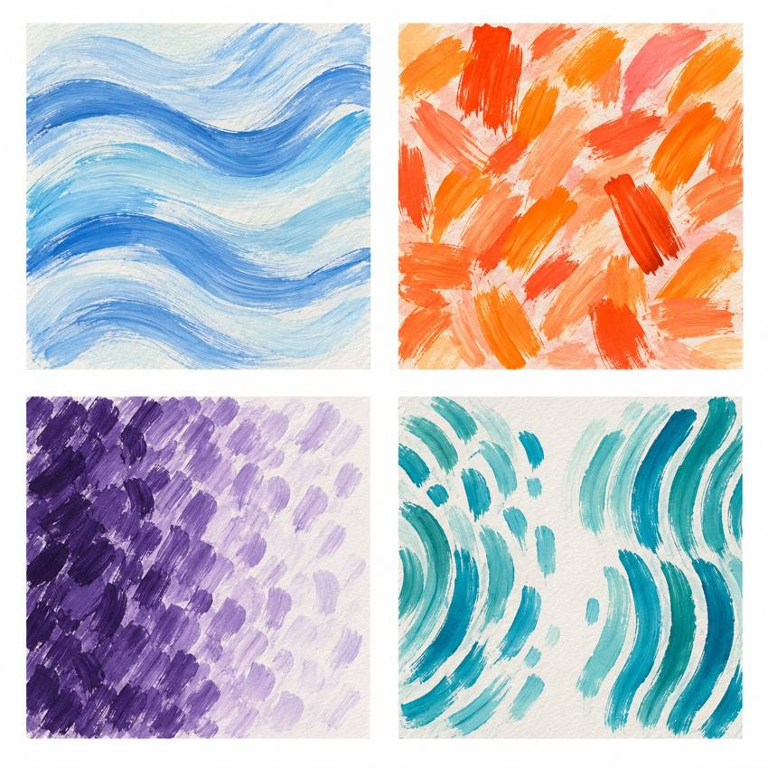
Original teacher models, not work by the artist. You may see or hear a different feeling.
Choose a quiet or silent route if helpful. Ask for help or take a calm pause. Use an artist method to make your own response.

My task and routes
BUILD Spring 1 Week 3 Tuesday 19 January 2027 P1 Year A Explore

The main task
In your book or arts log, use your real test.
Make a small piece with your own shapes or moves.
Choose a layout for a made-up feeling.
Check one part. Keep or change it for a reason.
Add the artist link and your own words.

Supported
Hear the card again. Find the two facts.
Choose a real test or make one now.
Make or direct your own small response.
Tell an adult the artist link and your choice.

Independent
Recall two facts about the artist.
Use a test to make your own small piece.
Keep or change one part for a reason.
Log the method link and your own choice.

Aspire
Complete your own response and log.
Try one new layout with the same shapes.
Say which layout best fits your idea and why.
Explain a different way someone could read it.

My words
The artist is ___.
I found out ___ and ___.
The artist's idea helped me ___.
My own choice was ___ because ___.
My work or witness note is ___.
Next I would like to ___.

Artist description and my response
BUILD Spring 1 Week 3 Tuesday 19 January 2027 P1 Year A Explore
Listen to the artist description. No copy of the artist's work is supplied.

Henri Matisse Cut-outs
Henri Matisse made art with line, colour and cut paper. He used line and colour to show feelings. He cut shapes from painted paper. He moved the shapes to try a new layout. We can read his art in our own way. We do not know his mood from it.

A detail and a view
What did he cut? What could he move?
How could moving your own shapes change the way your piece feels?
A fact comes from the card. A view is your own reading. We can use a method to make our own art.
One fact I found was ___.
My own piece could show ___ by ___.

My arts log entry
BUILD Spring 1 Week 3 Tuesday 19 January 2027 P1 Year A Explore
Actual date __________ Lesson ART_BUILD_S1_W03_P2
Use your own book or this log page. You can speak, sign or point. An adult can scribe your words and read them back.
Your own response sketch or observed action notes
The artist is ___.
I found out ___ and ___.
The artist's idea helped me ___.
My own choice was ___ because ___.
My work or witness note is ___.
Next I would like to ___.
Adult scribed my words: yes / no. I checked them: yes / not yet.
Staff note: actual help used and exact observed work. Label a plan, trial or finished piece honestly.

