GROW · Monday 25 January 2027 · P6 · ART_GROW_S1_W04_P1

Knowledge organiser
Making from my resilience plan
Weekly outcome: Create my resilience-themed piece.
I can start my piece from my own plan.

Today I can
I can use my plan to start making.
I can explain a making decision.
I can record what I made and what changed.

Words to use
resilience — Finding a way forward, with help or a change of plan.
intention — The idea or effect you want to show.
decision — A choice you make.
revise — Change part of a plan or piece.

One worked example
Teacher example only: I made the start and turn. I left a gap because it makes the new route clear. The ending still needs making.
Your idea may differ. Use your own words and choices.

GROW · Monday 25 January 2027 · P6 · ART_GROW_S1_W04_P1

Choose one task route

Supported
Read your plan with an adult.
Choose the first small section.
Make or direct it. Pause to check.
Say one choice and what comes next.

Independent
Check your plan and available tools.
Make the planned first section.
Keep or change one feature for a reason.
Log the real work, decisions and next step.

Aspire
Complete the core making task.
Test two small versions of one feature.
Choose the version that fits your intention.
Keep the comparison and your reason.
Use one route at a time. You may change route with the adult.

GROW · Monday 25 January 2027 · P6 · ART_GROW_S1_W04_P1

Activity cards
Use these as prompts. Complete your response in your book, arts log or chosen art form.

1 0 to 15 seconds
Point to the adult plan: start, block, turn and open space. State the intended idea.

2 15 to 30 seconds
Make the first line and block or show the first two planned actions.

3 30 to 45 seconds
Check the turn. Leave a clearer gap or pause and say why.

4 45 to 60 seconds
Record the actual decision and the unfinished next step. Keep the plan with the work.

Your own making
Make your own choice. Keep or change one feature and give your reason.
Perform or direct the planned silent sequence. Adult records exact actions, order, pauses, support and confirmed intention. No media capture is needed.

GROW · Monday 25 January 2027 · P6 · ART_GROW_S1_W04_P1

Plan and first section
Original class examples. These are not pupil work or evidence.
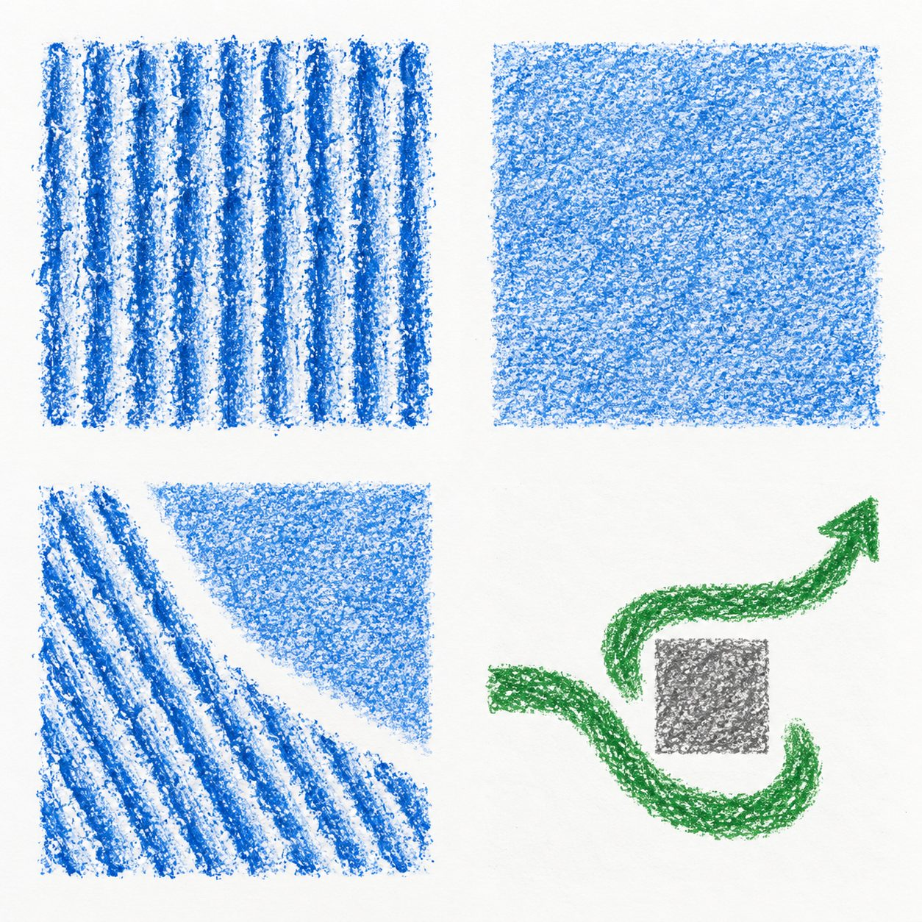

Plan
A line meets a block, turns and finds open space.
Intention: another way forward.

Actual first section
The line and turn are made. The gap is wider than planned.
Decision: the wider gap makes the turn clearer. The ending is still to do.
Say what you notice. The maker can choose a different meaning.

GROW · Monday 25 January 2027 · P6 · ART_GROW_S1_W04_P1

My arts log
In your book or existing arts log. You can draw, speak, sign or direct an adult.
My plan intended to show ___.
Today I actually made ___.
I decided ___ because ___.
I changed / kept ___ from my plan because ___.
The help or access method I used was ___.
My real next making step is ___.

Keep a true record
Actual activity date ___. Method used ___. Help used ___.
Adult scribed my words: yes / no. I checked them: yes / not yet.
Keep your own tests or actual work. A witness note should say exactly what happened.

