Two stars and one small wish
BUILD Spring 1 Week 5 Monday 1 February 2027 P5 Year A Explore
I can find two useful parts and choose one small change.
Weekly outcome: Review and improve my piece.
I can use a real piece of my own work.
I can give two stars with clear reasons.
I can choose and test one small wish.
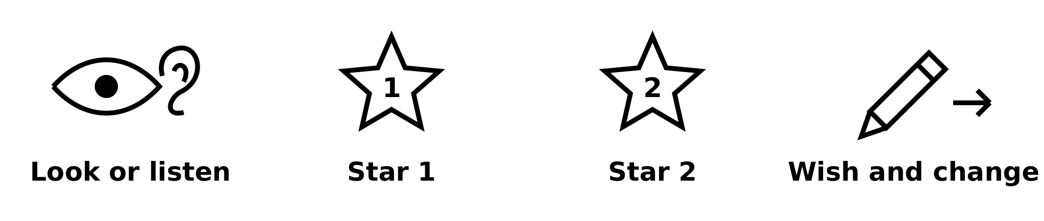
Picture prompts have words as well as symbols. Use your own real work; these prompts are not pupil evidence.
Choose a quiet or silent route if helpful. Ask for help or take a calm pause. Find two stars and one wish, then make one real improvement.

My task and routes
BUILD Spring 1 Week 5 Monday 1 February 2027 P5 Year A Explore

The main task
In your book or arts log, use one real piece.
Give star 1 and star 2. Point to each feature.
Choose one small wish and say why.
Test it on spare paper or in a short rehearsal.
Keep the before state, test and your own words.

Supported
Find real own work or make a tiny piece today.
Use the pictures to choose two helpful parts.
Choose one small wish with an adult.
Try the change. Keep what really happened.

Independent
Review one real piece with two stars and one wish.
Give a reason linked to each feature.
Test the one small wish in the same art form.
Keep the original, test and your review.

Aspire
Complete the two stars and one wish.
Explain how the wish builds on a useful part.
Test one small change and compare it with the start.
Choose the next action for a clear reason.

My words
My real piece or sequence is ___.
Star 1 is ___ because ___.
Star 2 is ___ because ___.
My wish is to ___ to help ___.
My real test showed ___.

Two stars and a wish
BUILD Spring 1 Week 5 Monday 1 February 2027 P5 Year A Explore
Use your own real work. Look, listen or watch a short part. Point, speak, sign or ask an adult to scribe.

Star one
Find one part that works. Point to it or show it. Say why it fits your idea.

Star two
Find a second part that works. Give a real detail, such as a gap, mark, sound or pause.

One wish
Choose one small change. Test it, then make a real revised piece or sequence. Keep the first version or a clear note. A new print can be a revised version on fresh paper.
My two stars are ___ and ___.
My wish is ___. I changed ___ because ___.

My arts log entry
BUILD Spring 1 Week 5 Monday 1 February 2027 P5 Year A Explore
Actual date __________ Lesson ART_BUILD_S1_W05_P1
Use your own book or this log page. You can speak, sign or point. An adult can scribe your words and read them back.
Your real work and one revised part
My real piece or sequence is ___.
Star 1 is ___ because ___.
Star 2 is ___ because ___.
My wish is to ___ to help ___.
My real test showed ___.
Adult scribed my words: yes / no. I checked them: yes / not yet.
Staff note: actual help used and exact observed work. Keep the starting work, real revision and support honest.

