Making one real improvement
BUILD Spring 1 Week 5 Tuesday 2 February 2027 P1 Year A Explore
I can make one real change and say how it helps my piece.
Weekly outcome: Review and improve my piece.
I can find the real work and my chosen wish.
I can make one real change in the same art form.
I can keep the before and after states and a reason.
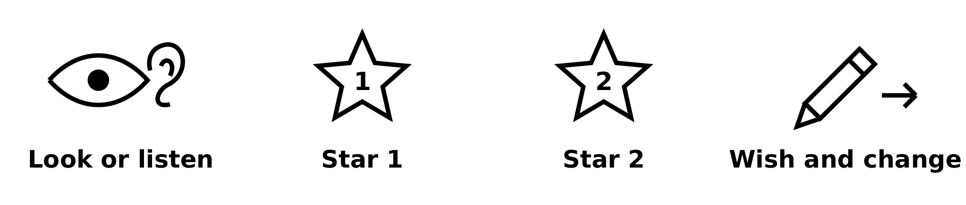
Picture prompts have words as well as symbols. Use your own real work; these prompts are not pupil evidence.
Choose a quiet or silent route if helpful. Ask for help or take a calm pause. Find two stars and one wish, then make one real improvement.

My task and routes
BUILD Spring 1 Week 5 Tuesday 2 February 2027 P1 Year A Explore

The main task
In your book or arts log, keep the real before state.
Use your one wish to make a small change.
For a dry print, you may make a new revised print.
Compare the same kind of work before and after.
Keep the real result and your own reason.

Supported
Find the real before state and one wish.
Make or direct one small real change.
Show the changed part to an adult.
Keep both states and your own reason.

Independent
Keep the real before state.
Make the one change from your wish.
Compare the same kind of work before and after.
Log the actual change, reason and effect.

Aspire
Complete the real revision and log.
Explain how it builds on one of your stars.
Use a detail from before and after to support your view.
Set one next step from the real result.

My words
Before, my real piece or sequence ___.
I made this change: ___.
I chose it because ___.
After, I noticed ___.
The before and after records are ___.
My next step is ___.

Two stars and a wish
BUILD Spring 1 Week 5 Tuesday 2 February 2027 P1 Year A Explore
Use your own real work. Look, listen or watch a short part. Point, speak, sign or ask an adult to scribe.

Star one
Find one part that works. Point to it or show it. Say why it fits your idea.

Star two
Find a second part that works. Give a real detail, such as a gap, mark, sound or pause.

One wish
Choose one small change. Test it, then make a real revised piece or sequence. Keep the first version or a clear note. A new print can be a revised version on fresh paper.
My two stars are ___ and ___.
My wish is ___. I changed ___ because ___.

My arts log entry
BUILD Spring 1 Week 5 Tuesday 2 February 2027 P1 Year A Explore
Actual date __________ Lesson ART_BUILD_S1_W05_P2
Use your own book or this log page. You can speak, sign or point. An adult can scribe your words and read them back.
Your real work and one revised part
Before, my real piece or sequence ___.
I made this change: ___.
I chose it because ___.
After, I noticed ___.
The before and after records are ___.
My next step is ___.
Adult scribed my words: yes / no. I checked them: yes / not yet.
Staff note: actual help used and exact observed work. Keep the starting work, real revision and support honest.

