Marking out step cards
Read or ask an adult to read. Staff may cut these cards on the table lines.
Cards | Cards
A  Draw the plan. Add 20 cm, 8 cm and the two fold lines. | B  Check the flat card is 20 cm by 8 cm. Choose one long start edge.
C  Put ruler zero at the start edge. Mark 2 cm and 6 cm at one short end. | D  At the other short end, mark 2 cm and 6 cm from that same long edge.
E  Join the two 2 cm marks. Then join the two 6 cm marks. Use dash lines. | F  Check the plan and marks. Add your ID. Store the card flat for next week.
Put the steps in order. Follow them on your own card.

Plan and mark help frames

My plan needs
A top view of the card.
20 cm length and 8 cm width.
A star on one long start edge.
Fold lines 2 cm and 6 cm from that edge.
The material and tools I will use.

My marks need
Ruler zero on the start edge.
Two marks at each short end.
Matching marks joined with dash lines.
A check at both ends.
My ID on the flat card.

A reason I can give
I start from zero because __.
Both marks use the same edge because __.
I checked __ and changed __.

Help card
Please help me with this step.
I can point to the part I mean.
Please read the words or steady the ruler.
I can ask for a pause.

A marking guide
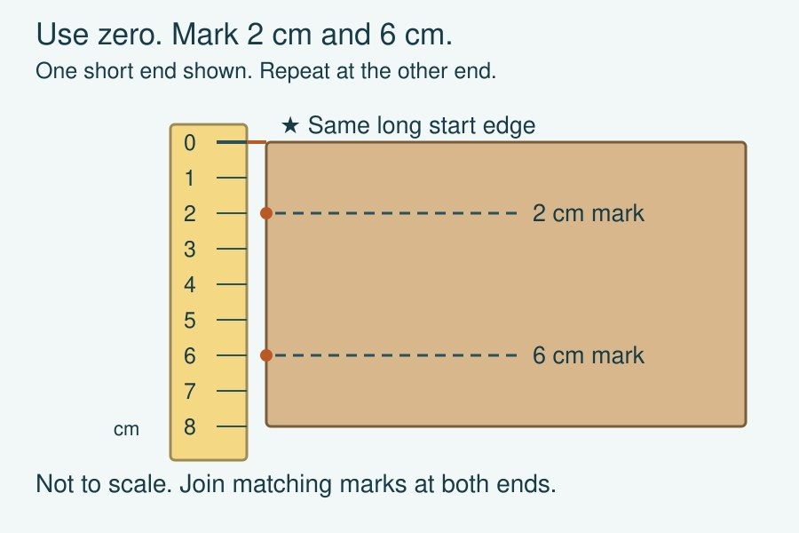
The ruler goes across the short end. Zero meets the starred long edge. Mark at 2 cm and 6 cm. Repeat at the other short end.
Join matching marks with dash lines. The middle panel is 4 cm wide. The two outer panels are 2 cm each. Keep the card flat for next week.
This guide is not to scale. Measure your actual card with a ruler.

