Scenario cards
Made-up cases. Read or ask an adult to read. Cut on the table lines.
Case cards | Case cards
A  Rae has £15. Travel costs £4 and lunch costs £5. A book costs £3. | B  Lee has £10. Travel costs £4 and lunch costs £5. Lee wants a £4 game.
C  Jo buys a new bag from a shop. Its zip is faulty. Jo has proof of purchase. | D  Kit buys a sound blue bag in a shop. Later, Kit wants red. There is no fault.
E  A site shows a £6 price. Kim has £8. The delivery cost is not shown yet. | F  A new torch is faulty. Ali lost the receipt but has other proof of purchase.
What fact matters? What could the person do next? Explain your reason.

Sort labels and help frames
Useful step | Needs a change | Check first
The step helps with the task. | The plan needs a different step. | A fact or some help is needed.

My reason
I chose __ because __.
The fact that matters is __.
The next step is __.
I need to check __ with __.

Steps I can use
1 Pause | 2 Check facts | 3 Choose a step | 4 Ask for help
Take a moment. | What do I know? | What could help? | Who can support me?

Private help card
Can I speak to you in private?
I need help.
I can show this card to the adult.
I can pass and use another made-up case.
If one adult cannot help, ask another trusted adult. Getting help is okay.

A shop problem
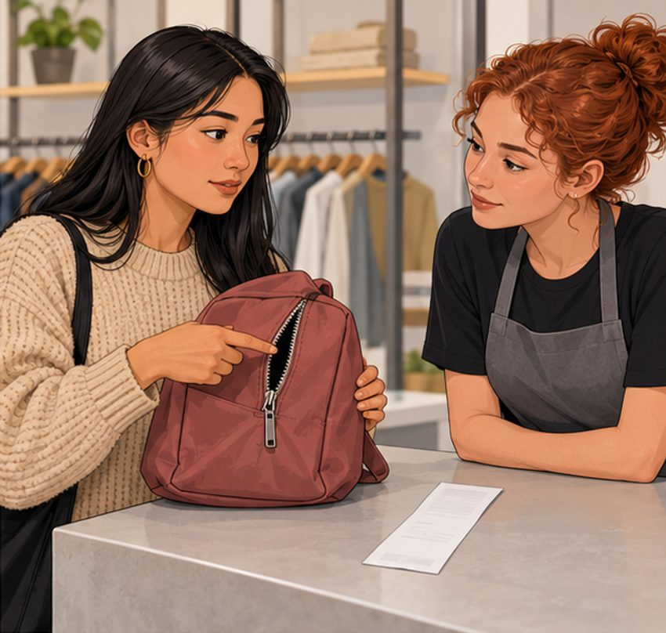
This is a made-up scene. You can use the words below as well as the picture.
A new bag has a faulty zip. The buyer can contact the shop and explain the problem.
Fault | Change of mind
The item does not work as it should. Ask the seller for a remedy. | The item is sound but you no longer want it. For an in-shop buy, check the returns policy.
A receipt can help prove a purchase. Other proof may count too. A refund is not promised for every return.

A message to practise
I bought __. The problem is __. Please can you help?

