A model comparison of two settlements
Tuesday 8 December 2026 | P2 | 40 minutes | Year A
White paper version | Read quietly. Point, write, type or use a scribe. No reading aloud is required.

Source 1 profiles and method S1
MODEL ONLY. Place A is a fictional inland settlement. Place B is a fictional coastal settlement. These internal cards are not real online pages, pupil fieldwork or facts about a named place.

The matched sample
An observer follows one comparable short route in each model place on one observation day. Each route has twenty plots. Every plot gets one primary land-use code. Both use the same categories and method. We count plots, not people, buildings or land area.

Our category key
R residential: mainly homes. S services: mainly serving people. W workshops: mainly making or repairing. O open space: mainly an open area. Give each plot one primary code, even if it has another use too.

Before comparing
Check units, categories and sample sizes. Both model samples total twenty plots. Use earlier fieldwork only from an approved nameless copy after an adult checks its method, categories and sample size. Otherwise retain the fictional baseline. Never call model data your real fieldwork.

A model comparison of two settlements continued
Tuesday 8 December 2026 | P2 | 40 minutes | Year A
White paper version | Read quietly. Point, write, type or use a scribe. No reading aloud is required.

Source 2 sampled plot counts S2
MODEL DATA. Same categories and unit: sampled plots, twenty per route.
Land use | Place A | Place B
Residential | 12 | 6
Services | 4 | 6
Workshops | 2 | 2
Open space | 2 | 6
Total sampled plots | 20 | 20
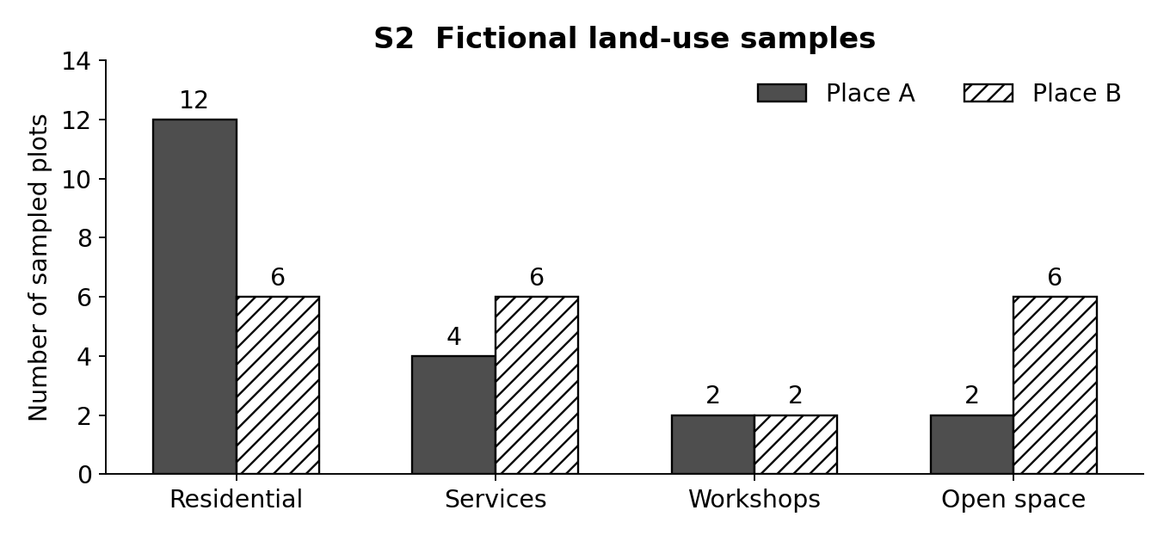
Check the same category, both values and the plot-count axis. The workshops are a similarity: two plots in each sample. Residential differs by six plots: 12 minus 6.
Optional proportion check: residential is 60% of sampled plots in A and 30% in B. Difference: 30 percentage points. Workshops are 10% in each. These counts do not show population or land area.

A model comparison of two settlements continued
Tuesday 8 December 2026 | P2 | 40 minutes | Year A
White paper version | Read quietly. Point, write, type or use a scribe. No reading aloud is required.

Source 3 model maps and limits S3
These schematic model cells display S2’s fictional plots. They are not real streets, real survey positions, distances or areas. R homes; S services; W workshops; O open space.
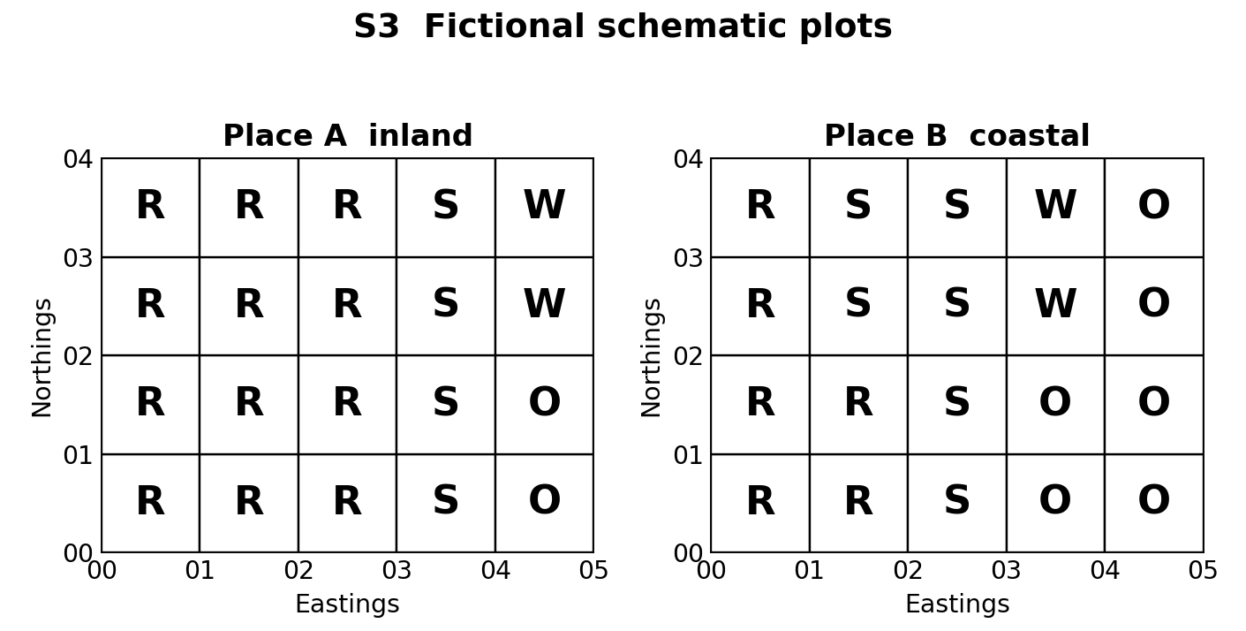
Model cell references: eastings first, then northings, using each cell’s lower-left corner. 0000 is residential in both. This retrieves a map skill; no national grid location or metric scale is claimed.

Description and explanation
Description: B's route has six open-space plots; A's has two. Tentative explanation: the routes may pass through different settlement areas. More evidence is needed to check this possibility. The counts cannot show that the coast caused the difference.

What the model cannot show
Twenty plots on one route on one day give a limited snapshot. Routes may miss other uses. One primary code hides mixed uses. We cannot describe the whole settlement, rank places as better, prove causes or assume the samples represent everyone.

Our visible finish
Keep your own note: one similarity and one contrast across two matched features, exact numbers, source codes, a possible explanation and a limit. Work as Analyst and Checker, then swap. Point, write or speak quietly; no forced reading aloud or cold calling. These notes are not the later assessed write-up.

