Fieldwork assessment guidance
Tuesday 15 December 2026 | P2 | 40 minutes | Year A
Keep this sheet away from the pupil assessment view. Use a separate four-plot pilot to model structure, then collect each pupil’s own response. Do not read out the S2 model findings before assessment.

Assessment profile
Part | 1 Developing evidence | 2 Clear evidence
Question | Relevant topic or partial question | Answerable question linked to the data
Method | Some correct details | Source, unit, sample and selection/coding described
Table | Some correct entries or headings | Accurate values, headings, unit and totals
Graph | Some correct bars or checks | Accurate graph or supported checking with labels, scale and key
Findings | One valid pattern or weak evidence | Two numerical findings and a bounded answer
Evaluation | A limit or improvement stated | Limit, effect and a linked improvement explained
Score 0 where no valid evidence is yet shown. Record a score for each part, exact evidence and actual support. Total /12 is a local task profile, not a qualification grade. Use the same criteria across routes; record independence separately.
For a supplied table or graph, ask the pupil to check entries, label it and use it in their answer. A high reasoning score with support does not establish independent construction. No supplied set proves actual data collection.

Actual records
L01: Q __ M __ T __ G __ F __ E __ Total __/12
Evidence and support ____________________________________
L02: Q __ M __ T __ G __ F __ E __ Total __/12
Evidence and support ____________________________________

Fieldwork assessment guidance continued
Tuesday 15 December 2026 | P2 | 40 minutes | Year A

S2 data and graph check
Homes A7/B3; services A1/B4; workshops A0/B1; open space A2/B2. Each section totals 10, route total 20. Hinge answer B: the sample covers two route sections only.
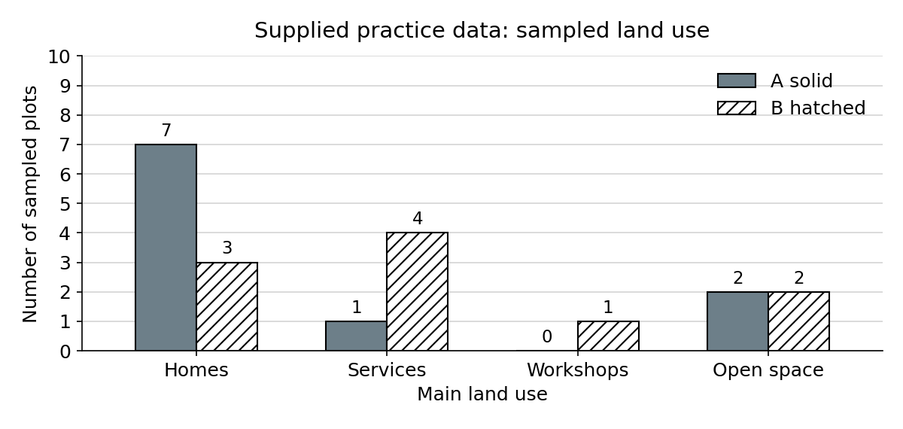
Homes differ by 4 plots, services by 3, workshops by 1; open space is equal. Homes are 70% of A and 30% of B, a 40-percentage-point gap. These are proportions of sampled plots, not population or land area.
Access option: give a crop or print of the graph only, after recording it as supplied. Keep the model findings and rubric page away from the pupil view. Assess their checks and reading, and leave independent graph construction unclaimed.

Fieldwork assessment guidance continued
Tuesday 15 December 2026 | P2 | 40 minutes | Year A

Illustrative answer after assessment
Question: How does land use differ between two sections of a residential route?
Method: I used the supplied fictional S1–S2 data. The model records the first ten plots on one side of each section, one main-use code per plot, during one dry weekday morning. The unit is a plot. I did not collect this data.
Findings: A has 7 home plots and B has 3, so A has 4 more. B has 4 service plots and A has 1, so B has 3 more. Both have 2 open-space plots. In these sampled sections, A has a greater share of homes and B a greater share of services.
Evaluation: The first ten plots on one side may miss other kinds of street. The pattern may change elsewhere. I would sample further sections using a planned selection rule and the same categories. That would improve coverage, though it would still be a sample. These counts cannot show why the pattern occurs.

Other valid answers
Accept other accurate count comparisons, a cautious conclusion and a justified limitation with a matching improvement. If pupils use their own data, mark against that source and method. Do not require the S2 numbers or a fictional method.

After review
Give one actual adult reply and NS. Keep the learner’s own change or usual supported response. Record R only after that exchange and E only after banking. Leave unfinished evidence visible. Award requirements remain a separate masked staff check.

