Townside picture plan
BUILD · Humanities · Summer 1 · Week 1
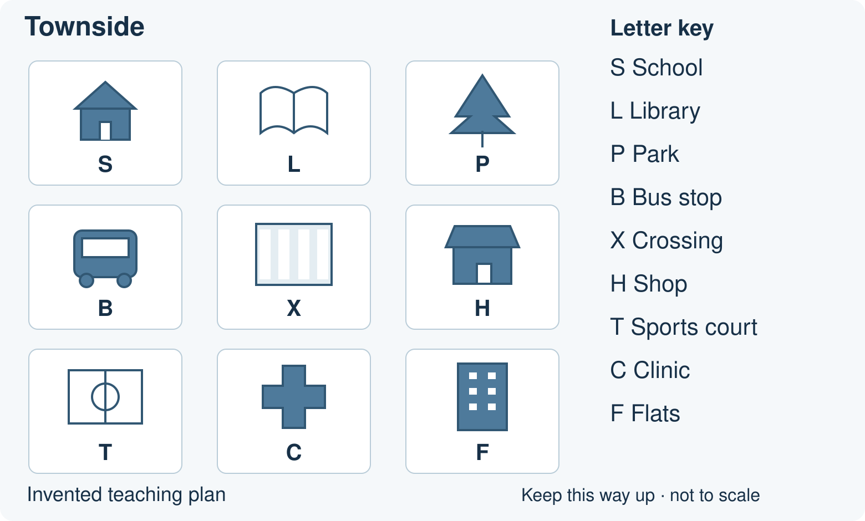
Invented teaching plan. Keep this way up. It is not to scale.
Practise with Townside. Use the teacher’s checked school plan for the real-school task.
Local: Near the place we are talking about.
Feature: Something in a place, such as a park or road.
Map: A picture that shows where places are.
Key: A guide to the symbols on a map.

Arrival: Supported
BUILD · Humanities · Summer 1 · Week 1
Use the Townside plan on page 1. Point, speak, draw or write. Keep your first response.

1. Point to the school picture.
Use the roof and S symbol.
My response:
___________________________________________________________________

2. Which picture shows a park?
Choose the tree or the bus.
My response:
___________________________________________________________________

3. Point to the place beside the school on its right.
Use your finger to move one square.
My response:
___________________________________________________________________

4. Find B in the key. What place does it mark?
Point to the bus picture or say its name.
My response:
___________________________________________________________________

Arrival: Standard
BUILD · Humanities · Summer 1 · Week 1
Use the Townside plan on page 1. Point, speak, draw or write. Keep your first response.

1. Where is the school on the plan?
Use top, bottom, left or right.
My response:
___________________________________________________________________

2. What does L in the key mean?
Find the same letter on the plan.
My response:
___________________________________________________________________

3. Which place is to the right of the library?
Keep the plan the same way up.
My response:
___________________________________________________________________

4. Which place is directly below the school?
Move down one square.
My response:
___________________________________________________________________

Arrival: Stretch
BUILD · Humanities · Summer 1 · Week 1
Use the Townside plan on page 1. Point, speak, draw or write. Keep your first response.

1. Locate the school without using a place name.
Describe its position on the plan.
My response:
___________________________________________________________________

2. Why is a key useful to a visitor?
Link a symbol to its meaning.
My response:
___________________________________________________________________

3. From the school, move two squares right. Where are you?
Check each square with your finger.
My response:
___________________________________________________________________

4. Is the library nearer to the school than the park on this plan?
Count the equal squares along the top row.
My response:
___________________________________________________________________

Clue hunt and visitor note
BUILD · Humanities · Summer 1 · Week 1
Use the Townside plan. Match each clue to a place. Point to the picture that helped you.
1. I want to borrow a book.
___________________________________________________________________
2. I need a place to wait for a bus.
___________________________________________________________________
3. I want an open green space.
___________________________________________________________________
4. I have an appointment with a nurse.
___________________________________________________________________

Repair the visitor note
“The library is to the left of the school.”
Check the plan. Change one word:
___________________________________________________________________
Show what helped you decide:
___________________________________________________________________

Our school: Supported
BUILD · Humanities · Summer 1 · Week 1
Use the plan your teacher supplies.
Choose the school label from two labels on your teacher’s plan.
Point to the school. Name it or show its label.
Find one local feature, then try a second with less help.
An adult reads one step. Use a counter to mark your choice. Point or say: The school is here.
School name and position:
___________________________________________________________________
Local feature and symbol:
___________________________________________________________________
Where the feature is:
___________________________________________________________________
My check or improvement:
___________________________________________________________________
Try the final location question without a content prompt.

Our school: Standard
BUILD · Humanities · Summer 1 · Week 1
Use the plan your teacher supplies.
Name and mark the school on your teacher’s plan.
Circle two local features. Name each one.
Tell or write where one feature is in relation to the school.
Use near, left, right or beside. Check the plan key.
School name and position:
___________________________________________________________________
Local feature and symbol:
___________________________________________________________________
Where the feature is:
___________________________________________________________________
My check or improvement:
___________________________________________________________________
Check one label with a partner. Make one improvement yourself.

Our school: Stretch
BUILD · Humanities · Summer 1 · Week 1
Use the plan your teacher supplies.
Locate and label the school and three local features.
Choose one feature that a visitor might need.
Describe a short route from the school to that feature.
Check each turn. Explain how the key helped.
Use the plan your teacher has checked. Keep it the same way up.
School name and position:
___________________________________________________________________
Local feature and symbol:
___________________________________________________________________
Where the feature is:
___________________________________________________________________
My check or improvement:
___________________________________________________________________
Compare two features: which looks nearer on this plan? Say how you checked.

Exit choices
BUILD · Humanities · Summer 1 · Week 1
Use one route. Use your teacher’s school plan. Give your own responses.

Supported
Show your school on the teacher’s plan.
My response:
___________________________________________________________________
Show one local feature without a content prompt.
My response:
___________________________________________________________________

Standard
Name and locate your school on the teacher’s plan.
My response:
___________________________________________________________________
Where is one local feature in relation to the school?
My response:
___________________________________________________________________

Stretch
Locate your school and two local features on the teacher’s plan.
My response:
___________________________________________________________________
Give a short route from the school to one feature.
My response:
___________________________________________________________________

