Practice picture plans
  - BUILD Humanities Summer 1 Week 2
Use the keys and labels. These places are invented. The plans show selected features and are not to scale.
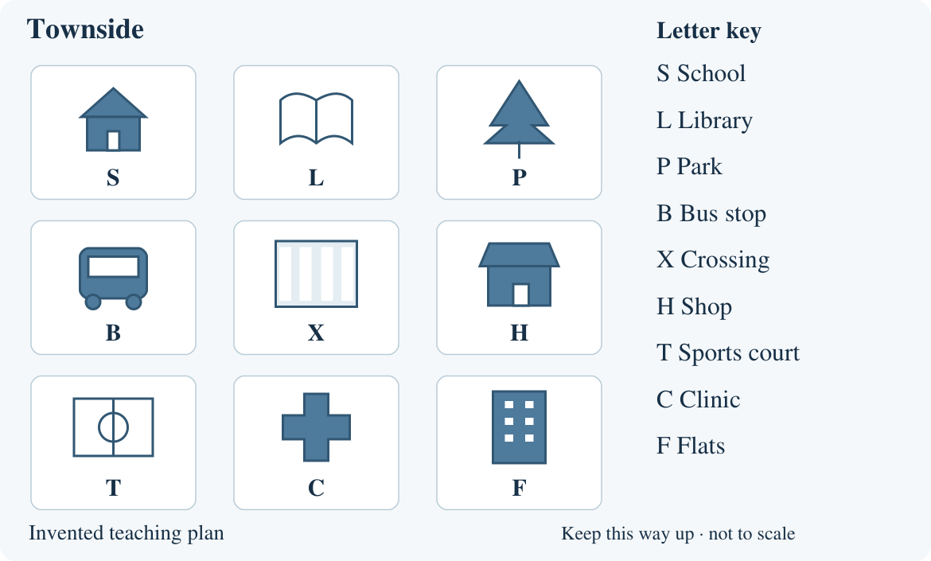
Keep the plan this way up. Move one square per direction. Left and right mean on the page. A route starts at a named place and ends at its destination.

Arrival task
  - Supported | Routes on a familiar plan
A plan shows places from above. Use the picture key. Left and right mean on this page. No previous lesson is needed.
Use the practice plan sheet. Start with questions 1 and 2.

1 Point to S, the school.
Help: Find the roof picture.
My response
________________________________________________________________

2 Show right on the page.
Help: Choose left or right with your finger.
My response
________________________________________________________________

3 Move from S one square down. Where are you?
Help: Trace with a counter.
My response
________________________________________________________________

4 Point to a destination. What does it mean?
Help: Think about where a route ends.
My response
________________________________________________________________

Arrival task
  - Standard | Routes on a familiar plan
A plan shows places from above. Use the picture key. Left and right mean on this page. No previous lesson is needed.
Use the practice plan sheet. Start with questions 1 and 2.

1 What does S mean?
Help: Use the key.
My response
________________________________________________________________

2 From S, move one square right. Where are you?
Help: Move to the adjacent square.
My response
________________________________________________________________

3 From L, move one square down. Where are you?
Help: Keep the page still.
My response
________________________________________________________________

4 What does destination mean?
Help: Think of the end of a journey.
My response
________________________________________________________________

Arrival task
  - Stretch | Routes on a familiar plan
A plan shows places from above. Use the picture key. Left and right mean on this page. No previous lesson is needed.
Use the practice plan sheet. Start with questions 1 and 2.

1 Start B. Move up, then right. Where are you?
Help: Track each move separately.
My response
________________________________________________________________

2 Start X. Move right, then down. Where are you?
Help: Use the key to name the final place.
My response
________________________________________________________________

3 Why must we name the start?
Help: Try the same direction from two places.
My response
________________________________________________________________

4 Give two moves from S to X.
Help: Try a different first direction.
My response
________________________________________________________________

Shared activity
  - Partner roles and practice record
Use the practice picture plans. A partner can point, speak, draw or write.
1. Navigator: choose a start and give two moves on the plan.
2. Checker: trace the moves with a counter and mark the destination.
3. Compare with the navigator’s intended destination. Swap roles.
Practice route | Destination
Start S. Right, then down. | ________________
Start S. Down, then down. | ________________
Start P. Down, then left. | ________________
Start F. Left, then up. | ________________
Start X. Left, then down. | ________________

Build a route
Navigator’s start and directions
________________________________________________________________
________________________________________________________________
Checker’s destination and check
________________________________________________________________
Swap roles. This is plan practice, not permission to walk around school.

Independent task
  - Supported | Routes on a familiar plan
Use a simple map or plan of a familiar place.
Use the checked familiar-place plan.
1. Find the start on the familiar-place plan with an adult.
2. Follow one short route, with directions read aloud.
3. Mark or point to the destination yourself.
Help: Use a counter. Hear one direction at a time. Point or say: I finish at ___.
My start
________________________________________________________________
My directions in order
________________________________________________________________
My destination
________________________________________________________________
How I checked
________________________________________________________________
Further challenge: Try a new destination with the content prompt removed.

Independent task
  - Standard | Routes on a familiar plan
Use a simple map or plan of a familiar place.
Use the checked familiar-place plan.
1. Mark a start on the familiar-place plan.
2. Build a short route for a partner. Swap roles.
3. Follow the new route and mark its destination independently.
Help: Use the key and directions on the checked plan. Say: From ___, go ___ to ___.
My start
________________________________________________________________
My directions in order
________________________________________________________________
My destination
________________________________________________________________
How I checked
________________________________________________________________
Further challenge: Check one unclear instruction and rewrite or say it more clearly.

Independent task
  - Stretch | Routes on a familiar plan
Use a simple map or plan of a familiar place.
Use the checked familiar-place plan.
1. Give a precise route on the familiar-place plan.
2. Ask a partner to test it. Repair any unclear instruction.
3. Follow a fresh route and mark its destination independently.
4. Explain one check using a feature on the plan.
Help: Keep the starting point and the plan orientation clear.
My start
________________________________________________________________
My directions in order
________________________________________________________________
My destination
________________________________________________________________
How I checked
________________________________________________________________
Further challenge: Find another valid route if the paths allow it. Explain the difference.

Exit tickets
  - Use only your chosen route
Give your own response using the checked local sources. Your usual reading or communication support can stay.

Supported
1. Show the start on your familiar-place plan. Point or name it.
_______________________________________________________________
2. Follow a new short route. Mark the destination yourself. Directions may be read aloud without giving the destination.
_______________________________________________________________

Standard
1. Where does the new route on your plan finish? Mark or name the destination yourself.
_______________________________________________________________
2. How did you check one direction? Point to a feature or explain.
_______________________________________________________________

Stretch
1. Follow a fresh route and mark its destination. Use the checked familiar-place plan.
_______________________________________________________________
2. Repair one unclear route instruction. Explain why your version is easier to follow.
_______________________________________________________________

Local evidence sheet
  - Teacher completes before the lesson
Use a checked plan of a familiar school area.
Familiar place and plan source
________________________________________________________________
Date checked and key
________________________________________________________________
Agreed start
________________________________________________________________
Partner route directions
________________________________________________________________
Fresh independent route directions
________________________________________________________________
Attach or paste the plan/source sets on an extra page if needed. Check the key, labels and source limits. Do not use personal home addresses. Keep staff answers on the teacher sheet.

