Our school route fieldwork
  - Pupil resources | GROW Humanities Summer 1 Week 3
Carry out simple fieldwork about my local area.
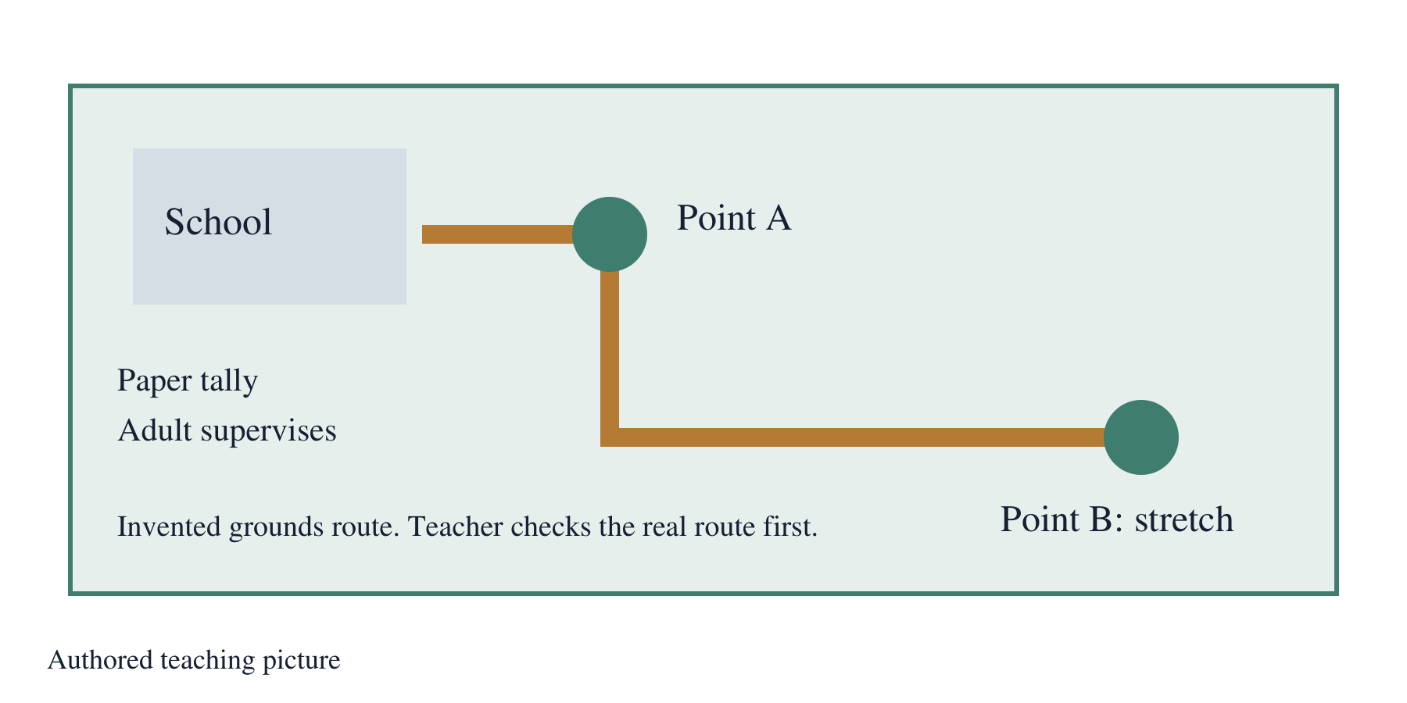
Authored teaching picture. Use the evidence cards and give your own response in the blank spaces.

Evidence cards
  - Read the source and limitation before using a detail

A Question and roles
Agree: What is the land used for along our route? Choose an observer, tally recorder and location checker. The adult supervises the approved grounds route. Swap a role after a count.
Source: Authored teaching example
Limit: This example supports practice. Check your own place separately.

B One clear counting rule
Count each visible feature once, using its main use. Keep a tally in the matching category. Mark uncertain uses with a question mark and check with the adult. A count of features does not measure land area.
Source: Authored teaching example
Limit: This example supports practice. Check your own place separately.

C Authored practice tally
AUTHORED PRACTICE at invented point A: learning 4, outdoor play 6, travel 3, nature 5, growing 2, services 1. Units: observed features. These are invented counts for a no-fieldwork lesson, not findings about our school.
Source: Authored practice tally for this pack
Limit: Replace with class counts after fieldwork. The categories must use the same counting rule.

D Return and record
Return with the adult. Add location, date, roles and the counting rule to the sheet. Check tallies against totals with a partner. Enter the counts indoors and label the graph. Keep a second point separate.
Source: Authored return-to-recording routine
Limit: A short route only represents the features observed there.

Practice data
  - Use only when real fieldwork is unavailable

AUTHORED PRACTICE tally at invented point A
AUTHORED PRACTICE tally created for this pack. Replace with the class’s own checked counts.
Units: observed features (count)
Main land use | Tally marks | Observed features
Learning | |||| | 4
Outdoor play | ||||| | | 6
Travel | ||| | 3
Nature | ||||| | 5
Growing | || | 2
Services | | | 1
Feature counts do not measure land area. One observation point cannot represent the whole locality.

Fieldwork tally sheet
  - Paper and pencil outdoors; adult-supervised grounds route
Agreed enquiry question
________________________________________________________________
Location and point label on the checked plan
________________________________________________________________
Date and time
________________________________________________________________
Observer / tally recorder / location checker
________________________________________________________________

Our checked tally
Use the same categories and count each feature once by its main use.
Units: observed features (count)
Main land use | Tally marks | Observed features
Learning
Outdoor play
Travel
Nature
Growing
Services
Feature counts do not measure land area. One observation point cannot represent the whole locality.
Return with the adult. Check tallies and totals, then enter the data indoors. Use a separate sheet for a second point. No photos of people or home addresses.

Arrival task
  - Supported
Start here: a map key explains symbols. A location label tells us where an observation was made. A tally records a count. Use card C if you missed the earlier map work.

1 What does a map key explain?
Help: Use the reminder.
My response
________________________________________________________________

2 Point to a tally category in card C.
Help: Read the category names.
My response
________________________________________________________________

3 Why label the location?
Help: Think about where the count happened.
My response
________________________________________________________________

4 Who supervises the route?
Help: Read card A.
My response
________________________________________________________________

Arrival task
  - Standard
Start here: a map key explains symbols. A location label tells us where an observation was made. A tally records a count. Use card C if you missed the earlier map work.

1 How does a location label help a reader?
Help: Use the reminder and card D.
My response
________________________________________________________________

2 What is a tally used for?
Help: Think about counting.
My response
________________________________________________________________

3 How can we avoid counting a feature twice?
Help: Read the rule on card B.
My response
________________________________________________________________

4 What should we do before entering counts?
Help: Use the return routine.
My response
________________________________________________________________

Arrival task
  - Stretch
Start here: a map key explains symbols. A location label tells us where an observation was made. A tally records a count. Use card C if you missed the earlier map work.

1 Why must two points use the same categories?
Help: Think about fair comparison.
My response
________________________________________________________________

2 What should you do with an uncertain use?
Help: Use card B.
My response
________________________________________________________________

3 Can one point represent every part of the locality?
Help: Think about the sample.
My response
________________________________________________________________

4 How can a partner check your record?
Help: Think about counts and labels.
My response
________________________________________________________________

Shared investigation
  - Suggest, check and swap roles
1. Agree the enquiry, counting rule and roles. Model one tally, then observe the adult-approved grounds route with paper. Use the practice tally indoors if the route cannot happen.
2. Return together. Label the location and date, check the totals, then enter counts and plot the graph. Keep a second observation point separate.
Our agreed counting rule
________________________________________________________________
________________________________________________________________
How we checked the totals
________________________________________________________________
________________________________________________________________
One result and a sample limit
________________________________________________________________
________________________________________________________________

Independent task
  - Supported
Carry out simple fieldwork about my local area.
1. Label point A and your role on the tally sheet. Use two highlighted categories first.
2. Collect or read the selected counts with an adult reader. Check tally marks against totals.
3. Independently explain one checked count and one safe action.
Help: Adult reads the route and category labels. You make the count or interpretation.
Enquiry and observation location
________________________________________________________________
Roles method and category counts
________________________________________________________________
Pattern using checked counts
________________________________________________________________
Sample limit and next check
________________________________________________________________
Further challenge: Add another category when ready.

Independent task
  - Standard
Carry out simple fieldwork about my local area.
1. Complete the enquiry, location, roles and counting-rule record.
2. Check all six category totals and plot the labelled data indoors.
3. Independently describe one pattern using a count and state one limit.
Help: Use the tally sheet and graph labels to check each entry.
Enquiry and observation location
________________________________________________________________
Roles method and category counts
________________________________________________________________
Pattern using checked counts
________________________________________________________________
Sample limit and next check
________________________________________________________________
Further challenge: Explain why location labels matter.

Independent task
  - Stretch
Carry out simple fieldwork about my local area.
1. Plan a second adult-approved observation point using the same categories.
2. Record both points separately, or explain what a second point would test if indoors.
3. Check totals and compare patterns without treating feature counts as land area.
4. Independently justify a method improvement using the evidence.
Help: Keep the method constant and explain any uncertainty.
Enquiry and observation location
________________________________________________________________
Roles method and category counts
________________________________________________________________
Pattern using checked counts
________________________________________________________________
Sample limit and next check
________________________________________________________________
Further challenge: Explain how sampling another point could change the conclusion.

Exit tickets
  - Give your own response using your chosen route

Supported
1. Describe one safe part of the method. Use your role record.
________________________________________________________________
2. Give one count and its category. Read your checked sheet.
________________________________________________________________

Standard
1. How did you keep the recording accurate? Name one check you used.
________________________________________________________________
2. What does one result show and not show? Include a count and a limit.
________________________________________________________________

Stretch
1. How would you compare a second point fairly? Refer to categories and method.
________________________________________________________________
2. Which uncertainty should be checked next? Use your evidence.
________________________________________________________________

