Physical and human features
  - Pupil resources | GROW Humanities Summer 1 Week 4
Describe physical and human features of a place.
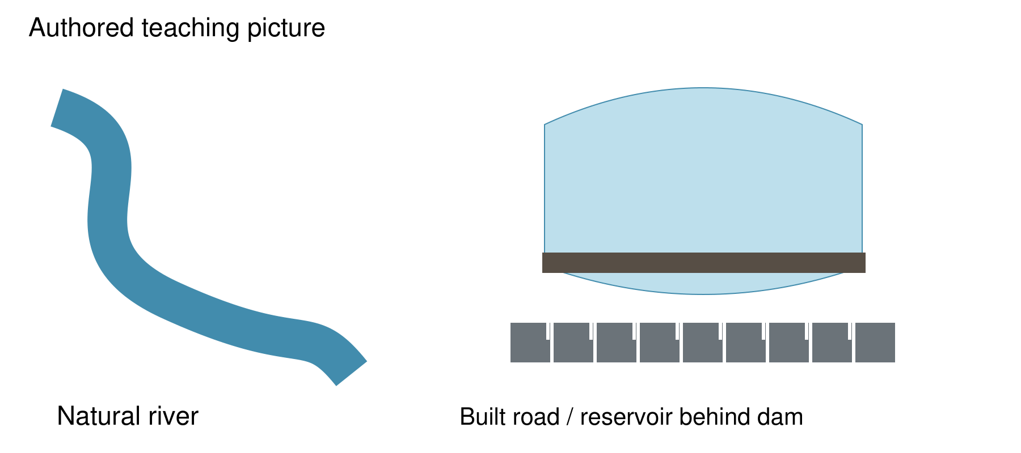
Authored teaching picture. Use the evidence cards and give your own response in the blank spaces.

Evidence cards
  - Read the source and limitation before using a detail

D River
In the authored picture, the river is a natural watercourse. Label the watercourse and explain the evidence for a physical feature.
Source: Authored feature picture
Limit: A real river may also be managed. This example specifies a natural watercourse.

H Road
The road in the picture was built for travel. Its surface and planned route are evidence of a human feature.
Source: Authored feature picture
Limit: The drawing does not tell us traffic levels.

O Reservoir
A reservoir holds water behind a dam built by people. Water is a physical part of the environment, while the dam and storage purpose are human changes. Explain why Could be both is useful here.
Source: Authored reservoir example
Limit: Some classifications call the whole reservoir human. State your criterion and justify it.

S Annotation method
Point to a feature. Name it, choose a category, then add a because statement using a visible detail. Check a partner’s label against the picture.
Source: Authored annotation routine
Limit: An attractive label is not enough without a supporting detail.

Arrival task
  - Supported
Start here: physical features occur naturally. Human features are made or changed by people. Some examples have both aspects. Use the three evidence cards even if you missed fieldwork.

1 Is a built road physical or human?
Help: People built it.
My response
________________________________________________________________

2 Find the river label.
Help: Use the supplied picture.
My response
________________________________________________________________

3 What does an annotation add?
Help: Choose a reason or decoration.
My response
________________________________________________________________

4 Can water and construction appear together?
Help: Read card O.
My response
________________________________________________________________

Arrival task
  - Standard
Start here: physical features occur naturally. Human features are made or changed by people. Some examples have both aspects. Use the three evidence cards even if you missed fieldwork.

1 What distinguishes a physical feature?
Help: Use the reminder.
My response
________________________________________________________________

2 Give evidence that the road is human.
Help: Read card H.
My response
________________________________________________________________

3 Why might the reservoir be ambiguous?
Help: Look for natural and built parts.
My response
________________________________________________________________

4 What makes a label useful evidence?
Help: Read card S.
My response
________________________________________________________________

Arrival task
  - Stretch
Start here: physical features occur naturally. Human features are made or changed by people. Some examples have both aspects. Use the three evidence cards even if you missed fieldwork.

1 Can people change a natural feature?
Help: Think about a dam.
My response
________________________________________________________________

2 How would you decide a boundary case?
Help: Name the rule used.
My response
________________________________________________________________

3 Why might two justified labels differ?
Help: Think about what each label describes.
My response
________________________________________________________________

4 How can you check an annotation?
Help: Use the picture and a partner.
My response
________________________________________________________________

Shared investigation
  - Suggest, check and swap roles
1. Sort Natural river, Built road and Reservoir behind a dam into Physical, Human or Could be both. Say what evidence supports each choice.
2. Discuss the reservoir boundary case. Model a because annotation, then annotate two features on the authored picture with a partner.
Feature card | My category | My reason
Natural river
Built road
Reservoir behind a dam
Category bank: Physical / Human / Could be both. Use the authored picture to add labels and reasons.

Independent task
  - Supported
Describe physical and human features of a place.
1. Point to the river and road with the picture key.
2. Add a category label to each with a sentence stem.
3. Independently explain one label using a visible detail.
Help: Use the word bank and one label at a time. An adult may scribe your words.
Feature named on the picture
________________________________________________________________
Category and visible evidence
________________________________________________________________
Ambiguous example and reason
________________________________________________________________
Comparison with a second feature
________________________________________________________________
Further challenge: Add a reason for the reservoir.

Independent task
  - Standard
Describe physical and human features of a place.
1. Annotate the river, road and reservoir on the picture.
2. For each, add a category and a because statement.
3. Independently compare two features and explain the ambiguous case.
Help: Use a pointer or leader line so each annotation names its feature.
Feature named on the picture
________________________________________________________________
Category and visible evidence
________________________________________________________________
Ambiguous example and reason
________________________________________________________________
Comparison with a second feature
________________________________________________________________
Further challenge: Suggest another feature that might need discussion.

Independent task
  - Stretch
Describe physical and human features of a place.
1. Create a clear annotation key for the picture.
2. Justify categories for all three features with evidence.
3. Give two defensible ways to classify the reservoir.
4. Independently compare the features and explain which rule you prefer.
Help: Separate what the picture shows from what you would need to investigate.
Feature named on the picture
________________________________________________________________
Category and visible evidence
________________________________________________________________
Ambiguous example and reason
________________________________________________________________
Comparison with a second feature
________________________________________________________________
Further challenge: Explain what further evidence could change a label.

Exit tickets
  - Give your own response using your chosen route

Supported
1. Name one physical feature and give a reason. Use the authored picture.
________________________________________________________________
2. Name one human feature and give a reason. Point or explain.
________________________________________________________________

Standard
1. How does your annotation show a physical or human feature? Include evidence.
________________________________________________________________
2. Why can the reservoir be discussed as both? Name both aspects.
________________________________________________________________

Stretch
1. Defend one classification of the reservoir. State your rule.
________________________________________________________________
2. Compare two features with a limit to your evidence. Use precise labels.
________________________________________________________________

