Help-seeking case cards
Read or ask an adult to read. Staff may cut on the table lines.
Cards | Cards
A  Rae does not understand the first step of a task. | B  Jo keeps getting unkind messages and feels unsafe.
C  Kit wants help but finds speaking hard. | D  Sam’s chosen adult is busy. Sam still needs help.
E  A person nearby is unconscious and will not wake up. | F  An adult ignores a concern that makes Lee feel unsafe.
What fact matters? What help or safer step would fit?

Ways to ask
Say a short request.
Write a note or show the help card.
Point, sign or use your usual communication aid.
Ask another trusted adult if help is not available.

Words I can use
Please help me with __.
Can we talk in private?
I need help now because __.
Who else can help me?

Help card
Please help me with this step.
I can point to what I mean.
Please read the words or show the step.
I can ask for a pause or private talk.

A visual guide
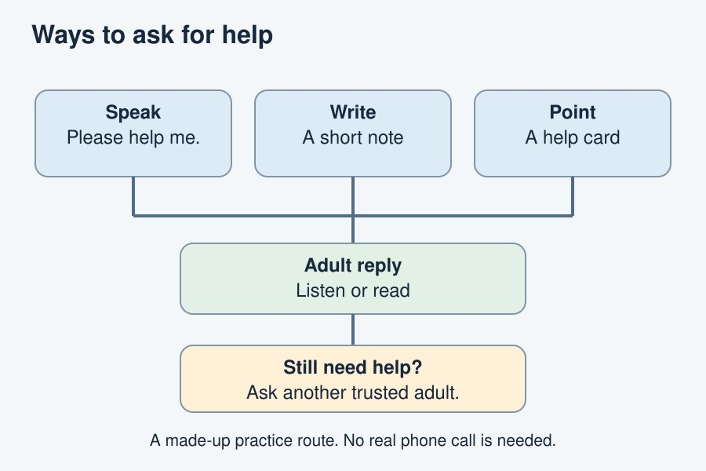
Say it, write it or show a help card. Keep trying.
The diagram is an example, not a record of your work. Use a fictional case or speak privately to staff. No personal details need to be shown to the group.
I notice __.
The next step is __.
I can ask __ for help.

