Help practice cards
Read or ask an adult to read. Staff may cut on the table lines.
Cards | Cards
A  Kit cannot read the first task instruction. | B  Jo needs a private talk but finds speaking hard.
C  The adult says later but gives no time or step. | D  A person sends repeated messages that make Sam feel unsafe.
E  The first adult is away and Lee still needs help. | F  An adult ignores Rae’s concern about being hurt.
What fact matters? What help or safer step would fit?

Check that the reply helps
Say what you need.
Use a note, point or usual aid if speaking is hard.
Ask what will happen next and when.
If help is not available, use another trusted adult.
Get prompt adult help for a safety concern.

Words I can use
Please help me with __.
When can we __?
Please show me the next step.
Who else can help?

Help card
Please help me with this step.
I can point to what I mean.
Please read the words or show the step.
I can ask for a pause or private talk.

A visual guide
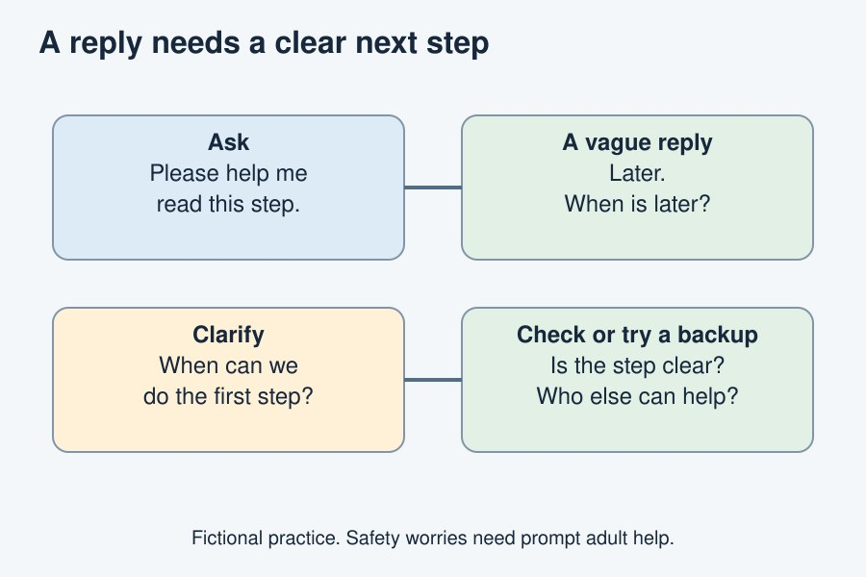
Ask, listen, check the next step. Keep trying if needed.
The diagram is an example, not a record of your work. Use a fictional case or speak privately to staff. No personal details need to be shown to the group.
I notice __.
The next step is __.
I can ask __ for help.

