Keeping-safe review cases
Read or ask an adult to read. Staff may cut on the table lines.
Cards | Cards
A  A stranger online asks Sam for a home address. | B  The first adult is away. Known staff are at the office.
C  Jo feels overloaded and asks staff for a quiet pause. | D  A person says being hurt must stay secret.
E  A task has too many spoken steps for Lee. | F  An adult gives a reply that Rae does not understand.
What fact matters? What help or safer step would fit?

My evidence check
Use your own words, signs or drawings.
Explain the clue and a safer step.
Check your first adult and a backup.
Say how to reach help.
Keep one wellbeing step and a reason.
Staff record what is banked and what is still missing.

Words I can use
The clue is __.
I would __ because __.
My first route is __.
My next step is __.

Help card
Please help me with this step.
I can point to what I mean.
Please read the words or show the step.
I can ask for a pause or private talk.

A visual guide
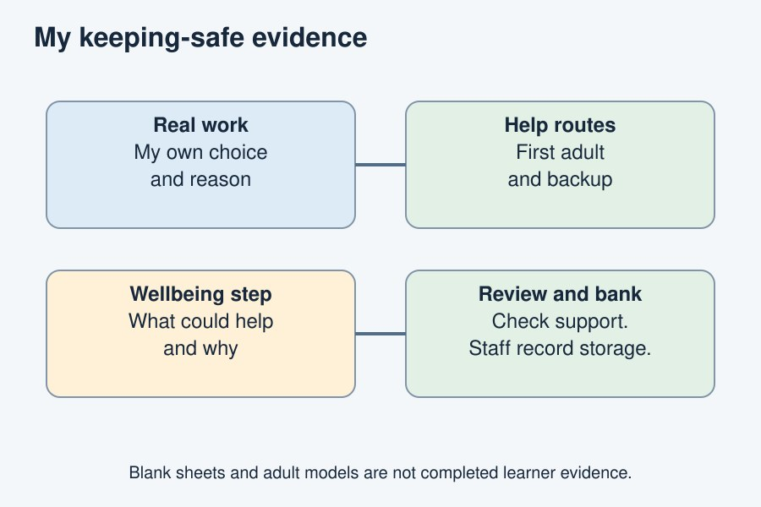
Your own choices and reasons are the evidence.
The diagram is an example, not a record of your work. Use a fictional case or speak privately to staff. No personal details need to be shown to the group.
I notice __.
The next step is __.
I can ask __ for help.

