Worker and skill cards
All workers and jobs here are made up.
Shop | Store | Garden
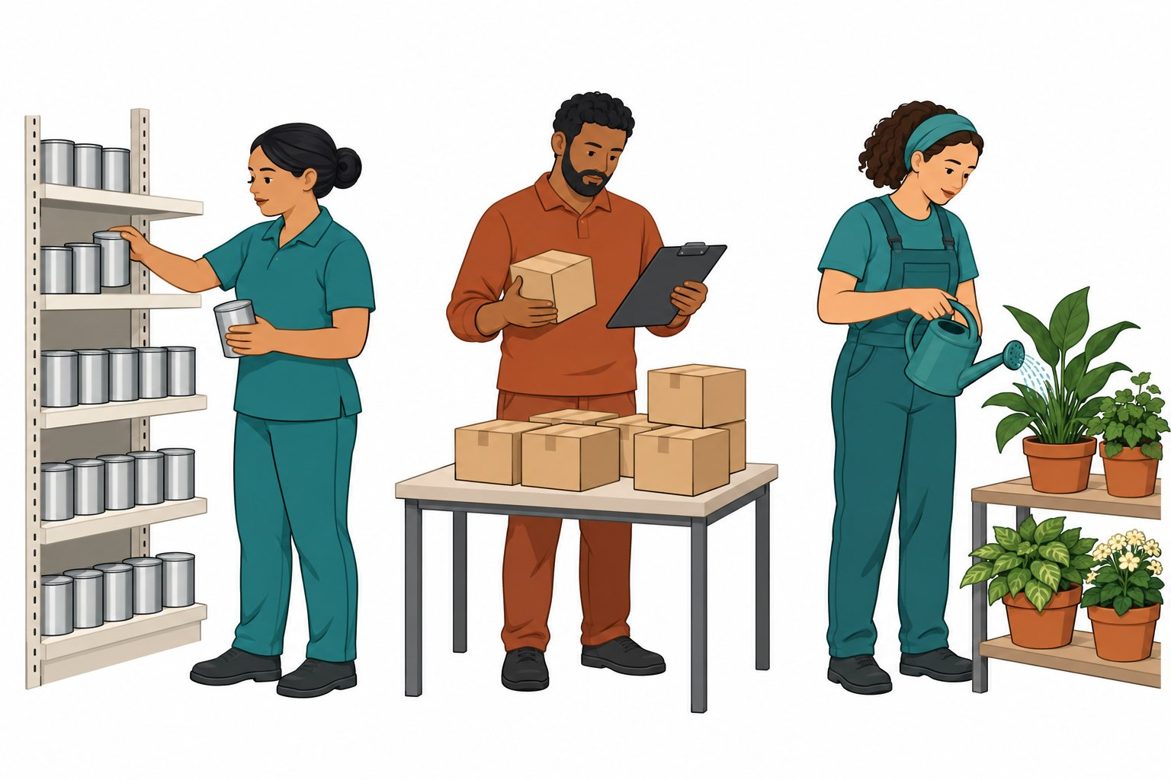
Shop: a worker puts tins in neat rows.
Store: a worker checks boxes on a list.
Garden: a worker gives plants care.
Look at the task. What skill could help?

Cut and match
Read the cards or ask for help.
Card | Card
A  A worker puts tins in neat rows. | B  A worker checks boxes on a list.
C  A worker shows a new worker where pots go. | D  A worker puts like shapes in sets.
E  A worker spots a card in the wrong set. | F  A worker gets a tray for a team mate.
Sort · Check · Help

Sort and check
Cut the six cards. Put like shapes in a set.
Cards | Cards | Cards
● | ■ | ●
■ | ● | ■
Keep these two mats whole.
● | ■
Skill cards to cut: Sort · Check · Help
Sort | Check | Help
Put things in sets. | Look to see if right. | Give a hand.
Check the sets. Point to a skill the task showed.
Help: Please read the words. Show the step. Give me time.

