People and acts of care
Every person and family in these stories is made up.
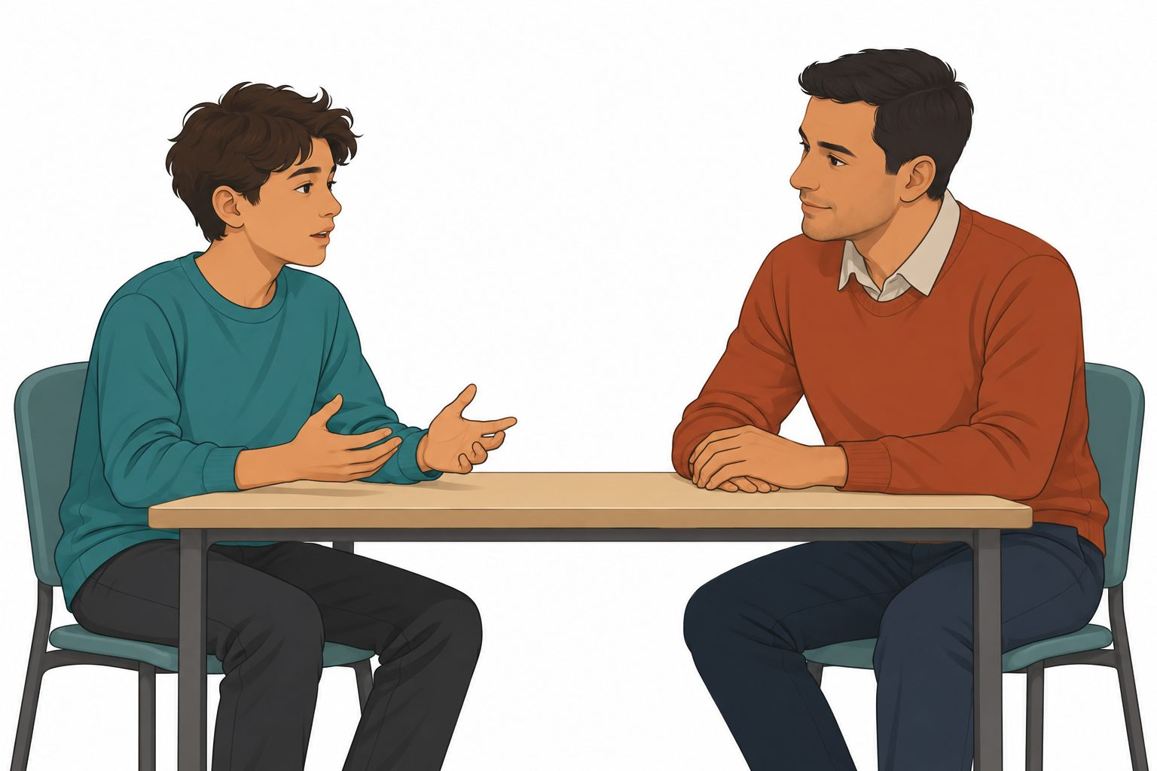
One made-up family | Another made-up family
A young person lives with one parent. The parent makes time to listen. | A young person lives with two parents. They help with a task.
A young person lives with a grandparent. The grandparent gives time and care. | A young person lives with a carer. The carer asks what help is wanted.
Families can look different. Which acts in the stories show care?

Cards for the fictional case
Which act could help the young person in each story?
Story card | Story card
A. A young person needs time to talk. | B. A young person is stuck on a task.
C. A young person asks for some space. | D. A young person asks a question. An adult laughs.
E. A young person wants to choose. An adult picks every time. | F. A young person needs help. The first adult is busy.
Some acts show care. Some acts need to change. What act could help?

A support map
This young person needs help to start a task. A tutor and a support adult are there.
Role cards to cut | What this adult can do
Tutor | Show one small step
Support adult | Help the person ask a question
Care cards to cut
Listen and give time | Show one small step
Give space | Ask what help is wanted
Map for the made-up young person
The young person needs | An adult who could help | A caring act
Help to start a task | ________________ | ________________
Help if the first adult is busy | ________________ | ________________
Why could this act help the young person?
________________________________________________
Every answer is about the made-up young person.

