Atlases grid references and digital maps
  - Pupil resources | GROW Humanities Summer 1 Week 2
Use atlases grid references and digital maps.
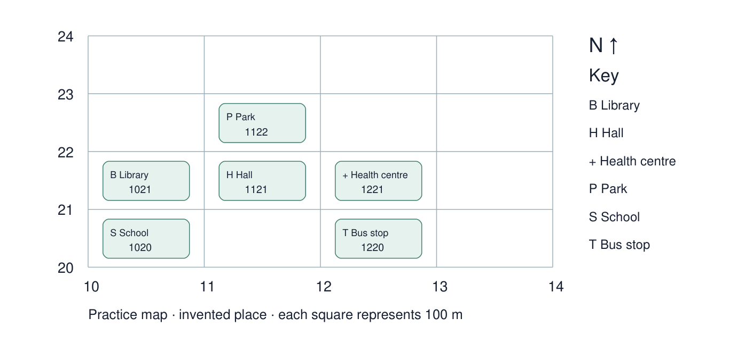
Use this labelled reference for the activities. Give your own response in the blank spaces. Point, speak, draw, type or write.
The practice place is invented. Read eastings first, then northings. Printed references are reference data; check your reading against them.

Evidence cards
  - Read with a partner or adult then use a named detail

A Practice grid method
The practice grid is an invented place. Read eastings across first, then northings up. Use the lines at the left and bottom of the square. Four figures identify a square, not an exact point.
Source: Authored practice grid; Ordnance Survey grid references guide
Limit: Its numbers are practice references, not full national-grid coordinates.

B Atlas view of the School
Fictional atlas example of the same practice place: the index entry School points to page A, square C2. Open that page and follow its page grid. The printed view and scale stay fixed until you choose a different map.
Source: Authored atlas evidence card for the supplied practice place
Limit: C2 is an atlas page locator. It is a different system from the four-figure practice grid.

C Digital view of the School
Fictional digital-map example of the same School: use its public place name in a search box, change zoom and switch relevant layers. These controls change what you see. Your teacher demonstrates equivalent controls on the school’s approved tool using a public place.
Source: Authored digital-map evidence card for the same practice place
Limit: No live map is embedded. The practice place is invented. Never search for a home address.

D A route between squares
On the practice grid, start at School. Move one square north to Library, then one square east to Hall. Trace each move and use the printed references. This is a map route, not an outdoor walking instruction.
Source: Authored practice grid
Limit: The grid does not show paths, entrances or a safe real-world route.

Arrival task
  - Supported
Revisit earlier atlas and grid work. Start here if it is new: an atlas is a book of maps; the key explains symbols; read eastings across first, then northings up. The practice map already prints each reference.
Begin with questions 1 and 2. Try 3 and 4 when ready. Use the reference map and cards.

1 What does an atlas contain?
Help: Choose maps or recipes.
My response
________________________________________________________________

2 Which number comes first: easting or northing?
Help: Across first, then up.
My response
________________________________________________________________

3 Find School and read its printed reference.
Help: Use the S label and the number below it.
My response
________________________________________________________________

4 What does a map key explain?
Help: Look at the key on the grid.
My response
________________________________________________________________

Arrival task
  - Standard
Revisit earlier atlas and grid work. Start here if it is new: an atlas is a book of maps; the key explains symbols; read eastings across first, then northings up. The practice map already prints each reference.
Begin with questions 1 and 2. Try 3 and 4 when ready. Use the reference map and cards.

1 How can an atlas index help you?
Help: Think about finding a named place.
My response
________________________________________________________________

2 State the order for reading a four-figure reference.
Help: Across, then up.
My response
________________________________________________________________

3 Read the reference printed for Hall.
Help: Use its left and bottom grid lines to check.
My response
________________________________________________________________

4 What does the reference identify?
Help: A whole square or an exact doorway?
My response
________________________________________________________________

Arrival task
  - Stretch
Revisit earlier atlas and grid work. Start here if it is new: an atlas is a book of maps; the key explains symbols; read eastings across first, then northings up. The practice map already prints each reference.
Begin with questions 1 and 2. Try 3 and 4 when ready. Use the reference map and cards.

1 How is an atlas index different from its page grid?
Help: Think about the two steps used to find a place.
My response
________________________________________________________________

2 Explain why the order of the numbers matters.
Help: Think about across and up.
My response
________________________________________________________________

3 Read Park’s reference and explain each pair.
Help: Check the lines left of and below its square.
My response
________________________________________________________________

4 Could the grid alone show a safe route through a real place?
Help: Look for paths and entrances.
My response
________________________________________________________________

Shared map investigation
  - One person locates and the other checks then swap
1. Model Library: eastings 10, northings 21, reference 1021. Trace School → Library → Hall. Partners set and check a fresh feature challenge.
2. Compare cards B and C showing the same School. Watch the teacher use the approved mapping tool for a public place; identify search, zoom and an available layer.
Same School | How I find it | What I can change
Atlas card B
Digital card C
Our route School to Library to Hall with directions and references
________________________________________________________________
________________________________________________________________
One control shown by the teacher
________________________________________________________________
My partner challenge and how we checked
________________________________________________________________

Independent task
  - Supported
Use atlases grid references and digital maps.
1. Find Library and Hall. Copy and check each printed reference.
2. Trace School → Library → Hall with an adult. Say north, then east.
3. Independently find the feature in 1220, then choose one useful digital control from card C.
Help: Cover unused parts of the grid. Read one card at a time. Adult reads instructions; you choose the feature and explain.
Feature and printed grid reference
________________________________________________________________
Route with directions and squares
________________________________________________________________
Independent location response
________________________________________________________________
Atlas and digital map comparison
________________________________________________________________
Further challenge: Give the reference of School without a location prompt.

Independent task
  - Standard
Use atlases grid references and digital maps.
1. Record the printed references for Library, Health centre and Park.
2. Describe the grid route School → Library → Hall, using directions and square references.
3. Independently identify the feature in 1220 and explain one atlas/digital-map difference.
Help: Eastings first: ___. Northings second: ___. The square is ___. An atlas ___; a digital map ___.
Feature and printed grid reference
________________________________________________________________
Route with directions and squares
________________________________________________________________
Independent location response
________________________________________________________________
Atlas and digital map comparison
________________________________________________________________
Further challenge: Set a new partner challenge using a different labelled feature.

Independent task
  - Stretch
Use atlases grid references and digital maps.
1. Check references for Library, Hall, Health centre and Park against the printed grid.
2. Write the School → Library → Hall route with references and directions, then reverse it.
3. Independently identify the feature in 1220 and justify your reading order.
4. Compare atlas page grid and digital zoom/layers for the same School. State one limitation of each.
Help: Use the supplied sources. Distinguish a practice grid reference from the atlas card’s page locator.
Feature and printed grid reference
________________________________________________________________
Route with directions and squares
________________________________________________________________
Independent location response
________________________________________________________________
Atlas and digital map comparison
________________________________________________________________
Further challenge: Explain why an atlas page locator and a four-figure grid reference need different keys, and why a grid route is not a safe walking route.

Exit tickets
  - Use your chosen route and give your own response

Supported
1. Which feature is in 1220? Read the map yourself.
________________________________________________________________
2. Which pair comes first in a four-figure reference? Use the words easting and northing.
________________________________________________________________

Standard
1. Give Health centre’s reference and explain the reading order. Use the printed grid to check.
________________________________________________________________
2. Give one useful difference between the atlas and digital views of the same School. Use cards B and C and the teacher demonstration.
________________________________________________________________

Stretch
1. Give the reverse route Hall → Library → School, with directions and references. Check every square.
________________________________________________________________
2. Why might you use both an atlas and a digital map for the same public place? Explain their uses and one limit.
________________________________________________________________

