Middlesbrough and Helmsley
  - Pupil resources | GROW Humanities Summer 1 Week 5
Compare my locality with a contrasting place.
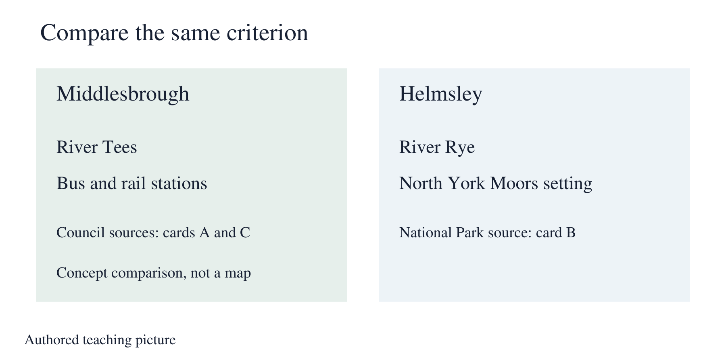
Authored teaching picture. Use the evidence cards and give your own response in the blank spaces.

Evidence cards
  - Read the source and limitation before using a detail

A Our locality: Middlesbrough
Middlesbrough is on the River Tees. The Tees Transporter Bridge links the Middlesbrough side with Port Clarence across the river. This is evidence about physical setting and a built feature.
Source: Middlesbrough Council: Tees Transporter Bridge
Limit: This source does not establish the size of either settlement or its job totals. It does not mean the bridge is open.

B Contrasting place: Helmsley
Helmsley is a market town in North Yorkshire by the North York Moors. The River Rye, a market square, shops, cafés and restaurants are described by the National Park Authority.
Source: North York Moors National Park Authority: Helmsley
Limit: A visitor page selects features. It does not describe every land use or every job.

C Travel evidence
Middlesbrough Council identifies a town-centre bus station and rail station. The Helmsley visitor page identifies bus routes and a cycleway through the town. Both sources give evidence of transport.
Source: Middlesbrough Council: Public transport and getting around; National Park Authority: Helmsley
Limit: Do not conclude that an unlisted transport type is absent. No journey time is supplied.

D A fair comparison grid
Agree the criteria before comparing. For each criterion, record evidence for Middlesbrough and Helmsley, then explain a similarity or contrast. Write not evidenced when a source cannot answer. Choose one important contrast and cite both sides.
Source: Authored comparison routine using the named source cards
Limit: Size and job totals need comparable dated evidence. This pack makes no numerical claim about them.

Arrival task
  - Supported
Start here: compare the same feature in two places. A source supplies evidence. A physical feature is natural, while a human feature is made or changed by people. Read both place cards before choosing a contrast.

1 What does compare mean?
Help: Look at the same feature in two places.
My response
________________________________________________________________

2 Which river is named for Middlesbrough?
Help: Read card A.
My response
________________________________________________________________

3 Which river is named for Helmsley?
Help: Read card B.
My response
________________________________________________________________

4 What should you write if a detail is missing?
Help: Use card D.
My response
________________________________________________________________

Arrival task
  - Standard
Start here: compare the same feature in two places. A source supplies evidence. A physical feature is natural, while a human feature is made or changed by people. Read both place cards before choosing a contrast.

1 Why agree a criterion first?
Help: Think about a fair comparison.
My response
________________________________________________________________

2 Name a physical-setting detail for each place.
Help: Read cards A and B.
My response
________________________________________________________________

3 Which card helps compare transport?
Help: Use the card headings.
My response
________________________________________________________________

4 Can these cards establish job totals?
Help: Read the limits.
My response
________________________________________________________________

Arrival task
  - Stretch
Start here: compare the same feature in two places. A source supplies evidence. A physical feature is natural, while a human feature is made or changed by people. Read both place cards before choosing a contrast.

1 How can source purpose affect a comparison?
Help: Think about a visitor page.
My response
________________________________________________________________

2 Why is not evidenced different from absent?
Help: Think about missing information.
My response
________________________________________________________________

3 What evidence would support a size comparison?
Help: Use matching definitions and dates.
My response
________________________________________________________________

4 How do you support an important contrast?
Help: Include both places.
My response
________________________________________________________________

Shared investigation
  - Suggest, check and swap roles
1. Co-construct criteria: size, land use, jobs, transport and physical setting. Read both place cards and agree what each source can support.
2. Complete one comparison row together using the interactive record. Preview it, then explain one important contrast with evidence for both places. Mark unsupported details not evidenced.
Agreed criterion | Middlesbrough evidence | Helmsley evidence
Size
Land use
Jobs
Transport
Physical setting
Use the same criterion in both columns. Write not evidenced when the supplied sources cannot establish a detail.

Independent task
  - Supported
Compare my locality with a contrasting place.
1. Choose physical setting and transport from the criterion bank.
2. Complete a row for each place using the named cards and a frame.
3. Independently explain one contrast and name the two supporting cards.
Help: Read one place card at a time. Use two highlighted details, then choose your own explanation.
Agreed criterion for both places
________________________________________________________________
Middlesbrough evidence and source
________________________________________________________________
Helmsley evidence and source
________________________________________________________________
Important contrast and evidence limit
________________________________________________________________
Further challenge: Identify a similarity as well.

Independent task
  - Standard
Compare my locality with a contrasting place.
1. Complete the grid for physical setting, land use and transport.
2. For size and job totals, mark what is not evidenced rather than guessing.
3. Independently explain one important contrast with sources and a limit.
Help: Use the same criterion in both columns and put the source beside each claim.
Agreed criterion for both places
________________________________________________________________
Middlesbrough evidence and source
________________________________________________________________
Helmsley evidence and source
________________________________________________________________
Important contrast and evidence limit
________________________________________________________________
Further challenge: Explain why a visitor source is selective.

Independent task
  - Stretch
Compare my locality with a contrasting place.
1. Review all five agreed criteria and the purposes of the sources.
2. Complete supported rows and distinguish evidence gaps from absent features.
3. Explain one important contrast and why it matters for this enquiry.
4. Independently propose a comparable source for a missing criterion and explain its value.
Help: Evaluate the evidence without judging people or making unsupported generalisations.
Agreed criterion for both places
________________________________________________________________
Middlesbrough evidence and source
________________________________________________________________
Helmsley evidence and source
________________________________________________________________
Important contrast and evidence limit
________________________________________________________________
Further challenge: Describe how different boundaries might distort a size comparison.

Exit tickets
  - Give your own response using your chosen route

Supported
1. Give one supported difference between the places. Use the cards.
________________________________________________________________
2. Which sources support it? Name a card for each place.
________________________________________________________________

Standard
1. Explain one important contrast using both places. State the criterion and evidence.
________________________________________________________________
2. What cannot your sources establish? Name a specific gap.
________________________________________________________________

Stretch
1. Which contrast is most useful for your enquiry and why? Cite both sources.
________________________________________________________________
2. What further evidence would improve the comparison? Specify a matching measure or source.
________________________________________________________________

