An accurate Earth Day campaign
  - Pupil resources | LAUNCH Humanities Summer 1 Week 4
Create a digital sustainability campaign linked to Earth Day.
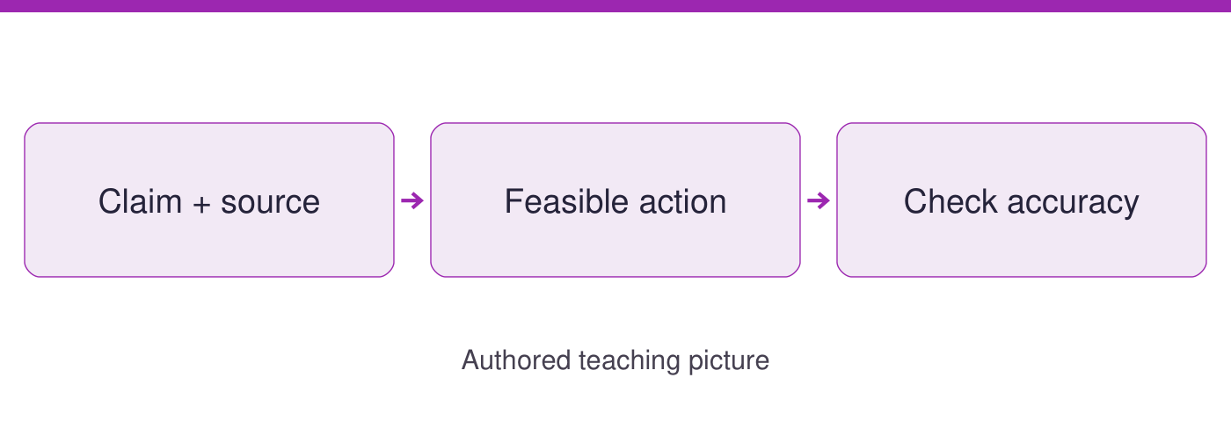
Use the evidence cards and blank spaces to give your own response. Speak, point, draw, type or write.
Start here: a claim needs evidence. A request asks someone to act. The cards give the date, classroom brief and action, even if earlier work is missing.

Evidence cards
  - Check the source and limit before using a detail

A Earth Day and our audience
Earth Day is observed on 22 April. Our product is a classroom digital message for school users. Name one feasible action and its intended effect. Keep it on the school-approved classroom device; do not create accounts or publish it online.
Source: EARTHDAY.ORG History; authored classroom brief
Limit: The date does not prove that a campaign action has worked.

B A supported climate link
NASA explains that burning fossil fuels releases CO2, which contributes to warming. A campaign may explain that link with a citation. It must not turn a small proposed action into a promise to stop climate change.
Source: NASA Causes; authored campaign application
Limit: This source does not calculate a CO2 saving for a school paper tray or a particular campaign.

C Weak drafts to repair
AUTHORED EXAMPLES, not facts: This will stop climate change. Our tray has already saved a tonne of CO2. Both go beyond the supplied evidence. Repair the claim, name the audience and action, and state what you will measure.
Source: Authored weak-draft examples, 21 September 2026
Limit: These are deliberately unsupported claims for editing, not estimates to repeat.

D An honest action message
AUTHORED PLAN: invite school users to choose clean spare paper for suitable drafts, with teacher permission. Count new sheets issued for the same task before and during a short trial. Explain the intended effect as reducing new-sheet use, then check it.
Source: Authored campaign and measurement plan, 21 September 2026
Limit: No guaranteed result or carbon saving is supplied. Include no pupil names, faces or personal details.

Arrival task
  - Supported
Start here: a claim needs evidence. A request asks someone to act. The cards give the date, classroom brief and action, even if earlier work is missing.

1 When is Earth Day?
Help: Read card A.
My response
________________________________________________________________

2 Who is our message for?
Help: Use the classroom brief.
My response
________________________________________________________________

3 Can we claim the tray has saved a tonne of CO2?
Help: Check for a measurement on card C.
My response
________________________________________________________________

4 Where is the message kept?
Help: Read card A.
My response
________________________________________________________________

Arrival task
  - Standard
Start here: a claim needs evidence. A request asks someone to act. The cards give the date, classroom brief and action, even if earlier work is missing.

1 What makes the first weak draft an overclaim?
Help: Compare the promise with evidence.
My response
________________________________________________________________

2 What feasible action does card D propose?
Help: Read the invitation.
My response
________________________________________________________________

3 What indicator can check that action?
Help: Use the counting plan.
My response
________________________________________________________________

4 How do a claim and a request differ?
Help: Compare says with asks.
My response
________________________________________________________________

Arrival task
  - Stretch
Start here: a claim needs evidence. A request asks someone to act. The cards give the date, classroom brief and action, even if earlier work is missing.

1 Why is intended effect different from proven effect?
Help: Consider when the trial happens.
My response
________________________________________________________________

2 Why must a campaign cite a source precisely?
Help: Ask whether it supports that claim.
My response
________________________________________________________________

3 What must be removed from an unsafe draft?
Help: Use the classroom rules.
My response
________________________________________________________________

4 How can a qualification improve a message?
Help: Think about honest scope.
My response
________________________________________________________________

Shared investigation
  - Use the evidence; explain and check together
1. Repair both AUTHORED weak drafts in the editor. Replace each overclaim with a feasible action, supporting evidence and a measurable intention.
2. Identify school users as the audience. Prepare a classroom-only Earth Day message with a source, intended effect and a clear limit.
AUTHORED WEAK DRAFT: This will stop climate change
My accurate repair, source and intended effect
________________________________________________________________
________________________________________________________________
AUTHORED WEAK DRAFT: Our tray has already saved a tonne of CO2
My accurate repair, source and intended effect
________________________________________________________________
________________________________________________________________
Audience and feasible action
________________________________________________________________
Classroom product only. No real posting, accounts, pupil names or faces. Earth Day: 22 April (EARTHDAY.ORG).

Independent task
  - Supported
Create a digital sustainability campaign linked to Earth Day.
1. Choose school users as the audience and highlight one feasible action from card D.
2. Make a digital message on the approved classroom device using the supplied frame.
3. Independently explain its intended effect and check one claim against its source.
Help: Use highlighted evidence and the frame. An adult may read or scribe your own words.
Audience and proposed action
________________________________________________________________
Supported claim and source
________________________________________________________________
Intended effect and indicator
________________________________________________________________
Accurate final classroom message
________________________________________________________________
Further challenge: Explain a second detail if ready.

Independent task
  - Standard
Create a digital sustainability campaign linked to Earth Day.
1. Repair the two drafts and plan a message for a stated school audience.
2. Create a classroom digital message with Earth Day’s date, a feasible action and a named source.
3. Independently explain the intended effect, indicator and one limit on your claim.
Help: Use the cards and organiser. Choose your own evidence and explanation.
Audience and proposed action
________________________________________________________________
Supported claim and source
________________________________________________________________
Intended effect and indicator
________________________________________________________________
Accurate final classroom message
________________________________________________________________
Further challenge: Compare your reasoning with one alternative.

Independent task
  - Stretch
Create a digital sustainability campaign linked to Earth Day.
1. Audit both drafts for evidence gaps and implied promises.
2. Create a concise classroom message that separates evidence from a request to act.
3. Justify the audience, action, intended effect and indicator using source limits.
4. Independently revise one phrase after a peer accuracy check and explain the revision.
Help: Use the source limits and test a different priority or assumption.
Audience and proposed action
________________________________________________________________
Supported claim and source
________________________________________________________________
Intended effect and indicator
________________________________________________________________
Accurate final classroom message
________________________________________________________________
Further challenge: Propose a further evidence check and explain its value.

Exit tickets
  - Use your chosen route and give your own response

Supported
1. Give your audience and proposed action. Use a named detail and your own explanation.
________________________________________________________________
2. Which source supports one claim? Use a named detail and your own explanation.
________________________________________________________________

Standard
1. Explain your message’s intended effect. Use a named detail and your own explanation.
________________________________________________________________
2. How did you repair an unsupported claim? Use a named detail and your own explanation.
________________________________________________________________

Stretch
1. Why does your evidence justify that wording? Use a named detail and your own explanation.
________________________________________________________________
2. What measurement could test the intended effect? Use a named detail and your own explanation.
________________________________________________________________

