Our sustainability decision report
  - Pupil resources | LAUNCH Humanities Summer 1 Week 6
Complete a sustainability decision report.
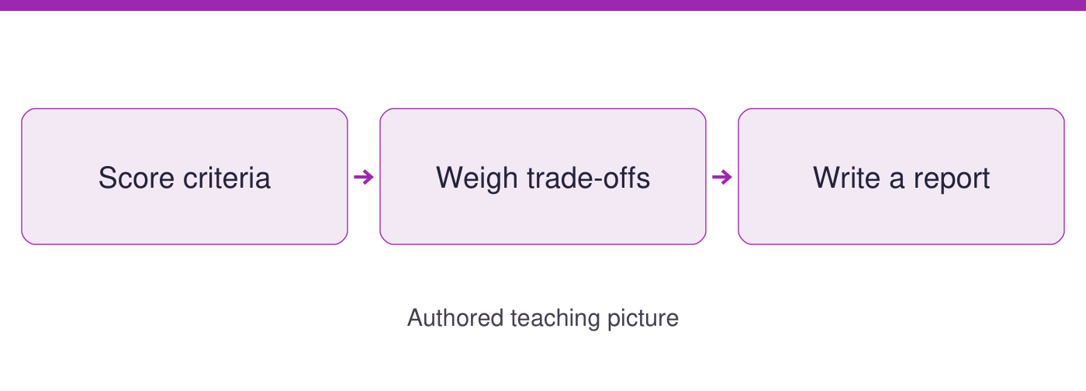
Use the evidence cards and blank spaces to give your own response. Speak, point, draw, type or write.
Start here: a decision uses criteria and evidence. Cards A to D restate the options, scoring method and report requirements; earlier work is optional.

Evidence cards
  - Check the source and limit before using a detail

A Explicit decision criteria
AUTHORED options: A uses spare paper before new sheets for suitable drafts. Assume teacher permission and a daily checker; it does not suit every task. B proposes an accessible cool break space for hot weather. It needs adult assessment and permission before use; no result is measured. Compare resource benefit, access and feasibility. Score each criterion 1 for weak support, 2 for some support or 3 for clear support, with an evidence note.
Source: Authored decision-scoring framework, 21 September 2026
Limit: Scores are judgements supported by evidence, not measured environmental savings or an examination grade.

B Evidence available
The NOAA table records CO2 concentration. NASA explains the climate link and response types. The school options and 12-to-8 sheet comparison are AUTHORED PRACTICE. A real school decision needs the teacher’s checked local evidence as well.
Source: NOAA GML; NASA Causes and Mitigation and Adaptation; authored practice record
Limit: A global climate source cannot establish a particular school action’s result.

C Explain the preferred option
State your priority and preferred option. Give criterion scores with evidence, a trade-off, an evidence limit and a realistic next action. A higher total informs a decision but does not remove the need to explain who can use the option.
Source: Authored report framework, 21 September 2026
Limit: Different priorities can lead to different justified decisions. Nobody must disclose a family or personal view.

D Keep the report your own
Check figures, units, sources and whether a claim is observed, inferred or proposed. Record the access support and any content prompts used. An adult may faithfully record your spoken response with a date. Select the report and supporting grid as evidence.
Source: Authored evidence-retention checklist
Limit: Do not copy the shared model as your independent conclusion. No qualification code or award is assigned.

Arrival task
  - Supported
Start here: a decision uses criteria and evidence. Cards A to D restate the options, scoring method and report requirements; earlier work is optional.

1 Name one report criterion.
Help: Read card A.
My response
________________________________________________________________

2 What must support a score?
Help: Read the scoring rule.
My response
________________________________________________________________

3 What is a trade-off?
Help: Use the glossary.
My response
________________________________________________________________

4 What should be recorded about help?
Help: Read card D.
My response
________________________________________________________________

Arrival task
  - Standard
Start here: a decision uses criteria and evidence. Cards A to D restate the options, scoring method and report requirements; earlier work is optional.

1 What five elements should the report explain?
Help: Read card C.
My response
________________________________________________________________

2 Are the scenario scores environmental measurements?
Help: Check card A’s limit.
My response
________________________________________________________________

3 Can NOAA prove a paper-tray saving?
Help: Compare the quantities and coverage.
My response
________________________________________________________________

4 Why record a realistic next action?
Help: Consider an evidence gap.
My response
________________________________________________________________

Arrival task
  - Stretch
Start here: a decision uses criteria and evidence. Cards A to D restate the options, scoring method and report requirements; earlier work is optional.

1 Why might a higher total not settle a decision?
Help: Consider access and priorities.
My response
________________________________________________________________

2 How could you test sensitivity to an assumption?
Help: Change one reasoned score.
My response
________________________________________________________________

3 What makes a report independent?
Help: Distinguish access from supplied answers.
My response
________________________________________________________________

4 What evidence might justify revising the report?
Help: Name a local check.
My response
________________________________________________________________

Shared investigation
  - Use the evidence; explain and check together
1. Score the two authored options against resource benefit, access and feasibility. Require an evidence note for each 1-to-3 judgement.
2. Preview a practice report selection in the portfolio. Check preferred option, trade-offs, limits and next action before independent reports.
Score each criterion: 1 = weak support; 2 = some support; 3 = clear support. Give evidence for every judgement. These are decision criteria, not grades.
Criterion | Option A: score + evidence | Option B: score + evidence
Resource benefit
Access
Feasibility
Preferred option and trade-off
________________________________________________________________
Limitation and realistic next action
________________________________________________________________
Support used / adult note
________________________________________________________________

Independent task
  - Supported
Complete a sustainability decision report.
1. Use both option cards and score resource benefit, access and feasibility with the frame.
2. Write a report naming your preferred option, one evidence detail and a trade-off.
3. Independently give a limitation and next action; record support or an adult note.
Help: Use highlighted evidence and the frame. An adult may read or scribe your own words.
Criterion scores and evidence
________________________________________________________________
Preferred option and trade-offs
________________________________________________________________
Limitations and realistic next action
________________________________________________________________
Accuracy check and support recorded
________________________________________________________________
Further challenge: Explain a second detail if ready.

Independent task
  - Standard
Complete a sustainability decision report.
1. Score both options against the three stated criteria and justify each score.
2. Write the report with preferred option, evidence, trade-offs, limitations and next action.
3. Independently check the report against unit success criteria and retain the support record.
Help: Use the cards and organiser. Choose your own evidence and explanation.
Criterion scores and evidence
________________________________________________________________
Preferred option and trade-offs
________________________________________________________________
Limitations and realistic next action
________________________________________________________________
Accuracy check and support recorded
________________________________________________________________
Further challenge: Compare your reasoning with one alternative.

Independent task
  - Stretch
Complete a sustainability decision report.
1. Audit the criteria and explain any extra priority before scoring both options.
2. Test how one changed assumption might alter the preference.
3. Write a report weighing the alternative fairly with evidence limits and a realistic next action.
4. Independently justify the final decision and record what stronger evidence could change it.
Help: Use the source limits and test a different priority or assumption.
Criterion scores and evidence
________________________________________________________________
Preferred option and trade-offs
________________________________________________________________
Limitations and realistic next action
________________________________________________________________
Accuracy check and support recorded
________________________________________________________________
Further challenge: Propose a further evidence check and explain its value.

Exit tickets
  - Use your chosen route and give your own response

Supported
1. State your preferred option and one reason. Use a named detail and your own explanation.
________________________________________________________________
2. Give a limit and next action. Use a named detail and your own explanation.
________________________________________________________________

Standard
1. Explain your decision using criterion scores and evidence. Use a named detail and your own explanation.
________________________________________________________________
2. What trade-off and limitation have you retained? Use a named detail and your own explanation.
________________________________________________________________

Stretch
1. Why does your final judgement remain defensible? Use a named detail and your own explanation.
________________________________________________________________
2. What evidence could change it and what support was used? Use a named detail and your own explanation.
________________________________________________________________

