Knowledge organiser
I can match a question to a model.
I can give a claim with a matching clue.
I can say one thing the model cannot show.

I am learning to… choose a model that fits a science question and use a matching clue.
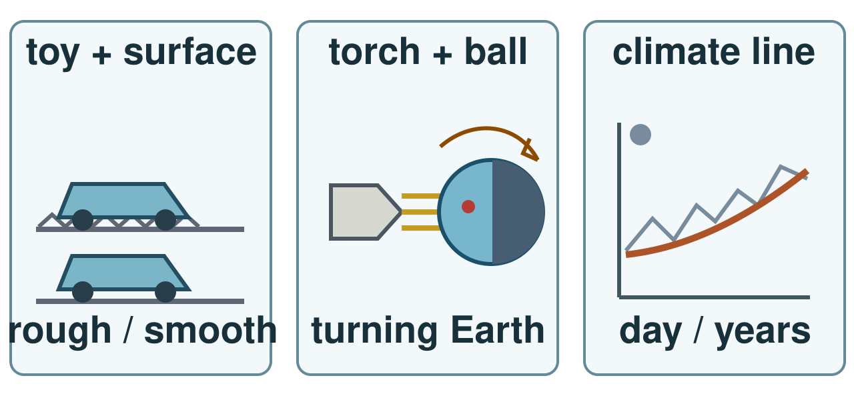
Choose a model: toy and surface, torch and ball, or long climate record. Sketches are simplified; the climate line is not data.
I can match a question to a model. I can give a claim with a matching clue. I can say one thing the model cannot show.

Word page
I can match a question to a model.
I can give a claim with a matching clue.
I can say one thing the model cannot show.

Word | It means | Example
force | a push or pull on an object | Friction is a force that can slow a toy.
rotation | a turn around an axis | Earth’s rotation brings day and night.
evidence | an observation or result that supports a claim | The shorter run is evidence for my answer.
climate | weather patterns over many years | A hot day alone does not show a climate trend.

Read the question first. Choose the model that can show a useful clue. Give the clue, your claim and one limit.

Arrival and starter
I can match a question to a model.
I can give a claim with a matching clue.
I can say one thing the model cannot show.

Match each question to a kit card: toy and surface, globe and torch, or warming chain.
Think back. Say, point or write one answer for each question.
1. Give one link in the warming chain.
2. Name one fact our Solar System cards support.
3. How can friction affect a moving toy?
You may point, sign, say or write your first ideas.

I do · model and check
I can match a question to a model.
I can give a claim with a matching clue.
I can say one thing the model cannot show.

I choose a toy for a motion question. The toy went less far on rough paper in this run. I must repeat before I claim why.
Watch: Toy motion question → choose toy and surface → measure distance → test friction as one cause.
Show me: If my question is about day and night, should I point to the toy or torch-and-ball?
Choose a model: toy and surface, torch and ball, or long climate record. Sketches are simplified; the climate line is not data.

We do · sort and explain
I can match a question to a model.
I can give a claim with a matching clue.
I can say one thing the model cannot show.

Torch and ball are chosen for day and night. Add the missing clue. Say why it fits.
Our turn: Day and night question → choose torch and ball → observe ____ → explain Earth’s turn.
Talk, then sort.
Card | Choose a group
Why did the toy slow? | toy and surface / torch and ball / warming cards
Why is a place in night? | toy and surface / torch and ball / warming cards
Why is climate warming? | toy and surface / torch and ball / warming cards

Supported: Show the torch and marked ball; point to the place that moves into shade.
Independent: Give an answer and a matching clue.
Aspire: Explain why a toy run cannot test a climate claim even when it gives a clear result.

We do 2 · choose and explain
I can match a question to a model.
I can give a claim with a matching clue.
I can say one thing the model cannot show.

What helps test a toy-motion claim?
A. A toy run with the same start
B. One day of weather
All of us: A model trolley stops sooner on a mat than on a smooth board. Which idea is relevant to test?
A. The length of Earth’s orbit.
B. Friction at the trolley surface.
C. The amount of daylight outside.
D. The climate of the whole Earth.
Show your choice and say why. You may use a point, card, board or sign. Take one quiet minute to reset.

Independent · Supported
I can match a question to a model.
I can give a claim with a matching clue.
I can say one thing the model cannot show.

Choose two stations. Give a claim and matching clue for each. Name one limit.
Talk first. You can plan in any language.
Point, sign, speak, draw, type, write, use a scribe or show a staff-captured photo.
Match a question to a model.
Say first: For ___, I choose the ___ model.
Question or model | My claim and clue | One limit
____________ | ________________ | ________________
____________ | ________________ | ________________

Choose one route within the full 8 minutes. Keep your own response.

Independent · Independent
I can match a question to a model.
I can give a claim with a matching clue.
I can say one thing the model cannot show.

Choose two stations. Give a claim and matching clue for each. Name one limit.
Talk first. You can plan in any language.
Point, sign, speak, draw, type, write, use a scribe or show a staff-captured photo.
Give an answer and a matching clue.
Say first: My claim is ___; the clue is ___.
Question or model | My claim and clue | One limit
____________ | ________________ | ________________
____________ | ________________ | ________________

Choose one route within the full 8 minutes. Keep your own response.

Independent · Aspire
I can match a question to a model.
I can give a claim with a matching clue.
I can say one thing the model cannot show.

Choose two stations. Give a claim and matching clue for each. Name one limit.
Talk first. You can plan in any language.
Point, sign, speak, draw, type, write, use a scribe or show a staff-captured photo.
Compare two models, clues and limits.
Say first: The ___ model fits because ___, but it cannot show ___.
Go deeper: Compare two models: what can each show and miss?
Model limits: Two toy runs differ on one surface. Can friction alone explain this? Choose one control that would help.
Question or model | My claim and clue | One limit
____________ | ________________ | ________________
____________ | ________________ | ________________

Choose one route within the full 8 minutes. Keep your own response.

Practical model · safe steps and record
I can match a question to a model.
I can give a claim with a matching clue.
I can say one thing the model cannot show.

Guess first: Which surface may let the same toy travel farther?
Kit: Small toy · Rough and smooth paper · Start line · Ruler · Torch and ball · Warming cards
Mark one start and use the same toy.
Launch twice on each surface in the same way.
Measure each run and record it.
Use other models only for their own questions.
Risk: A moving toy may hit someone or fall from the table.
Safe: Use a low clear track. Keep hands and faces away from the run.
Surface | run 1 | run 2
Rough | ___ | ___
Smooth | ___ | ___

Distance unit: ______. Use the same unit for all four runs.
Use the kit your teacher has checked. A picture or adult-led model is a valid route.

Review and exit
I can match a question to a model.
I can give a claim with a matching clue.
I can say one thing the model cannot show.

Does your clue fit? Fix one clue or add a limit.
VF: hear one comment. NS(+): name a next step. //: edit one part. ?: ask for a read-back. Take one quiet minute.
Name a model, claim and clue. Say what changed after feedback.
? Read it back: choose a model that fits a science question and use a matching clue.
My feedback was… say what changed. Next I need to… name a fix.
How I know: I can match a question to a model. I can give a claim with a matching clue. I can say one thing the model cannot show.
The adult hears you and chooses our next example. Take one quiet minute.

Staff answers and checks
Starter: burning fossil fuel adds carbon dioxide and extra greenhouse gas slows heat loss (Autumn 2 Week 4). The Sun is a star, Earth orbits the Sun, or the Moon orbits Earth (Autumn 2 Week 3). Friction can slow a moving toy (Autumn 1 Week 3). Check actual taught coverage.
Model: choose toy and surface for a motion question, measure distance and test friction as one possible cause. The source notes a single run and requires repeats before a cause claim. For day and night choose torch and marked ball. The missing shared observation is the marked place moving into shade or away from light.
Sort in source order: toy slowing = toy and surface; a place in night = torch and ball; climate warming = warming cards. The diagram is simplified and its climate line is not data. Day/night involves rotation, whereas a climate pattern needs records over years.
Step check: first, a toy run with the same start. Hinge: B, second, Friction at the trolley surface. The other choices substitute orbit length, daylight or whole-Earth climate for the changed surface. Parallel hinge: a block pulled over two surfaces needs friction, not Earth’s rotation.

Staff answers · task, limits and next move
The practical uses the same toy, start and launch method, with two measured runs on rough paper and two on smooth. Record actual results, including units. Repeat safely and note variation. Do not supply invented measurements or infer that one uncontrolled difference proves roughness caused it.
Independent core: choose two stations, give a claim and a matching clue for each, and name one limit. Supported uses a question–model match with the same core supported by an adult; Independent adds claim and clue; Aspire compares models, clues and limits. Go deeper asks what two models can show or miss. If two toy runs differ, examine start/push controls rather than claiming friction alone.
Useful limits: toy runs do not test global climate; a torch/ball model is not to scale and leaves out much of the real Earth–Sun system; a warming-chain card describes a mechanism and is not a measurement record. The climate line in the source picture must not be mistaken for data.
Review repairs a mismatched clue or adds a limit. Exit names model, claim and clue and what changed after feedback. Keep each learner’s evidence and adult read-back. Next weekly line: Consolidate and revisit key ideas through investigation. Career link: an engineering technician matches a test and evidence before changing a design.

Staff guidance · pair, access and feedback
The pair works with a shared model and individual evidence. One explains and one asks for the clue, then they swap. Hear both independent reasons before moving on. Re-model an unsure learner’s step and use a fresh parallel question while the other continues.
No cold calling or forced public reading. A learner may pass. Point, sign, speak, draw, type, write, direct an adult or use exact scribing. Read the task exactly when needed. Keep the science challenge and allow planning in any language. EAL is language, not SEN.
Use a stable tray or large cards and the agreed accessible input. Give processing time. Agree a quiet supervised pause and a brief first–then cue. Re-enter at the last completed step. Do not gather evidence while a learner is distressed.
Record actual VF, WS, I, NS(+), E, R, // and ? only when they occur. Keep deepest adult prompt separate from the pupil response. A real adult receives and names back the science. R requires the pupil’s response to an NS(+) next step and real Audience; never award it for a click or completion. Keep the pupil’s own wording and own-colour response.

Staff guidance · evidence and handover
Keep each first response, result or labelled explanation, the feedback and the pupil’s edit or justified decision to keep it. E requires an observable curriculum action on [SYS]. Use SCI-GROW-A2-W05 for written, spoken, practical or photographic evidence. Record prompt level, response mode, support faded and what was independent.
At Independent agree actual adult roles and swap across the week. If one adult attends, use the actual staffing plan. Follow individual support and behaviour plans. Record access, regulation and curriculum actions against the learner’s own targets without recording a diagnosis as evidence.
If behind, preserve Choose two stations. Give a claim and matching clue for each. Name one limit. and the safety teaching. After a secure check shorten repeated oral rehearsal. Record any change, reason and coverage impact. Pass checked understanding, deepest prompt and unresolved errors to Week 6. Do not replace incomplete individual work with a group product.
Evaluation: date taught; delivered as planned; criteria met; actual adaptations and reasons; changes to the scheme and coverage; evidence banked. Source evidence mapping remains [AWARD] [QUAL]; no unit or qualification award is claimed by this lesson.

TA brief · access, kit and safety
Prepare a small toy, rough and smooth paper, start line, ruler, low clear track, torch and marked ball, warming-chain cards and record sheets. The toy table has two runs on each surface. A demonstration, supplied model or pointing route is valid.
Check the school risk assessment and current local science guidance. A moving toy may fall or hit someone. Use a low clear track and keep hands and faces away. Keep kit at desk height and torch light out of eyes. Keep the toy, start and launch method the same; one uncontrolled run cannot establish a cause.
The pair works with a shared model and individual evidence. One explains and one asks for the clue, then they swap. Hear both independent reasons before moving on. Re-model an unsure learner’s step and use a fresh parallel question while the other continues.
No cold calling or forced public reading. A learner may pass. Point, sign, speak, draw, type, write, direct an adult or use exact scribing. Read the task exactly when needed. Keep the science challenge and allow planning in any language. EAL is language, not SEN.
Use the least prompt needed, then fade it. Keep prompts separate from the pupil’s response.

TA brief · prompt ladder and stage handover
1. Point to the relevant place / instruction.
2. Ask one short question: "What is it asking you to find?"
3. Rephrase the instruction in simpler language.
4. Provide a scaffold or limited choice.
5. Model the first step only, then return the task to the pupil.
Arrival: predictable start and private choice. Starter: hear first attempts before answers. I do: point to the model and let the learner track each step. We do: leave the missing step to the learner. Independent: protect an individual first try.
Review and Exit: the adult receives the learner’s own science, names it back and agrees a precise next move. Record the deepest prompt and what was independent. No physical prompting; pass and pause remain available.
Timing: Arrival 5 min, Starter 3 min, I do 5 min, We do 7 min, We do 2 5 min, Independent 8 min, Review 4 min, Exit 3 min. Total 40 minutes. Alternative route views share the same task time.

