Knowledge organiser
I can choose a model that fits my question.
I can give a clue that supports my answer.
I can name one next step after feedback.

I am learning to… use a model and a matching clue to show what you know in science.
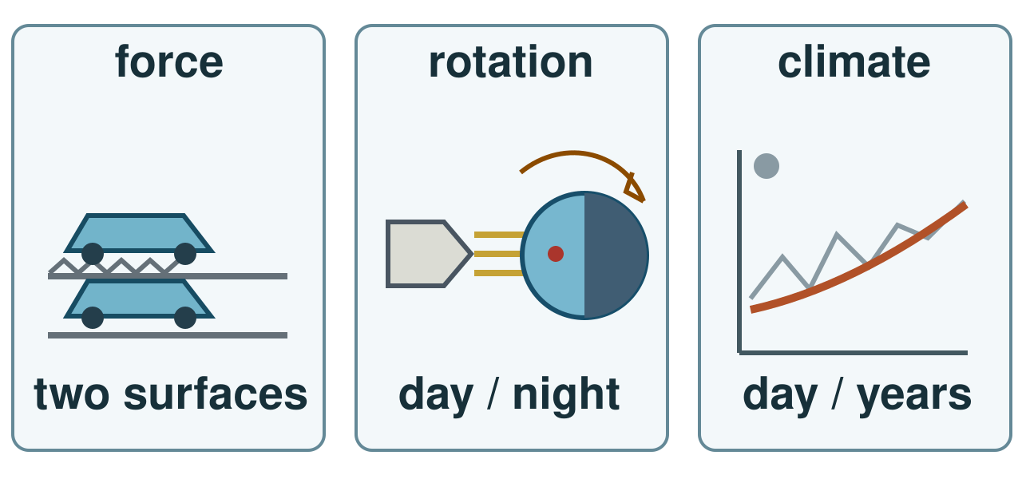
Three ideas: toy on two surfaces, day and night, and a long climate pattern. Sketches are simplified; the line is not data.
I can choose a model that fits my question. I can give a clue that supports my answer. I can name one next step after feedback.

Word page
I can choose a model that fits my question.
I can give a clue that supports my answer.
I can name one next step after feedback.

Word | It means | Example
evidence | a result or observation that supports a claim | A measured distance is evidence about a toy run.
force | a push or pull on an object | Friction is a contact force.
rotation | a turn around an axis | Earth’s rotation makes day and night.
climate | weather patterns over many years | Climate is not the weather on one day.

Choose a model that fits your question. Use a real clue. Keep one fair limit.

Arrival and starter
I can choose a model that fits my question.
I can give a clue that supports my answer.
I can name one next step after feedback.

Choose a model used this term. Point to one question it could help answer.
Think back. Say, point or write one answer for each question.
1. What changed in last week’s fair test?
2. What model can help with a toy motion question?
3. Name one force you learned in Autumn 1.
You may point, sign, say or write your first ideas.

I do · model and check
I can choose a model that fits my question.
I can give a clue that supports my answer.
I can name one next step after feedback.

I choose a question, then a matching model and clue. For day and night, the torch lights one side of a turning ball. I explain the place turning into shade. This is practice, not help during formal evidence.
Watch: Question: why does a place get night? → choose torch and turning ball → marked place turns away from light → explain Earth’s rotation.
Show me: Show me the model you would use for day and night.
Three ideas: toy on two surfaces, day and night, and a long climate pattern. Sketches are simplified; the line is not data.

We do · sort and explain
I can choose a model that fits my question.
I can give a clue that supports my answer.
I can name one next step after feedback.

In practice, the question and torch-and-ball model are supplied. Complete the missing clue: what happens to the marked place as the ball turns?
Our turn: Question: what slowed the toy? → choose toy and surface → observe ____ → explain a possible force; check with repeat runs.
Talk, then sort.
Card | Choose a group
Question about friction | toy and surface / torch and ball / long-term cards
Question about day and night | toy and surface / torch and ball / long-term cards
Question about climate | toy and surface / torch and ball / long-term cards

Supported: Point to the torch and the marked place before naming the clue.
Independent: Use a model and matching clue to explain a science idea.
Aspire: Explain why a correct model can still leave out size, distance or other details.

We do 2 · choose and explain
I can choose a model that fits my question.
I can give a clue that supports my answer.
I can name one next step after feedback.

Which clue fits a day-and-night claim?
A. A marked place turns away from torch light
B. A toy travels farther
All of us: A new question asks why a model sled stops sooner on a mat. Which kit can help test it?
A. Sled and two marked surfaces.
B. A torch and turning globe.
C. Two ice cubes on dark card.
D. A weather report from today.
Show your choice and say why. You may use a point, card, board or sign. Take one quiet minute to reset.

Independent · Supported
I can choose a model that fits my question.
I can give a clue that supports my answer.
I can name one next step after feedback.

Choose two science questions from forces, space or climate. Show an answer with a model and a matching clue. Use only your agreed support if this is formal evidence.
Talk first. You can plan in any language.
Point, sign, speak, draw, type, write, use a scribe or show a staff-captured photo.
Match one question to its model.
Say first: For ___, I choose ___.
My question and answer | Model and clue
________________ | ________________
________________ | ________________

Choose one route within the full 8 minutes. Keep your own response.

Independent · Independent
I can choose a model that fits my question.
I can give a clue that supports my answer.
I can name one next step after feedback.

Choose two science questions from forces, space or climate. Show an answer with a model and a matching clue. Use only your agreed support if this is formal evidence.
Talk first. You can plan in any language.
Point, sign, speak, draw, type, write, use a scribe or show a staff-captured photo.
Use a model and matching clue to explain a science idea.
Say first: My answer is ___; I saw ___ in the model.
My question and answer | Model and clue
________________ | ________________
________________ | ________________

Choose one route within the full 8 minutes. Keep your own response.

Independent · Aspire
I can choose a model that fits my question.
I can give a clue that supports my answer.
I can name one next step after feedback.

Choose two science questions from forces, space or climate. Show an answer with a model and a matching clue. Use only your agreed support if this is formal evidence.
Talk first. You can plan in any language.
Point, sign, speak, draw, type, write, use a scribe or show a staff-captured photo.
State one limit of a model and suggest a further check.
Say first: The model suggests ___, but I would check ___ because ___.
Go deeper: For one claim, give two checks and one model limit. Say which extra observation you would seek.
Two ways to check: Compare two model limits. Choose a claim neither can settle alone and name a new observation that would help.
My question and answer | Model and clue
________________ | ________________
________________ | ________________

Choose one route within the full 8 minutes. Keep your own response.

Practical model · safe steps and record
I can choose a model that fits my question.
I can give a clue that supports my answer.
I can name one next step after feedback.

Kit: Adult-prepared familiar model kit for the selected question
Use only the prepared model selected for the agreed practice or formal task.
Risk: Loose model parts, a toy launch or a torch beam could cause harm if misused.
Safe: Keep model parts on the tray, launch only with adult permission and aim a torch away from eyes.
Use the kit your teacher has checked. A picture or adult-led model is a valid route.

My own evidence and next step
I can choose a model that fits my question.
I can give a clue that supports my answer.
I can name one next step after feedback.

My name __________ Date __________
My claim: __________________________________
My real model, work, page or date: __________________________
My clue and what it shows: _________________________________
What I cannot show yet: ___________________________________
The adult’s response: ______________________________________
My change, or why I kept it: _________________________________
Next check: _______________________________________________

Review and exit
I can choose a model that fits my question.
I can give a clue that supports my answer.
I can name one next step after feedback.

In practice, hear one comment on claim and clue. Self-edit one mismatch. If this is formal evidence, receive and act on feedback after collection under the agreed conditions.
VF: hear one comment. NS(+): name a next step. //: edit one part. ?: ask for a read-back. Take one quiet minute.
Tell the adult what you learned, which clue you used, your feedback and one next step. They use your answer to plan the next model or support.
? Read it back: use a model and a matching clue to show what you know in science.
My feedback was… say what changed. Next I need to… name a fix.
How I know: I can choose a model that fits my question. I can give a clue that supports my answer. I can name one next step after feedback.
The adult hears you and chooses our next example. Take one quiet minute.

Staff answers and checks
Starter: last week’s toy investigation changed surface and controlled toy, start and launch. Toy and surfaces can test a motion question. Gravity, air resistance or friction are acceptable prior forces. Check real taught coverage, not assumed attendance.
Model: a marked place turns out of torch light as the ball rotates. This models day and night. The globe and light are not to scale. The climate sketch is schematic, not measured data. Climate needs a long-term pattern, not one weather report.
Sort in source order: toy and surface; torch and ball; long-term cards. Fill the missing marked-place clue and choose a real distance observation for the toy claim. A force explanation needs a suitable repeated comparison with controls.
Step check: A, the marked place turns away from torch light. Hinge: A, sled and two marked surfaces. B is a day/night model; C is a melting-ice model; D is one weather report. All learners choose privately before group discussion. Check each learner’s reason; do not apply the old three-in-four threshold.

Staff answers · task, limits and next move
Parallel check: a new place on a globe turns into shade. Use a globe and fixed lamp, not sled and mat. With five learners use a pair and a trio. Re-model a shared error or support an unsure learner while secure learners choose a fresh question.
Independent: choose two questions from forces, space or climate and connect each to a matching model and clue. Supported may complete one question at a time with access support, then attempt the second. Independent explains the link. Aspire states a model limit, suggests another check, and compares two limits without claiming either model answers everything.
Formal evidence: staff decide and record conditions before the task. Use only agreed support, collect the individual first response, then give feedback under those conditions. Practice, shared rehearsal and adult prompting remain separate from individual evidence. No new unit, criterion, level or award is asserted.
Review and exit: keep the original, genuine source locator, actual response and learner’s change. Hear the science from each learner. Where evidence is absent, record not found yet and plan a locating check. Hand checked questions, limits and support to the next lesson, then Spring 1 Week 1.

Staff guidance · group, access and feedback
GROW: up to five learners. Use a pair and a trio for five, two pairs for four, a trio for three, or a pair for two. In a pair, one explains and one asks for the clue; swap. In a trio, the third checks the source, then rotate all roles. Each learner first chooses privately and keeps their own record. Hear every learner at the hinge. Re-model a shared error, or support an unsure learner while secure learners try a fresh check. Never use a percentage rule.
No cold calling or forced public reading. A learner may pass. Point, sign, speak, draw, type, write, direct an adult or use exact scribing. Read the task exactly when needed. Keep the science challenge and allow planning in any language. EAL is language, not SEN.
Use a stable tray or large cards and the agreed accessible input. Give processing time. Agree a quiet supervised pause and a brief first–then cue. Re-enter at the last completed step. Do not gather evidence while a learner is distressed.
Record actual VF, WS, I, NS(+), E, R, // and ? only when they occur. Keep deepest adult prompt separate from the pupil response. A real adult receives and names back the science. R requires the pupil’s response to an NS(+) next step and real Audience; never award it for a click or completion. Keep the pupil’s own wording and own-colour response.

Staff guidance · evidence and handover
Keep each first response, result or labelled explanation, the feedback and the pupil’s edit or justified decision to keep it. E requires an observable curriculum action on [SYS]. Use SCI-GROW-A2-W07 for written, spoken, practical or photographic evidence. Record prompt level, response mode, support faded and what was independent.
At Independent agree actual adult roles and swap across the week. If one adult attends, use the actual staffing plan. Follow individual support and behaviour plans. Record access, regulation and curriculum actions against the learner’s own targets without recording a diagnosis as evidence.
If behind, preserve Choose two science questions from forces, space or climate. Show an answer with a model and a matching clue. Use only your agreed support if this is formal evidence. and the safety teaching. After a secure check shorten repeated oral rehearsal. Record any change, reason and coverage impact. Pass checked understanding, deepest prompt and unresolved errors to Spring 1 Week 1. Do not replace incomplete individual work with a group product.
Evaluation: date taught; delivered as planned; criteria met; actual adaptations and reasons; changes to the scheme and coverage; evidence banked. Source evidence mapping remains [AWARD] [QUAL]; no unit or qualification award is claimed by this lesson.

TA brief · access, kit and safety
For up to five learners: two sets of toy/surface cards, two torches and marked balls or their picture models, two long-term climate-card sets, trays, and five record sheets with pencils. Five work as a pair plus trio; four as two pairs; three as a trio. Keep one record per learner.
Use familiar adult-checked kit. Keep small parts on trays, any toy run low and clear, and torch beams away from eyes. Launch only with permission. Prepared cards are a valid route. Confirm the local risk assessment and any formal-evidence conditions.
GROW: up to five learners. Use a pair and a trio for five, two pairs for four, a trio for three, or a pair for two. In a pair, one explains and one asks for the clue; swap. In a trio, the third checks the source, then rotate all roles. Each learner first chooses privately and keeps their own record. Hear every learner at the hinge. Re-model a shared error, or support an unsure learner while secure learners try a fresh check. Never use a percentage rule.
No cold calling or forced public reading. A learner may pass. Point, sign, speak, draw, type, write, direct an adult or use exact scribing. Read the task exactly when needed. Keep the science challenge and allow planning in any language. EAL is language, not SEN.
Use the least prompt needed, then fade it. Keep prompts separate from the pupil’s response.

TA brief · prompt ladder and stage handover
1. Point to the relevant place / instruction.
2. Ask one short question: "What is it asking you to find?"
3. Rephrase the instruction in simpler language.
4. Provide a scaffold or limited choice.
5. Model the first step only, then return the task to the pupil.
Arrival: predictable start and private choice. Starter: hear first attempts before answers. I do: point to the model and let the learner track each step. We do: leave the missing step to the learner. Independent: protect an individual first try.
Review and Exit: the adult receives the learner’s own science, names it back and agrees a precise next move. Record the deepest prompt and what was independent. No physical prompting; pass and pause remain available.
Timing: Arrival 5 min, Starter 3 min, I do 5 min, We do 7 min, We do 2 5 min, Independent 8 min, Review 4 min, Exit 3 min. Total 40 minutes. Alternative route views share the same task time.

