Choosing a school sustainability option
  - Pupil resources | LAUNCH Humanities Summer 1 Week 3
Make a reasoned geographical decision.
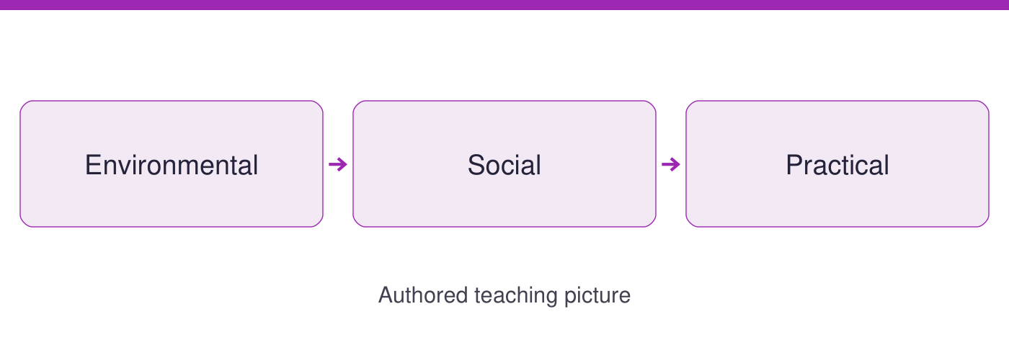
Use the evidence cards and blank spaces to give your own response. Speak, point, draw, type or write.
Start here: read the two authored options. Environmental concerns resources; Social concerns people and access; Practical concerns carrying out a plan.

Evidence cards
  - Check the source and limit before using a detail

A Option A reuse paper
AUTHORED OPTION A: put clean spare paper in an accessible classroom tray for suitable drafts. Assume the teacher approves the paper and a pupil checks the tray daily. Intended resource benefit: use spare sheets before taking new ones. Disadvantage: it does not suit every task.
Source: Authored school-option scenario, 21 September 2026
Limit: No measured reduction or emissions saving is claimed. Never reuse paper with personal information.

B Option B plan a cool space
AUTHORED OPTION B: ask an adult to assess an accessible shaded break space. Assume a suitable space can be checked but permission is not yet given. Intended social benefit: a usable option during hot weather. Disadvantage: it needs adult assessment before use.
Source: Authored option; NASA Mitigation and Adaptation gives heat planning as an example
Limit: This is a proposal, not evidence that a particular school is safe, cooler or at risk.

C Sort the evidence
For these authored options, a statement about using spare sheets fits Environmental. A statement about who can reach the break space fits Social. A statement about obtaining permission fits Practical. Some statements fit more than one category; explain your main reason.
Source: Authored sorting criteria, 21 September 2026
Limit: A category organises evidence. It does not decide which option everyone must prefer.

D A reasoned choice
Compare A and B against all three criteria. Name the evidence behind each judgement, one disadvantage of your preferred option, and what must be checked next. The options solve different immediate problems, so explain your priority.
Source: Authored decision framework, 21 September 2026
Limit: Do not present assumed benefits as measured outcomes or judge the people who prefer another option.

Arrival task
  - Supported
Start here: read the two authored options. Environmental concerns resources; Social concerns people and access; Practical concerns carrying out a plan.

1 Name one Environmental issue for option A.
Help: Read its intended benefit.
My response
________________________________________________________________

2 Name one Social issue for option B.
Help: Look for who can use the space.
My response
________________________________________________________________

3 What permission does option B need?
Help: Read card B.
My response
________________________________________________________________

4 Must everyone choose the same option?
Help: Read card D.
My response
________________________________________________________________

Arrival task
  - Standard
Start here: read the two authored options. Environmental concerns resources; Social concerns people and access; Practical concerns carrying out a plan.

1 What is a trade-off?
Help: Use the glossary.
My response
________________________________________________________________

2 Which criterion fits access?
Help: Use the three labels.
My response
________________________________________________________________

3 Why are these options not evidence of real school results?
Help: Check their labels.
My response
________________________________________________________________

4 What should accompany a preferred option?
Help: Read card D.
My response
________________________________________________________________

Arrival task
  - Stretch
Start here: read the two authored options. Environmental concerns resources; Social concerns people and access; Practical concerns carrying out a plan.

1 Can one statement fit two criteria?
Help: Compare access and permission.
My response
________________________________________________________________

2 How could a changed priority alter the choice?
Help: Weigh access against immediate feasibility.
My response
________________________________________________________________

3 Why separate an assumption from an observation?
Help: Think about confidence.
My response
________________________________________________________________

4 What makes an alternative view useful?
Help: Consider the same evidence.
My response
________________________________________________________________

Shared investigation
  - Use the evidence; explain and check together
1. Sort the three statements into Environmental, Social or Practical. Read options A and B and discuss statements that could fit more than one criterion.
2. Build a two-option grid across all three criteria. Model a choice with a disadvantage, then compare another justified priority.
Evidence statement | Category and reason
Option A uses spare sheets before new ones
Option B must be accessible to users
Option B needs adult assessment and permission
Criterion | Option A | Option B
Environmental
Social
Practical
My preference and one disadvantage
________________________________________________________________

Independent task
  - Supported
Make a reasoned geographical decision.
1. Read the two option cards with a highlighted criterion.
2. Complete the two-option grid using one detail per option.
3. Independently choose an option and name one disadvantage.
Help: Use highlighted evidence and the frame. An adult may read or scribe your own words.
Option and stated priority
________________________________________________________________
Environmental social and practical evidence
________________________________________________________________
Preferred option and disadvantage
________________________________________________________________
Assumption and next check
________________________________________________________________
Further challenge: Explain a second detail if ready.

Independent task
  - Standard
Make a reasoned geographical decision.
1. Compare both options using Environmental, Social and Practical criteria.
2. Explain a trade-off with details from the authored cards.
3. Independently choose and justify an option, naming a disadvantage and a needed check.
Help: Use the cards and organiser. Choose your own evidence and explanation.
Option and stated priority
________________________________________________________________
Environmental social and practical evidence
________________________________________________________________
Preferred option and disadvantage
________________________________________________________________
Assumption and next check
________________________________________________________________
Further challenge: Compare your reasoning with one alternative.

Independent task
  - Stretch
Make a reasoned geographical decision.
1. Compare the two options across all three criteria and identify an assumption.
2. Explain how giving access a different priority could change a decision.
3. Evaluate the strength of the scenario evidence and propose a local check.
4. Independently justify your choice while fairly explaining an alternative.
Help: Use the source limits and test a different priority or assumption.
Option and stated priority
________________________________________________________________
Environmental social and practical evidence
________________________________________________________________
Preferred option and disadvantage
________________________________________________________________
Assumption and next check
________________________________________________________________
Further challenge: Propose a further evidence check and explain its value.

Exit tickets
  - Use your chosen route and give your own response

Supported
1. Which option do you choose and why? Use a named detail and your own explanation.
________________________________________________________________
2. Name one disadvantage. Use a named detail and your own explanation.
________________________________________________________________

Standard
1. Justify your choice using two criteria. Use a named detail and your own explanation.
________________________________________________________________
2. Which trade-off or uncertainty matters most? Use a named detail and your own explanation.
________________________________________________________________

Stretch
1. Why is your preferred option stronger under your priority? Use a named detail and your own explanation.
________________________________________________________________
2. What evidence could favour the alternative? Use a named detail and your own explanation.
________________________________________________________________

