Words for our sale plan
Read, point or listen. Use one word in your own reason.
Picture | Word | Meaning
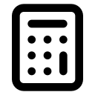 | budget | Money we plan to spend.
 | cost | Money we spend.
 | price | Money we ask for one item.
 | batch | Food made in one go.
 | portion | One piece to sell.
 | takings | All the money from sales.
 | decision tool | A way to help us choose.
 | allergen | A thing in food that some people react to. It can make them very ill. An adult must check the label.
I used __ to choose __. My reason is __. A check still due is __.

