Words for jobs and skills
Read, point or listen. Match the word to your work.
Cue | Word | What it means
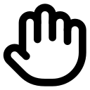 | job | Work a person does.
 | task | One piece of work to do.
 | skill | Something you learn how to do.
 | proof | Work that shows what you did.
 | team | People who work together.
 | detail | A small part that may need a check.
 | profile | Short facts about one job.
 | next step | One thing you will try or learn.
This job needs __ and __.
I used __ when I __.
My next step is __.

