Practice picture plans
  - BUILD Humanities Summer 1 Week 3
Use the keys and labels. These places are invented. The plans show selected features and are not to scale.
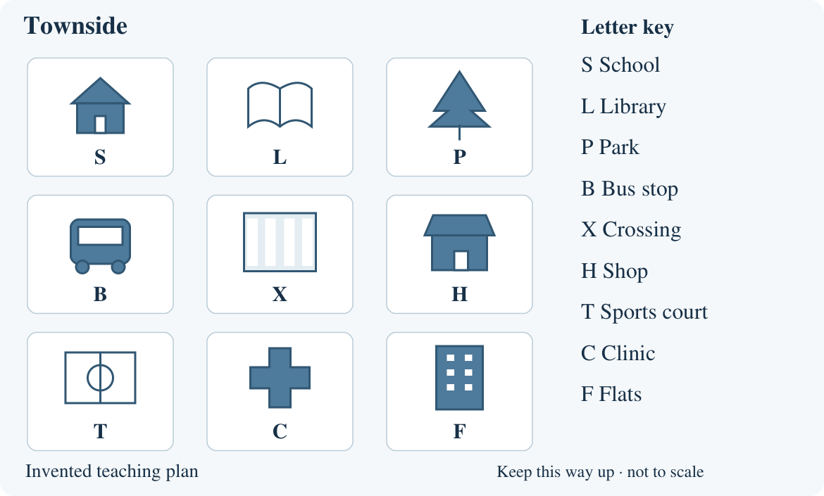

Coastside picture plan
  - Source B for comparison with Townside source A
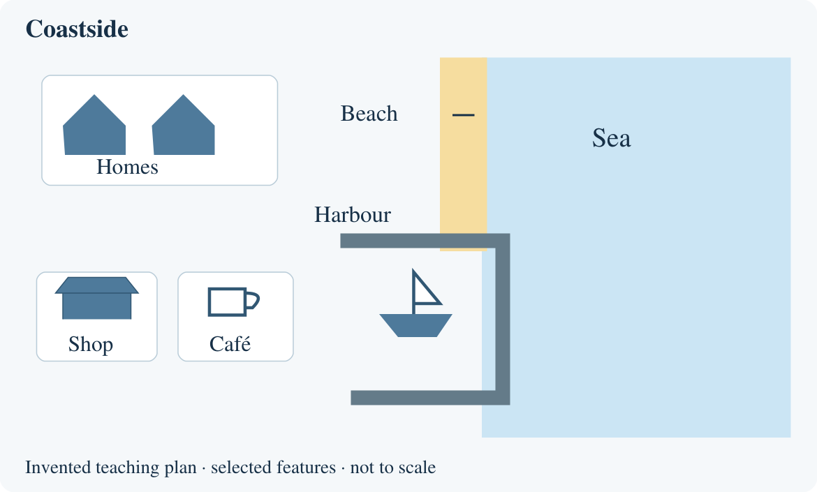
Compare the same feature in both plans. A missing symbol means not shown; it does not prove a feature is absent from the whole place.

Arrival task
  - Supported | Comparing two places
Compare means looking at two places. First point to what each picture plan shows. No previous lesson is needed.
Use the practice plan sheet. Start with questions 1 and 2.

1 Point to a shop on Townside.
Help: Use H in the key.
My response
________________________________________________________________

2 Point to a shop on Coastside.
Help: Find the shop picture and label.
My response
________________________________________________________________

3 Show the plan with a beach.
Help: Look for sand beside the sea.
My response
________________________________________________________________

4 Both plans show a shop. Is this the same or different?
Help: Choose same or different.
My response
________________________________________________________________

Arrival task
  - Standard | Comparing two places
Compare means looking at two places. First point to what each picture plan shows. No previous lesson is needed.
Use the practice plan sheet. Start with questions 1 and 2.

1 Name one feature shown on Townside.
Help: Use the key.
My response
________________________________________________________________

2 Name one feature shown on Coastside.
Help: Use the labels.
My response
________________________________________________________________

3 Name one feature shown on both.
Help: Compare the shops or homes.
My response
________________________________________________________________

4 Which plan shows a beach? What is your evidence?
Help: Point to the label and picture.
My response
________________________________________________________________

Arrival task
  - Stretch | Comparing two places
Compare means looking at two places. First point to what each picture plan shows. No previous lesson is needed.
Use the practice plan sheet. Start with questions 1 and 2.

1 Give one similarity with evidence from both plans.
Help: Compare the same feature.
My response
________________________________________________________________

2 Give one difference shown by the plans.
Help: Use a feature from each.
My response
________________________________________________________________

3 Can the plans tell us which place is noisier?
Help: Look for noise measurements.
My response
________________________________________________________________

4 Does no school symbol prove Coastside has no school?
Help: Think about what a plan leaves out.
My response
________________________________________________________________

Shared activity
  - Partner roles and practice record
Use the practice picture plans. A partner can point, speak, draw or write.
1. Together, sort each evidence card: both plans, Townside only or Coastside only.
2. Build one comparison row: feature, Townside evidence, Coastside evidence.
3. Swap observer and recorder roles. Explain one difference with both sources.
Evidence card | Both / Townside / Coastside
A shop is shown. | ________________
A park is shown. | ________________
A beach is shown. | ________________
Homes are shown. | ________________
A harbour is shown. | ________________
Feature | Townside A | Coastside B
Open space
Our choice
Our difference with evidence
________________________________________________________________

Independent task
  - Supported | Comparing two places
Compare my place with a contrasting place.
Use the checked local and contrasting source sets.
1. Choose one feature on the local source set with your teacher.
2. Point to or draw what each place shows in the two columns.
3. Say one difference using both sources.
Help: Adult reads the labels. Use: My place shows ___. The other place shows ___.
Feature | My place | Contrasting place
__________
My comparison and why it could matter
________________________________________________________________
________________________________________________________________
Further challenge: Try a second comparison with less prompting.

Independent task
  - Standard | Comparing two places
Compare my place with a contrasting place.
Use the checked local and contrasting source sets.
1. Use the local and contrasting source sets.
2. Complete two rows of the comparison grid.
3. Explain one important difference using evidence from both places.
Help: Use: In source ___ I can see ___. In source ___ I can see ___. This matters because ___.
Feature | My place | Contrasting place
__________
__________
My comparison and why it could matter
________________________________________________________________
________________________________________________________________
Further challenge: Add one similarity, or state something the sources cannot tell you.

Independent task
  - Stretch | Comparing two places
Compare my place with a contrasting place.
Use the checked local and contrasting source sets.
1. Choose three features to compare in the two source sets.
2. Record accurate observations from both.
3. Explain which contrast could matter most for one activity.
4. State one limit of the evidence.
Help: Choose an activity such as playing outdoors or reaching a shop. Say “could” when making an inference.
Feature | My place | Contrasting place
__________
__________
__________
My comparison and why it could matter
________________________________________________________________
________________________________________________________________
Further challenge: Suggest a photo, map or observation that would help check your explanation.

Exit tickets
  - Use only your chosen route
Give your own response using the checked local sources. Your usual reading or communication support can stay.

Supported
1. Point to one feature in each place’s source set. Use your own observations.
_______________________________________________________________
2. Say one difference between the places. My place shows ___. The other shows ___.
_______________________________________________________________

Standard
1. Give one comparison of your place and the contrasting place. Name the same feature or type of feature in both.
_______________________________________________________________
2. What evidence supports your comparison? Point to or name both source labels.
_______________________________________________________________

Stretch
1. Explain one important contrast using both sources. Say why it could matter for an activity.
_______________________________________________________________
2. What can these sources not tell you? Suggest one way to check.
_______________________________________________________________

Local evidence sheet
  - Teacher completes before the lesson
Attach two labelled photo/map sets: our place and a contrasting place. Choose sets with at least one clear, meaningful difference.
Our place name and source labels
________________________________________________________________
Contrasting place name and source labels
________________________________________________________________
Source dates and credits
________________________________________________________________
Features to compare
________________________________________________________________
What these sources leave out
________________________________________________________________
Attach or paste the plan/source sets on an extra page if needed. Check the key, labels and source limits. Do not use personal home addresses. Keep staff answers on the teacher sheet.

