Fieldwork in our grounds
  - Pupil resources | BUILD Humanities Summer 1
Carry out simple fieldwork in the grounds.
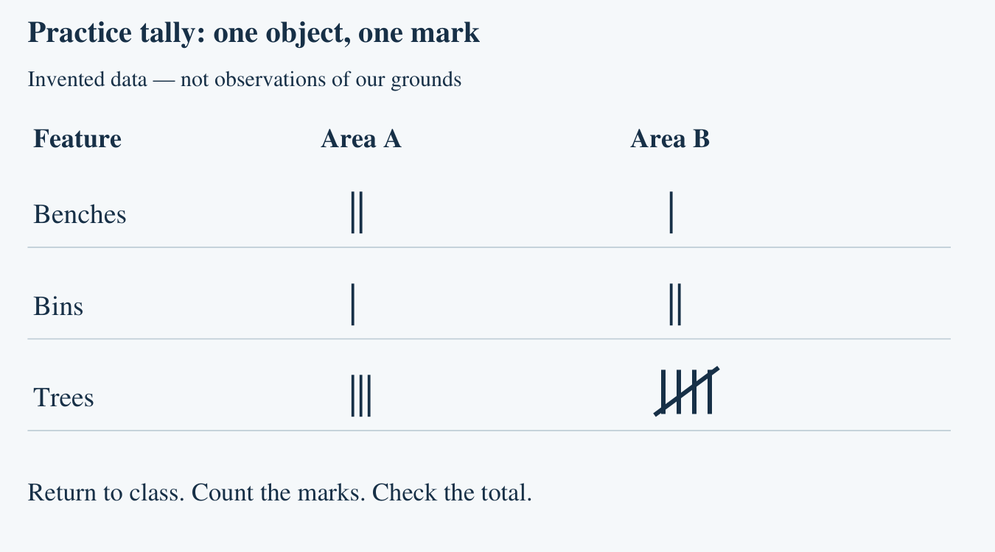
Use the paper tally sheet outdoors. Leave devices indoors. If fieldwork cannot happen, use the labelled practice tally and mark your work PRACTICE.

Paper fieldwork tally
  - Real observations | Take this page, a pencil and a clipboard
Question: How many benches, bins and trees are in our two agreed areas?
Stay with the supervising adult. Follow the agreed route inside the grounds. Observe from the path. Make one mark for each object. Count each object only once. Return to class to total and check. No device is needed outdoors; do not photograph people.
Date and agreed areas A / B
________________________________________________________________
Area | Feature | Tally marks | Total
A | Benches
A | Bins
A | Trees
B | Benches
B | Bins
B | Trees
Group each set of five marks: four upright lines and a fifth line across them. Leave a clear gap before the next group. If unsure whether an object is in the area, ask the adult before counting.

Practice tally fallback
  - INVENTED DATA | Classroom use when fieldwork cannot take place
Read the marks in the picture, then write each total below. These are practice observations, not results from our grounds. Area A and Area B do not overlap.
Feature | Area A total | Area B total | Both areas
Benches
Bins
Trees
One thing I did to check
________________________________________________________________

Arrival task
  - Supported | Fieldwork in our grounds
Fieldwork means observing a place. A tally uses one mark for each object. You can learn the method without an earlier lesson.
Use the reference sheet. Start with questions 1 and 2.

1. Show one tally mark.
Help: One mark means one object.
My response
________________________________________________________________

2. How many marks are | |?
Help: Touch each mark once.
My response
________________________________________________________________

3. Choose a feature to count: a bench or someone’s name.
Help: Count an object in the grounds.
My response
________________________________________________________________

4. Who leads the route?
Help: Choose the adult or a pupil walking away alone.
My response
________________________________________________________________

Arrival task
  - Standard | Fieldwork in our grounds
Fieldwork means observing a place. A tally uses one mark for each object. You can learn the method without an earlier lesson.
Use the reference sheet. Start with questions 1 and 2.

1. What does one tally mark stand for?
Help: Think of one thing counted.
My response
________________________________________________________________

2. Record three trees with tally marks.
Help: One mark for each tree.
My response
________________________________________________________________

3. Why label the study area?
Help: Think about using the sheet later.
My response
________________________________________________________________

4. What should you do if a stop is unavailable?
Help: The route is supervised.
My response
________________________________________________________________

Arrival task
  - Stretch | Fieldwork in our grounds
Fieldwork means observing a place. A tally uses one mark for each object. You can learn the method without an earlier lesson.
Use the reference sheet. Start with questions 1 and 2.

1. How would you tally five trees?
Help: The fifth mark crosses the first four.
My response
________________________________________________________________

2. Why can counting one tree twice mislead us?
Help: Think about the total.
My response
________________________________________________________________

3. How can two areas overlap?
Help: Think about seeing the same feature twice.
My response
________________________________________________________________

4. Can practice data prove we went outdoors?
Help: Think about the source label.
My response
________________________________________________________________

Shared activity
  - Put the fieldwork method in order
1. Put the fieldwork method cards in order.
2. Rehearse with the practice observation card and paper tally sheet.
3. Swap observer and recorder roles. Check that each object gets one mark.
Number these cards 1–4, or cut them apart and put them in order. Explain how the order helps the count.
Method card | Order
Then: make one tally mark for each object seen.
First: agree the question, route, boundaries and roles.
Finally: return to class, total the marks and check.
Next: look carefully in the agreed study area.
Our evidence and explanation
________________________________________________________________
________________________________________________________________

Independent task
  - Supported | Fieldwork in our grounds
Carry out simple fieldwork in the grounds.
Use the paper tally sheet outdoors. Leave devices indoors. If fieldwork cannot happen, use the labelled practice tally and mark your work PRACTICE.
1. Use the agreed paper route with the adult.
2. Count one feature type in area A. Make one mark per object.
3. Point to or say your total and one check when back inside.
Help: Choose benches or bins. Adult reads the row; you make the marks. Use your usual communication support.
Study area and feature
________________________________________________________________
My tally and total
________________________________________________________________
How I checked
________________________________________________________________
Real fieldwork or practice fallback
________________________________________________________________
Further challenge: Try the same method in area B with less prompting.

Independent task
  - Standard | Fieldwork in our grounds
Carry out simple fieldwork in the grounds.
Use the paper tally sheet outdoors. Leave devices indoors. If fieldwork cannot happen, use the labelled practice tally and mark your work PRACTICE.
1. Observe the agreed feature types in A and B on the supervised route.
2. Keep a separate tally for each feature and area.
3. Return, total each row and explain one check yourself.
Help: Observer points; recorder marks. Swap roles so everyone has their own recording evidence.
Study area and feature
________________________________________________________________
My tally and total
________________________________________________________________
How I checked
________________________________________________________________
Real fieldwork or practice fallback
________________________________________________________________
Further challenge: Combine one feature’s totals across the two non-overlapping areas.

Independent task
  - Stretch | Fieldwork in our grounds
Carry out simple fieldwork in the grounds.
Use the paper tally sheet outdoors. Leave devices indoors. If fieldwork cannot happen, use the labelled practice tally and mark your work PRACTICE.
1. Use the same supervised route and clearly defined boundaries.
2. Record each feature once, then check a row independently.
3. Combine the totals for one feature and explain your method.
4. Name a limitation of today’s observations.
Help: Say: We counted ___ in area ___. We avoided repeats by ___.
Study area and feature
________________________________________________________________
My tally and total
________________________________________________________________
How I checked
________________________________________________________________
Real fieldwork or practice fallback
________________________________________________________________
Further challenge: Suggest how to make a repeat observation more consistent.

Exit tickets
  - Use only your chosen route
Give your own response. Your usual communication support can stay.

Supported
1. Show one tally you made and its total. Point, speak or write.
_______________________________________________________________
2. Show or explain one way you kept the count accurate. State whether you used real observations or practice data.
_______________________________________________________________

Standard
1. What did you observe and how many did you record? Name the feature and study area.
_______________________________________________________________
2. How did you check your tally? State whether the source was real fieldwork or practice.
_______________________________________________________________

Stretch
1. Explain one checked result using the labelled tally. Give the feature, area and total.
_______________________________________________________________
2. What could affect a repeat count? Suggest one improvement and identify real or practice data.
_______________________________________________________________

