Continents and oceans
  - Pupil resources | BUILD Humanities Summer 1
Talk about the wider world using continents and oceans.
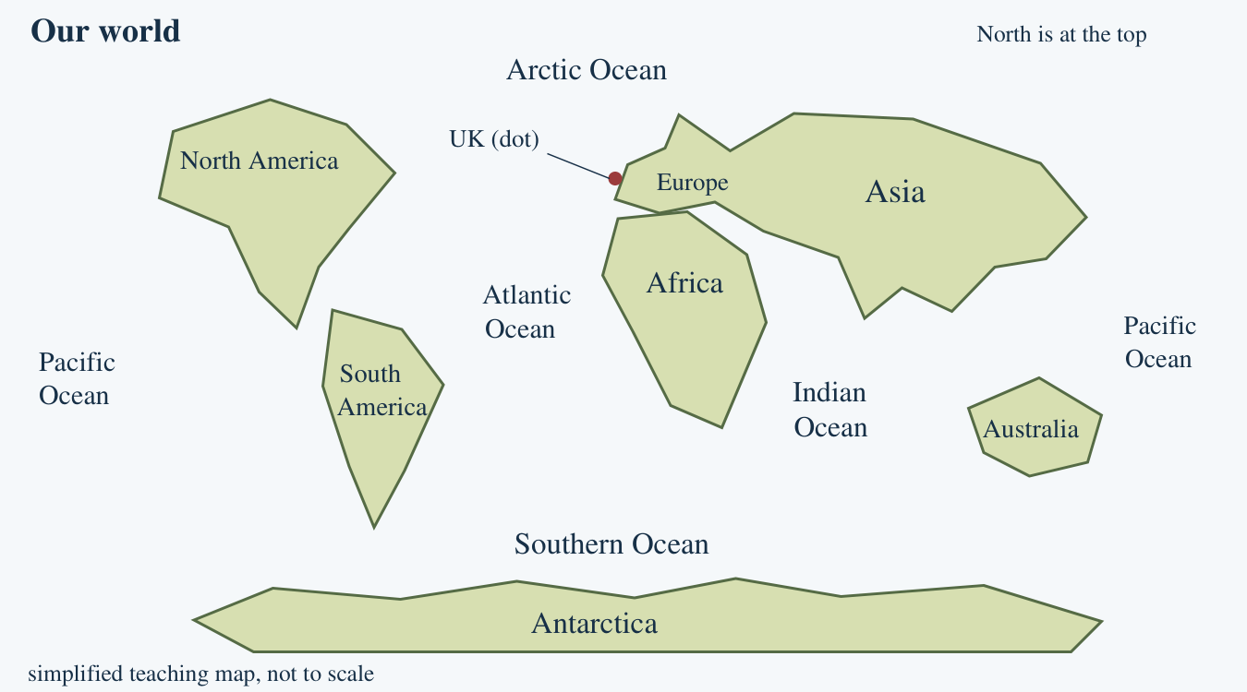
Use the pupil world map and label bank. Point, place a card, speak, draw or write.

My world map
  - Place or write labels, then point and explain
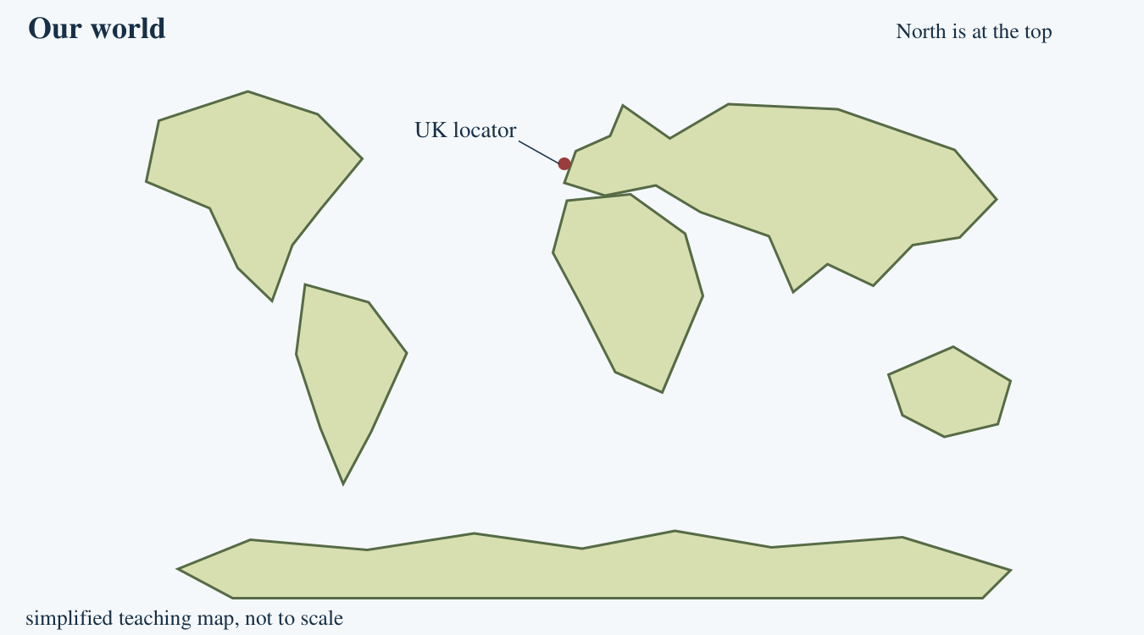
Use the label bank or the reduced choice bank your adult gives you. You may point or place a label while an adult records your own choice. The UK dot helps you start; it is not a country border.
My chosen continent
________________________________________________________________
My chosen ocean
________________________________________________________________

World-map label cards
  - Cut out or copy the names
Place each name on land or water. Use the reference map to check after your first attempt. One Pacific label may sit on either edge: it is the same ocean.
Continent labels | Ocean labels
Africa | Arctic Ocean
Antarctica | Atlantic Ocean
Asia | Indian Ocean
Australia | Pacific Ocean
Europe | Southern Ocean
North America
South America

Reduced choice bank
Continent | Ocean
Europe | Atlantic Ocean
Seven continents and five oceans. Land shapes and distances are simplified. There are no country borders on this teaching map.

Arrival task
  - Supported | Continents and oceans
A continent is a large land region. An ocean is a named part of the world’s connected salt water. We will use the labels together.
Use the reference sheet. Start with questions 1 and 2.

1. Point to some land.
Help: Use a green or cream land shape.
My response
________________________________________________________________

2. Point to some ocean.
Help: Use the blue area.
My response
________________________________________________________________

3. Find Europe using the label.
Help: Look near the UK callout.
My response
________________________________________________________________

4. Choose the ocean name: Atlantic Ocean or Europe.
Help: An ocean name labels water.
My response
________________________________________________________________

Arrival task
  - Standard | Continents and oceans
A continent is a large land region. An ocean is a named part of the world’s connected salt water. We will use the labels together.
Use the reference sheet. Start with questions 1 and 2.

1. What is a globe?
Help: Think about its shape.
My response
________________________________________________________________

2. Is Africa a continent or an ocean?
Help: Find Africa on land.
My response
________________________________________________________________

3. What continent contains the UK?
Help: Use the dot and label.
My response
________________________________________________________________

4. Name an ocean from the map.
Help: Choose any ocean label.
My response
________________________________________________________________

Arrival task
  - Stretch | Continents and oceans
A continent is a large land region. An ocean is a named part of the world’s connected salt water. We will use the labels together.
Use the reference sheet. Start with questions 1 and 2.

1. Name a continent south of Europe.
Help: Look down the north-up map.
My response
________________________________________________________________

2. Which ocean lies between the Americas and Europe?
Help: Read the water label.
My response
________________________________________________________________

3. Why is Pacific written at both edges?
Help: A flat map has to have a cut.
My response
________________________________________________________________

4. Can this drawing compare exact continent sizes?
Help: Read the map caption.
My response
________________________________________________________________

Shared activity
  - Match a clue to the world map
1. Use the labelled world map to match each clue to a place.
2. Partners place one continent card and one ocean card on a paper map.
3. Point to each choice, check it, then swap roles.
Card | My choice
The continent containing the UK.
The continent south of Europe, with the Atlantic to its west.
The ocean between the Americas and Europe/Africa.
The ocean shown at both the left and right edges.
Our evidence and explanation
________________________________________________________________
________________________________________________________________

Independent task
  - Supported | Continents and oceans
Talk about the wider world using continents and oceans.
Use the pupil world map and label bank. Point, place a card, speak, draw or write.
1. Use the reduced bank: Europe and Atlantic Ocean.
2. Place or write each label on your pupil map.
3. Point to and name one continent and one ocean yourself.
Help: Use the labelled map for reference. An adult can read the names, then fade the location prompt.
My continent and map position
________________________________________________________________
My ocean and map position
________________________________________________________________
My check
________________________________________________________________
A fact about the wider world
________________________________________________________________
Further challenge: Choose Africa or Indian Ocean for a new check.

Independent task
  - Standard | Continents and oceans
Talk about the wider world using continents and oceans.
Use the pupil world map and label bank. Point, place a card, speak, draw or write.
1. Choose one continent and one ocean from the full word bank.
2. Mark both on your pupil world map.
3. Name each and say where one is using another map label.
Help: Use: ___ is a continent. ___ is an ocean. It is beside/between ___.
My continent and map position
________________________________________________________________
My ocean and map position
________________________________________________________________
My check
________________________________________________________________
A fact about the wider world
________________________________________________________________
Further challenge: Find the UK and name its continent.

Independent task
  - Stretch | Continents and oceans
Talk about the wider world using continents and oceans.
Use the pupil world map and label bank. Point, place a card, speak, draw or write.
1. Locate two continents and two oceans on the pupil map.
2. Describe one ocean’s position using nearby continents.
3. Explain why Pacific appears at both edges.
Help: Use the labelled reference to check locations, then give your own explanation.
My continent and map position
________________________________________________________________
My ocean and map position
________________________________________________________________
My check
________________________________________________________________
A fact about the wider world
________________________________________________________________
Further challenge: Explain one reason to compare this map with a globe.

Exit tickets
  - Use only your chosen route
Give your own response. Your usual communication support can stay.

Supported
1. Point to and name Europe on your map. Choose it from your two-label bank if needed.
_______________________________________________________________
2. Point to and name the Atlantic Ocean. Use your own location response.
_______________________________________________________________

Standard
1. Name and locate a continent of your choice. Point, label or speak.
_______________________________________________________________
2. Name and locate an ocean of your choice. Say one way you checked.
_______________________________________________________________

Stretch
1. Name and locate a continent and a neighbouring ocean. Describe their relative positions.
_______________________________________________________________
2. Why are the two Pacific labels one ocean? Use the flat map and round Earth explanation.
_______________________________________________________________

