Our class map
  - Pupil resources | BUILD Humanities Summer 1
Record local features on a class map.
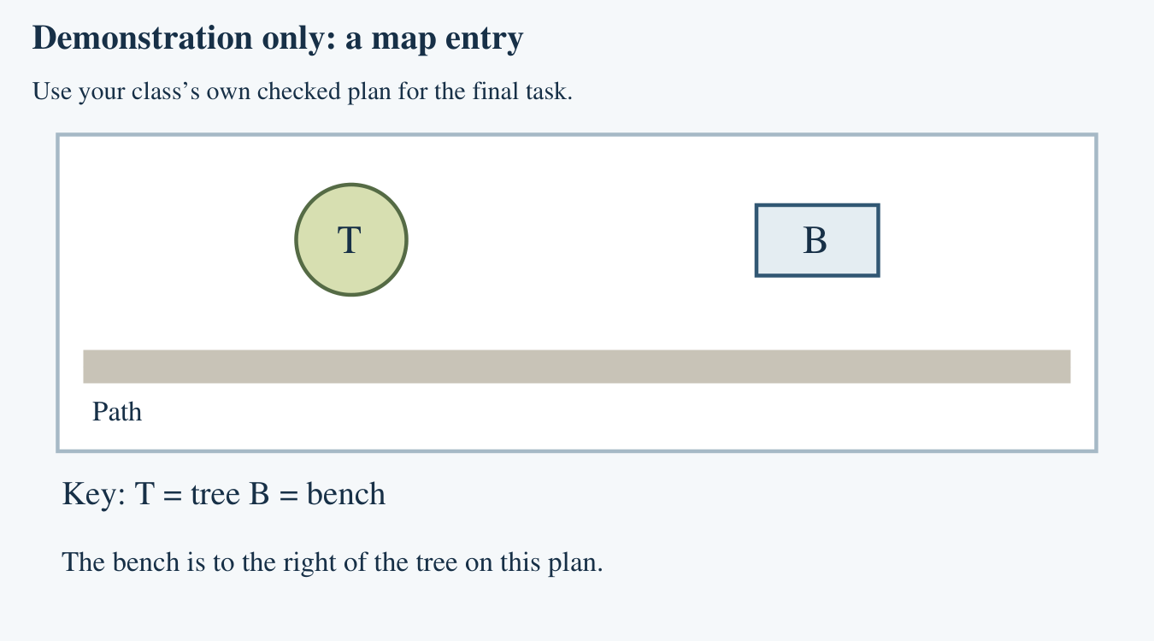
Use the class’s own checked plan and actual local observations. Keep an individual contribution record as well as the shared map.

Our checked class plan
  - Attach or draw from the class’s own checked plan
Adult: mount a copy of the class’s own checked school/local plan here or use the existing class map. Confirm the source and date before pupils add entries. Do not substitute the invented demonstration or the practice tally for local evidence. No home addresses.
Plan source and date checked
________________________________________________________________
Mount the checked plan here
Key used by our class
________________________________________________________________
________________________________________________________________

My map contribution
  - Individual evidence for the class map
Use the same orientation as the checked class plan. Draw or describe your entry. An adult may record what you point to or say; your choice and explanation must remain your own.
My feature and its position
________________________________________________________________
________________________________________________________________
My symbol or label | Its key meaning
My checked observation or source
________________________________________________________________
My explanation and one check or improvement
________________________________________________________________
________________________________________________________________

My unit review
  - Use your own earlier work and today’s contribution
Show evidence or give a fresh response for each prompt. If evidence is missing, tell your teacher what you need to try next.
Point to a familiar feature and explain its symbol or label.
________________________________________________________________
________________________________________________________________
Use your earlier comparison sources to explain one similarity or difference.
________________________________________________________________
________________________________________________________________
Show an observation you recorded. Say whether it was real fieldwork or practice.
________________________________________________________________
________________________________________________________________
Name and locate one continent and one ocean on the supplied world map.
________________________________________________________________
________________________________________________________________

Arrival task
  - Supported | Our class map
A map symbol stands for a feature. A key explains it. We will use checked evidence to decide which entries belong on our class map.
Use the reference sheet. Start with questions 1 and 2.

1. Point to the tree symbol on the practice plan.
Help: Use T in the key.
My response
________________________________________________________________

2. What does B mean in the key?
Help: Choose bench or ocean.
My response
________________________________________________________________

3. Which can help check a map entry: an observation or a guess?
Help: Choose the checked source.
My response
________________________________________________________________

4. Show where the key is.
Help: Look for symbol meanings.
My response
________________________________________________________________

Arrival task
  - Standard | Our class map
A map symbol stands for a feature. A key explains it. We will use checked evidence to decide which entries belong on our class map.
Use the reference sheet. Start with questions 1 and 2.

1. What is a map key for?
Help: Think about symbols.
My response
________________________________________________________________

2. Where is the practice bench in relation to the tree?
Help: Keep the plan the same way up.
My response
________________________________________________________________

3. Why check the evidence before adding a feature?
Help: Think about an accurate map.
My response
________________________________________________________________

4. Should our school map include home addresses?
Help: Think about the map’s purpose.
My response
________________________________________________________________

Arrival task
  - Stretch | Our class map
A map symbol stands for a feature. A key explains it. We will use checked evidence to decide which entries belong on our class map.
Use the reference sheet. Start with questions 1 and 2.

1. How could an old map entry become inaccurate?
Help: Think about changes to a place.
My response
________________________________________________________________

2. How can we check an uncertain position?
Help: Use a checked plan or adult observation.
My response
________________________________________________________________

3. Can a shared map prove who made each decision?
Help: Think about individual evidence.
My response
________________________________________________________________

4. Why label practice data clearly?
Help: Think about confusing it with observation.
My response
________________________________________________________________

Shared activity
  - Decide which map entries belong
1. Read each proposed map entry. Choose Add to map, Check first or Leave out.
2. Explain your choice using the evidence and the purpose of a local map.
3. On the shared checked plan, rehearse one verified entry and its key label.
Card | My choice
The adult-checked plan and today’s observation agree: a bench is beside the tree.
A visitor thinks there may be a bin behind the hall, but nobody has checked.
Someone suggests adding a pupil’s home address.
A practice tally from an invented area shows five trees.
An old plan shows a bench, but it may have moved.
Our evidence and explanation
________________________________________________________________
________________________________________________________________

Independent task
  - Supported | Our class map
Record local features on a class map.
Use the class’s own checked plan and actual local observations. Keep an individual contribution record as well as the shared map.
1. Choose one checked local feature from two options.
2. Place its symbol at the verified position on the class plan.
3. Point to its key meaning and give your own explanation.
Help: An adult reads the evidence. Use: I added ___. It is ___. I checked ___.
My feature and map position
________________________________________________________________
My symbol and key meaning
________________________________________________________________
Evidence I used
________________________________________________________________
My explanation and check
________________________________________________________________
Further challenge: Check a second symbol or explain one source.

Independent task
  - Standard | Our class map
Record local features on a class map.
Use the class’s own checked plan and actual local observations. Keep an individual contribution record as well as the shared map.
1. Select a feature supported by the checked local evidence.
2. Add its symbol or label to the class map and update the key.
3. Record and explain your own contribution and one check.
Help: Use: My source shows ___. I placed ___ beside ___. The key means ___.
My feature and map position
________________________________________________________________
My symbol and key meaning
________________________________________________________________
Evidence I used
________________________________________________________________
My explanation and check
________________________________________________________________
Further challenge: Review one earlier comparison and one continent/ocean response.

Independent task
  - Stretch | Our class map
Record local features on a class map.
Use the class’s own checked plan and actual local observations. Keep an individual contribution record as well as the shared map.
1. Choose a useful local feature and justify your evidence.
2. Add an accurate symbol or label and check its position.
3. Explain one uncertainty or limit and how to check it.
4. Review your earlier unit evidence and identify a next step.
Help: Use the class plan and real observations. Say what is confirmed and what still needs checking.
My feature and map position
________________________________________________________________
My symbol and key meaning
________________________________________________________________
Evidence I used
________________________________________________________________
My explanation and check
________________________________________________________________
Further challenge: Suggest one change that would make the class map easier for a visitor to use.

Exit tickets
  - Use only your chosen route
Give your own response. Your usual communication support can stay.

Supported
1. Show the feature you added and its key meaning. Point, speak or use your contribution sheet.
_______________________________________________________________
2. What helped you check its position? Name or point to your evidence.
_______________________________________________________________

Standard
1. Explain your own class-map contribution. Include the feature, position and key.
_______________________________________________________________
2. Which evidence supports it? Say one check or improvement you made.
_______________________________________________________________

Stretch
1. Justify your map entry using checked evidence. Explain any remaining uncertainty.
_______________________________________________________________
2. What does your unit evidence show you can do next? Choose a specific map, comparison, observation or world-location step.
_______________________________________________________________

