Our place in the wider world
  - Pupil resources | GROW Humanities Summer 1 Week 1
Locate my place the UK and the wider world on maps.
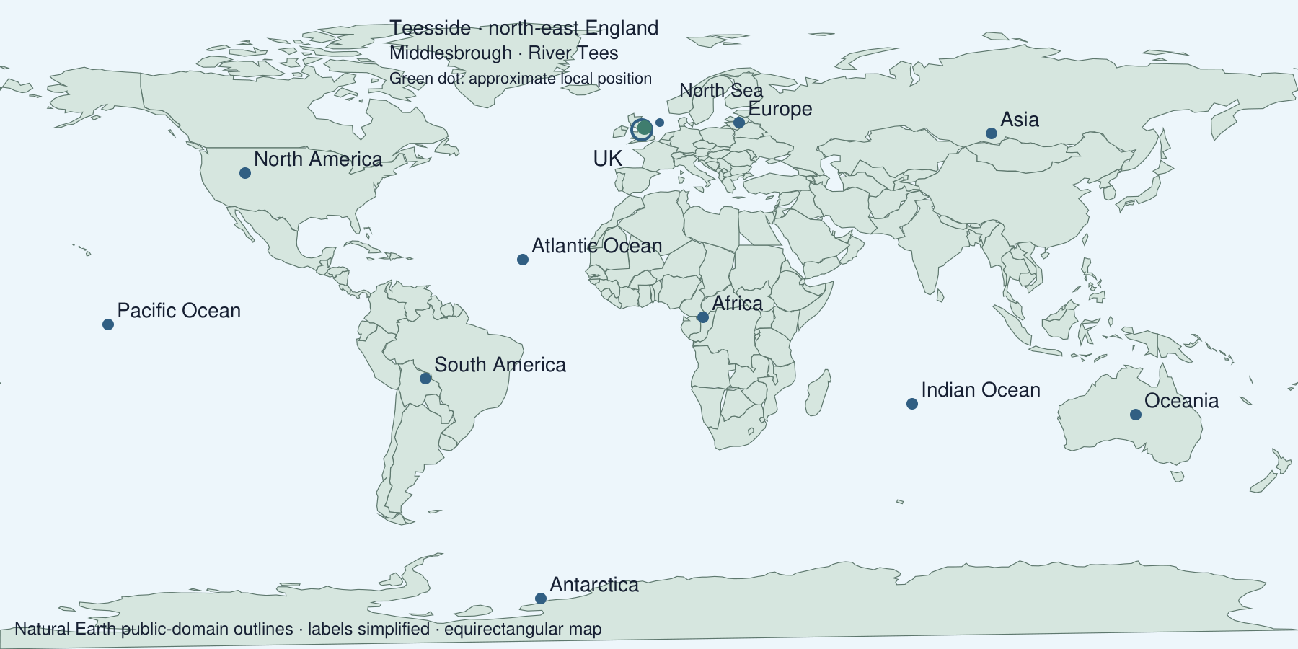
Use this labelled reference for the activities. Give your own response in the blank spaces. Point, speak, draw, type or write.
The world view locates our area approximately. Your teacher supplies a checked local map and UK atlas page for the closer views.

Evidence cards
  - Read with a partner or adult then use a named detail

A Our locality
Middlesbrough is on the River Tees, in Teesside in north-east England. These labels identify our locality within the UK. A local map shows more nearby detail than this world map.
Source: Locality facts from the task brief; teacher-checked local map
Limit: The world marker is approximate. It cannot show street positions.

B The UK and its neighbours
The UK is in Europe. The Atlantic Ocean lies to the west and the North Sea to the east. Use the UK marker and the named water labels.
Source: Natural Earth outlines and named geographical labels
Limit: Country outlines and labels are simplified at this scale.

C Choosing a map scale
Fictional task: a visitor needs to find our school entrance. A detailed local map is useful. A world map shows how the UK relates to continents and oceans, but cannot show the entrance.
Source: Authored classroom comparison of map purposes
Limit: Choose a map for the question. A world view does not show a safe walking route.

D A map comparison routine
Locate Teesside, then the UK, then Europe on the world view. Compare a teacher-selected local map, UK atlas page and world page. Name one detail that appears or disappears as the area shown changes.
Source: Teacher-selected atlas and local map; supplied world view
Limit: No map shows every feature. The local source must be checked before teaching.

Arrival task
  - Supported
Revisit earlier map work. You can start from these reminders: a continent is a large land region; an ocean is salt water; a key explains symbols. Use the labelled map and cards if this is new.
Begin with questions 1 and 2. Try 3 and 4 when ready. Use the reference map and cards.

1 Point to the UK marker.
Help: Use the labelled world map.
My response
________________________________________________________________

2 Is Europe a continent or an ocean?
Help: A continent is land.
My response
________________________________________________________________

3 Find the Atlantic Ocean label.
Help: Look west of the UK.
My response
________________________________________________________________

4 Would you use a local map or world map for a school entrance?
Help: Think about how much detail you need.
My response
________________________________________________________________

Arrival task
  - Standard
Revisit earlier map work. You can start from these reminders: a continent is a large land region; an ocean is salt water; a key explains symbols. Use the labelled map and cards if this is new.
Begin with questions 1 and 2. Try 3 and 4 when ready. Use the reference map and cards.

1 What does a map key explain?
Help: Think about symbols.
My response
________________________________________________________________

2 Which continent contains the UK?
Help: Use the map labels or card B.
My response
________________________________________________________________

3 Which ocean is west of the UK?
Help: Read the water label.
My response
________________________________________________________________

4 What happens to local detail as a map covers more of the world?
Help: Compare the teacher’s local and world views.
My response
________________________________________________________________

Arrival task
  - Stretch
Revisit earlier map work. You can start from these reminders: a continent is a large land region; an ocean is salt water; a key explains symbols. Use the labelled map and cards if this is new.
Begin with questions 1 and 2. Try 3 and 4 when ready. Use the reference map and cards.

1 How can a key help a reader locate a feature?
Help: Connect a symbol with its meaning.
My response
________________________________________________________________

2 Describe the UK using its continent and a neighbouring ocean.
Help: Use labels and a compass direction.
My response
________________________________________________________________

3 Which sea is east of the UK?
Help: Use card B and the map.
My response
________________________________________________________________

4 Why is a world map unsuitable for a school entrance?
Help: Explain the effect of scale.
My response
________________________________________________________________

Shared map investigation
  - One person locates and the other checks then swap
1. Locate Teesside, the UK and Europe together. Compare the teacher’s local map, UK atlas page and world page; say how the detail changes.
2. Swap locator and checker roles. Find the Atlantic Ocean and North Sea. Give their directions from the UK and explain one map choice.
Map view | One useful detail | What it cannot show
Local
UK
World
One location statement using direction
________________________________________________________________
________________________________________________________________
My partner challenge and how we checked
________________________________________________________________

Independent task
  - Supported
Locate my place the UK and the wider world on maps.
1. Locate the UK and Europe with the labelled map. Find Teesside using card A.
2. Choose Atlantic Ocean or North Sea to complete one direction statement about the UK.
3. Independently choose local or world map for the school entrance and give one reason.
Help: Read card B together. Use the sentence frame and two map choices. An adult may read or scribe your own words.
Places located and evidence used
________________________________________________________________
________________________________________________________________
Direction from the UK
________________________________________________________________
________________________________________________________________
A relationship on the map
________________________________________________________________
________________________________________________________________
Map choice and reason
________________________________________________________________
________________________________________________________________
Further challenge: Locate the other named water area and give its direction.

Independent task
  - Standard
Locate my place the UK and the wider world on maps.
1. Locate Teesside, the UK and Europe using the supplied labels and checked atlas pages.
2. Describe the UK using the Atlantic Ocean and North Sea.
3. Independently choose a map for a school-entrance question and explain why.
Help: ___ is in ___. ___ lies to its ___. I would use a ___ map because ___.
Places located and evidence used
________________________________________________________________
________________________________________________________________
Direction from the UK
________________________________________________________________
________________________________________________________________
A relationship on the map
________________________________________________________________
________________________________________________________________
Map choice and reason
________________________________________________________________
________________________________________________________________
Further challenge: Explain why the UK-area marker cannot show a precise street position.

Independent task
  - Stretch
Locate my place the UK and the wider world on maps.
1. Locate Middlesbrough, Teesside, the UK and Europe using the labels and checked local/atlas maps.
2. Describe two relationships using direction, continent and neighbouring water.
3. Compare a local, UK and world view. Explain one useful detail at each scale.
4. Independently justify which map answers the school-entrance question and one wider-location question.
Help: Select the evidence yourself. Use the same locality in all views and state a limit of the world map.
Places located and evidence used
________________________________________________________________
________________________________________________________________
Direction from the UK
________________________________________________________________
________________________________________________________________
A relationship on the map
________________________________________________________________
________________________________________________________________
Map choice and reason
________________________________________________________________
________________________________________________________________
Further challenge: Explain why a smaller-scale world map shows less local detail than a larger-scale local map.

Exit tickets
  - Use your chosen route and give your own response

Supported
1. Name the UK’s continent and one neighbouring ocean. Use the labels, then give your own response.
________________________________________________________________
2. Choose a map for the school entrance and give one reason. Local or world map?
________________________________________________________________

Standard
1. Locate the UK and describe it using a continent and a neighbouring sea or ocean. Use a compass direction.
________________________________________________________________
2. Why does your map choice suit a school-entrance question? Explain the detail needed.
________________________________________________________________

Stretch
1. Describe Teesside’s place within the UK and the wider world. Use the labelled local, UK and world views.
________________________________________________________________
2. Explain how scale changes the detail available for two different questions. Use the school entrance and a continent-location question.
________________________________________________________________

