Our locality study and evidence
  - Pupil resources | GROW Humanities Summer 1 Week 6
Complete a fieldwork and locality study and bank UAS evidence.
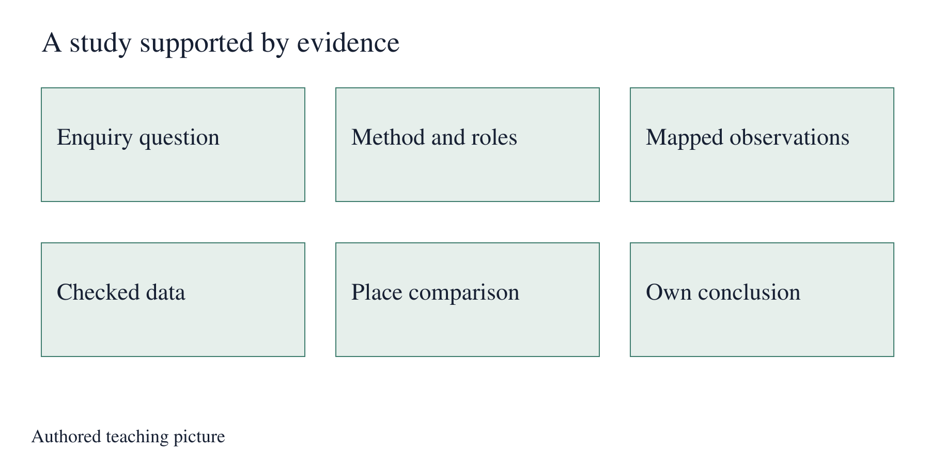
Authored teaching picture. Use the evidence cards and give your own response in the blank spaces.

Evidence cards
  - Read the source and limitation before using a detail

D Question and method
An enquiry needs a clear question and a method. State where observations happened, what you counted and how you avoided duplicates. Name the roles and safe route used.
Source: Authored study checklist
Limit: If you use the supplied tally, label the work as practice rather than real fieldwork.

H Mapped observations
Use the checked class plan. Put observation point labels beside the matching counts. Check that the table, graph and conclusion use the same units and totals.
Source: Authored accuracy checklist
Limit: A concept picture cannot replace a checked plan of real observations.

O Comparison and conclusion
Use the same criterion for both places. Give a conclusion that answers your enquiry and includes data. Explain one thing the evidence cannot establish.
Source: Authored evidence routine
Limit: A source gap needs further evidence rather than a guess.

S Evidence selection
Select the enquiry, method, mapped observations, comparison and conclusion. Add dates, support used and one accuracy check. An adult may record your own spoken or pointed response.
Source: Authored evidence-bank checklist
Limit: The centre checks the selected evidence against its chosen UAS requirements. No unit code is assigned here.

Arrival task
  - Supported
Start here: an enquiry is a question. A method explains the steps. Data are recorded observations. A conclusion answers the question using evidence. The practice record is available if earlier work is missing.

1 What is an enquiry?
Help: Use the reminder.
My response
________________________________________________________________

2 What does a method explain?
Help: Think about your steps.
My response
________________________________________________________________

3 Where should a location label go?
Help: Look at the plan and tally.
My response
________________________________________________________________

4 What should a conclusion use?
Help: Choose evidence or a guess.
My response
________________________________________________________________

Arrival task
  - Standard
Start here: an enquiry is a question. A method explains the steps. Data are recorded observations. A conclusion answers the question using evidence. The practice record is available if earlier work is missing.

1 Which sections should a study include?
Help: Read the checklist cards.
My response
________________________________________________________________

2 How can you check graph accuracy?
Help: Compare it with the table.
My response
________________________________________________________________

3 Why record support used?
Help: Think about what the evidence shows.
My response
________________________________________________________________

4 What should you do if evidence is missing?
Help: Use card O.
My response
________________________________________________________________

Arrival task
  - Stretch
Start here: an enquiry is a question. A method explains the steps. Data are recorded observations. A conclusion answers the question using evidence. The practice record is available if earlier work is missing.

1 Why might a conclusion need revising?
Help: Think about a changed count.
My response
________________________________________________________________

2 How do you distinguish practice from fieldwork evidence?
Help: Think about source labels.
My response
________________________________________________________________

3 What should an adult note include?
Help: Use card S.
My response
________________________________________________________________

4 How can you justify your evidence selection?
Help: Link each item to the enquiry.
My response
________________________________________________________________

Shared investigation
  - Suggest, check and swap roles
1. Use a separate practice example to assemble question, method, location label and result. Check that each claim points to evidence before writing a conclusion.
2. Use the portfolio record to preview the selection. Identify a missing section, an accuracy check and support used. Then work independently with your own study or labelled practice evidence.
Question and method
________________________________________________________________
Mapped observations and data
________________________________________________________________
Comparison and own conclusion
________________________________________________________________
Accuracy check / support / evidence selected
________________________________________________________________

Independent task
  - Supported
Complete a fieldwork and locality study and bank UAS evidence.
1. Use the checklist to assemble your question, method and one labelled observation point.
2. Add checked counts and a comparison using two source details.
3. Independently give your conclusion. Select evidence and record access support or an adult note.
Help: Use an adult reader or scribe for your own words. The adult does not supply the conclusion.
Enquiry question and method record
________________________________________________________________
Mapped observations and checked data
________________________________________________________________
Comparison and supported conclusion
________________________________________________________________
Evidence selected and support recorded
________________________________________________________________
Further challenge: Say how you checked one value.

Independent task
  - Standard
Complete a fieldwork and locality study and bank UAS evidence.
1. Assemble enquiry, method, mapped observations and comparison in the study record.
2. Check location labels, table totals, graph units and source references.
3. Independently conclude using data, state a limit and select dated evidence with support recorded.
Help: Use the checklist for organisation while keeping the conclusion your own.
Enquiry question and method record
________________________________________________________________
Mapped observations and checked data
________________________________________________________________
Comparison and supported conclusion
________________________________________________________________
Evidence selected and support recorded
________________________________________________________________
Further challenge: Identify an improvement for a future study.

Independent task
  - Stretch
Complete a fieldwork and locality study and bank UAS evidence.
1. Audit the full study against all required sections and identify a gap.
2. Check the mapped data and comparison for consistency and source limits.
3. Independently justify a conclusion with data and evaluate the effect of the gap.
4. Select evidence and explain the next observation that would strengthen it.
Help: Explain how evidence strength affects the conclusion and proposed next step.
Enquiry question and method record
________________________________________________________________
Mapped observations and checked data
________________________________________________________________
Comparison and supported conclusion
________________________________________________________________
Evidence selected and support recorded
________________________________________________________________
Further challenge: Explain which new evidence could challenge the conclusion.

Exit tickets
  - Give your own response using your chosen route

Supported
1. Give your conclusion and one supporting count. Use your checked study.
________________________________________________________________
2. What evidence and support will you record? Point to the selected items.
________________________________________________________________

Standard
1. How does your conclusion answer the enquiry? Include data and a limit.
________________________________________________________________
2. Which items show your learning and what support was used? Name the selected evidence.
________________________________________________________________

Stretch
1. How secure is your conclusion? Use data and an evidence gap.
________________________________________________________________
2. Which next check would most improve the study? Explain the choice.
________________________________________________________________

