Peace and remembrance cards
12 November 2026 | P3
White paper | You can point, write or ask an adult to write.

S1 A time to remember
Remembrance Day is on 11 November.
Many people remember people who died in wars.
Some take time to think about peace.
Peace means life without war.
Today is 12 November. We learn about the day that has just passed.
People may take part in their own way. You can think, point or choose a card. You can pass.

Words
remember, peace, care, quiet, help, pass

Start
Some people __.

Model
Some people think about peace.

Finish
Show one fact from this card. An adult can read or write with you. No personal story is needed.

Peace and remembrance cards continued
12 November 2026 | P3
White paper | You can point, write or ask an adult to write.

S2 Care choices
These are ideas. Choose a safe way to show care.
Word | Care action
space | Give someone space.
wait | Wait for a turn.
kind | Say a kind word.
You can draw a peace word, think in a quiet way or ask an adult to write. You can choose help or pass.

Words
space, wait, kind, peace, help, pass

Start
I can __. I choose __.

Model
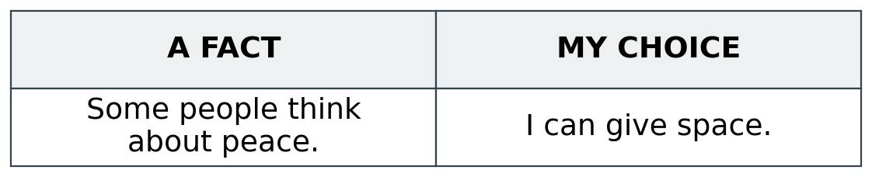

Finish
Keep one care choice. Show it in a quiet way. Other people can choose a different way.

