Festival objects and care
19 November 2026 | P3
White paper | You can point, write or ask an adult to write.
Route: Supported | My code ____
In your book: one feature and one care step.
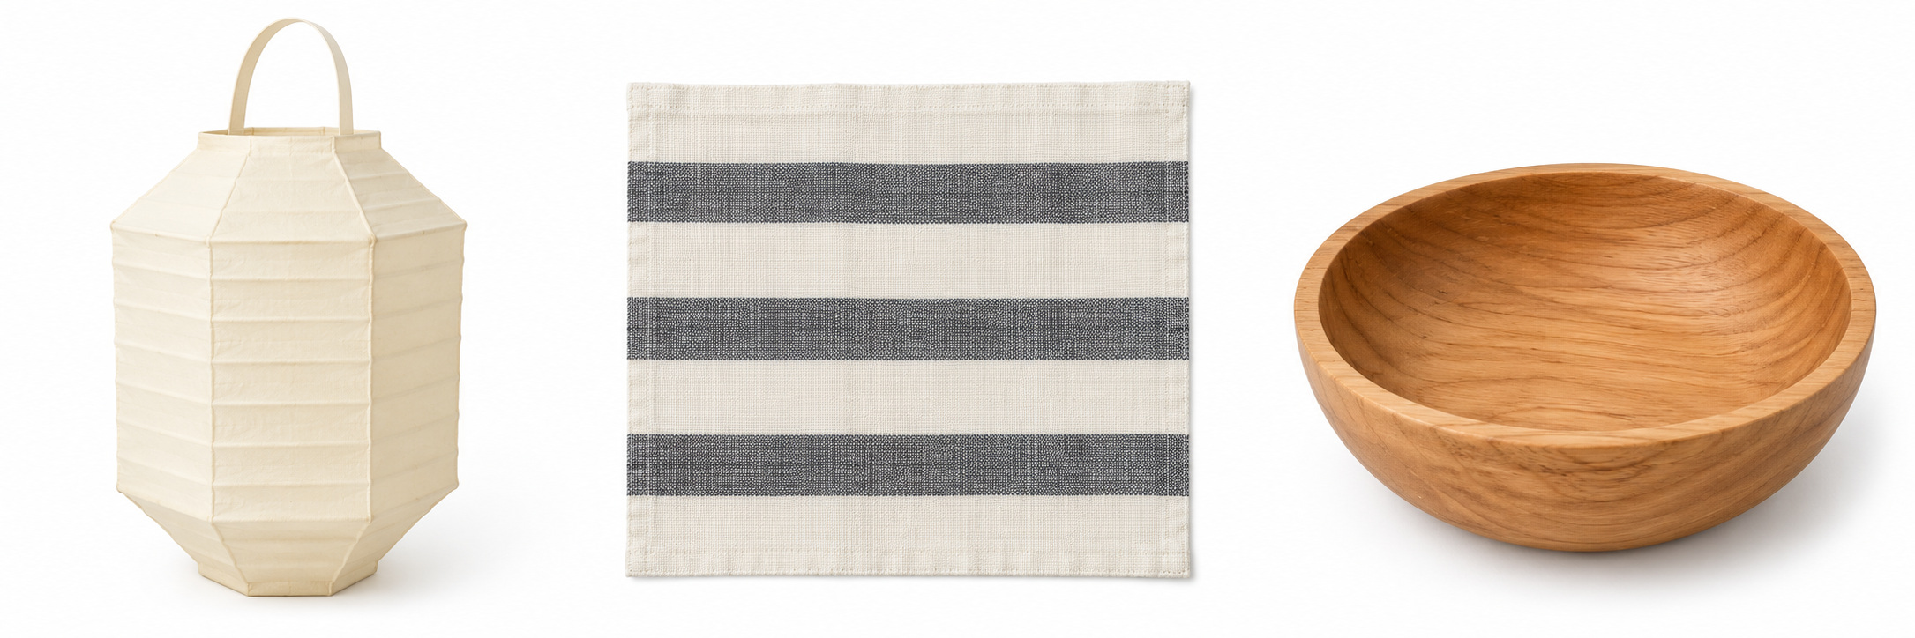
Left to right: A lantern, B cloth, C bowl.
1 Pick one picture. Point to a feature word.
2 Ask first. Wait for an adult to say yes.
3 Show the care step with help, or choose to look.

Words
round, stripes, folds, ask, wait, care

Start
I can see __. I show care when I __.

Model
What I see | How I show care
The bowl is round. | I ask first and wait.

Finish
One feature. One care step. Show an adult quietly.
You can point or ask an adult to write. Touch is a choice.

Festival objects and care continued
19 November 2026 | P3
White paper | You can point, write or ask an adult to write.
Route: Independent | My code ____
In your book: one feature and one care step.
Left to right: A lantern, B cloth, C bowl.
1 Pick a picture or allowed copy.
2 Show the care steps with the adult.
3 Put one feature and one care step in your book.

Words
round, stripes, folds, ask, wait, care

Start
I can see __. I show care when I __.

Model
What I see | How I show care
The bowl is round. | I ask first and wait.

Finish
One feature. One care step. Show an adult quietly.
You can point or ask an adult to write. Touch is a choice.

Festival objects and care continued
19 November 2026 | P3
White paper | You can point, write or ask an adult to write.
Route: Aspire | My code ____
In your book: one feature and one care step.
Left to right: A lantern, B cloth, C bowl.
1 Pick an object and show the care steps.
2 Describe a feature. Add why care matters.
3 You may add a use. Say “It might be for __.”

Words
round, stripes, folds, ask, wait, care, safe, display

Start
I can see __. I show care when I __.
It helps keep it __. It might be for __.

Model
What I see | How I show care
The bowl is round. | I ask first and wait.  This helps keep it safe.

Finish
One feature. One care step. Show an adult quietly.
You can point or ask an adult to write. Touch is a choice.

