Starter and choice cards
19 November 2026 | P3
White paper | You can point, write or ask an adult to write.

Ready starter
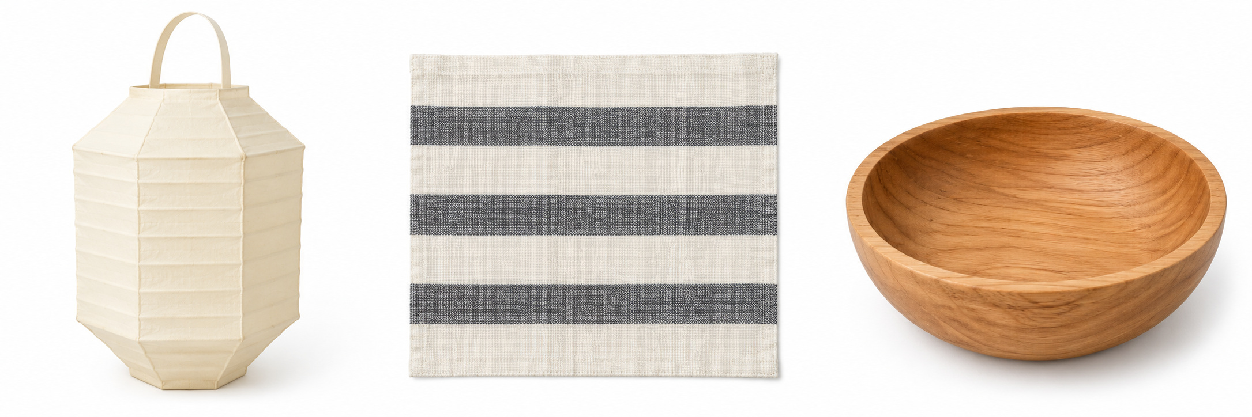
Left to right: A lantern, B cloth, C bowl.
1 Look at the pictures.
2 Match one picture and word.
3 Point, write or tell an adult quietly.

Words
lantern, cloth, bowl

Start
I see a __.

Model
I see a bowl. It is picture C.

Finish
One match. Show an adult quietly. An adult can write.

Starter and choice cards continued
19 November 2026 | P3
White paper | You can point, write or ask an adult to write.

My private choice
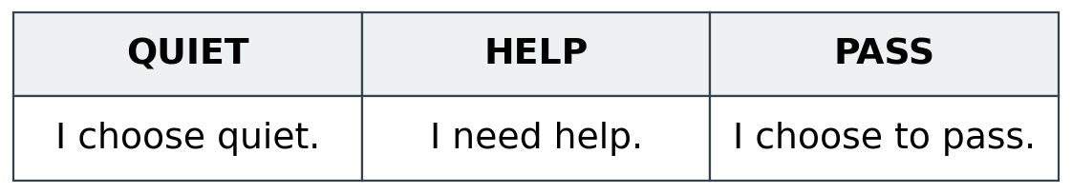
You may look without touch. Show HELP or PASS, point, or tell an adult quietly.

Words
look, help, pass, ask, wait

Start
I choose __. I need __.

Model
I choose to look. I need help.
An adult can hold the card. You can point to a feature. Or take an agreed quiet pause with support.

Care reminder
Ask first. Wait for yes. Follow the adult’s steps. Keep the item low over the table. Put it back with care.

Words
ask, wait, low, back

Start
I can __.

Model
I can ask first and wait.

Finish
Show one care step or ask for help. You can return when you are ready.

