Our invented workplace
An invented small business prepares simple paper packs for customers. It has a supervisor, a preparer and a checker. It has no name, real employer, location or contact details. This is classroom simulation only.
Picture | Work context
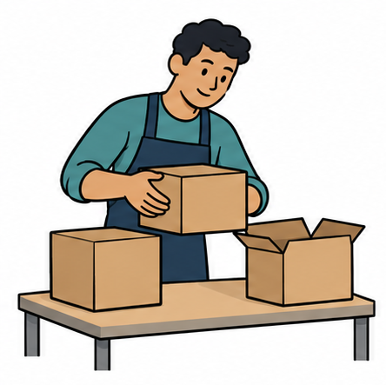 | Workers prepare and check simple paper packs. Figures are generic symbols.

The order
Prepare two paper packs. Each pack needs one large card and one paper strip. Put the items beside each other. Check both packs against this order. Tell the checker when they are ready.

Roles
The preparer arranges the materials. The checker reads the order and checks each pack. Agree roles, then swap after resetting the materials. An adult can take the other role if preferred.

Task limits
Use ready-cut paper only. No scissors, staplers, machines, food, money, customer data, live orders or deliveries. Accuracy, communication and support matter; speed is not assessed.

If plans change
Pause, explain what is unclear and ask for a revised step. The supervisor is played by an adult. No new task is agreed without checking it.

Five workplace expectations
These are the five expectations for our invented business. Real workplaces explain their own tasks and support.
Expectation | What it means
1 Readiness and reliability | Know the agreed start and task. Get agreed materials ready. Tell the supervisor if a delay or support need affects the plan.
2 Respectful communication | Listen or read, use respectful words and check meaning. You can ask for a pause or private help.
3 Instructions and quality | Check the steps. Ask if unsure. Check the finished work against the order before saying it is ready.
4 Safety and help | Keep the work area and access clear. Use only agreed materials. Stop and tell the supervisor if something is unsafe or unclear.
5 Teamwork and responsibility | Agree roles, share information and report mistakes honestly. Ask for a workable adjustment when needed.

Useful words
“Please explain this step.” “I need time or help to read it.” “This pack needs a strip.” “Which role will I do first?” “Can we check the order?”

Scenario cards
All workers and situations are invented. Match an expectation and choose a useful response. You may use more than one expectation if you explain the link.

A An unclear step
A worker sees an instruction they do not understand. They are about to guess so the task is finished quickly.

B Different ideas
The two workers both want to prepare the packs. Neither has agreed to check them.

C A blocked route
A worker notices an empty box in a walkway in the made-up workplace.

D One item missing
A worker is ready to report that the order is complete. The checker notices one pack has no paper strip.

E A changed start
A worker needs help to read the task before starting. The agreed start is approaching.

F A rushed reply
A worker does not understand their partner’s check and replies sharply.

Private help
Ask a trusted adult or use the school’s help route. You may pass or pause. No personal story is needed.

