Our invented workplace and service brief
An invented small business prepares simple paper packs for customers. It has a supervisor, a preparer and a checker. It has no name, real employer, location or contact details. This is classroom simulation only.
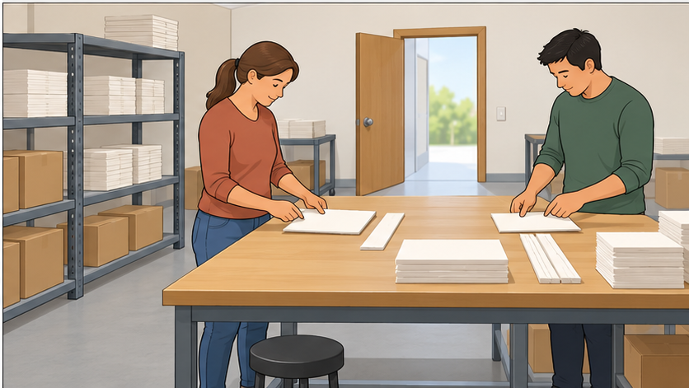

Service brief
In this invented practice, the service worker can offer two checked paper packs. Each pack has one large card beside one paper strip. A missing strip can be added and checked. A third pack is not available in this practice. Ask the supervisor about any extra request; do not promise an extra pack or a time. No money, real orders or customer details.

Roles and access
Use a calm customer card and the service brief. One is customer, one service worker. Reset and swap so each has a turn. An adult can partner. Both keep scripts and usual aid visible; speaking, writing or selecting words are valid.
Use ready-cut paper only if props help. No real orders, customers, money, data or deliveries. Speed is not assessed.

Three calm customer scenes
All scenes are invented. Choose one per round. Use the customer line and reply without adding pressure or anger.

Scene A A simple request
Customer: “Hello. Could I have two paper packs, please?”
Reply: “Yes, two please. Thank you.”
Worker goal: Greet, check the request, offer two checked packs, confirm and thank. No refusal is needed.

Scene B A missing strip
Customer: “Excuse me. One pack has no paper strip. Could you help, please?”
Reply: “A strip and a check would help. Thank you.”
Worker goal: Acknowledge the mild complaint, check what is missing, offer one strip and check the pack. Confirm the fix and thank. No refusal is needed.

Scene C One extra pack
Customer: “Could I have a third paper pack now, please?”
Reply: “I understand. Two is fine for now. Thank you.”
Worker goal: Greet and check the request. Explain the two-pack limit politely. Offer the two available packs or ask the supervisor about more without promising a result or time. Confirm and thank.

Roles and swap
Round one 23–29 minutes. Reset and swap customer/service worker for round two 29–35. Both see the brief and scripts. Use an aid, selected words, writing or adult partner. Times guide the routine; pause/reduce repeats for access. Record actual turns.

Five steps for customer service

1 Greet
Welcome the customer in a clear, polite way.

2 Listen
Hear or read the request. Check what the customer needs.

3 Solve
Offer a simple allowed fix, or ask the supervisor for help.

4 Say no politely
If needed, explain the limit calmly and offer an allowed next step.

5 Close
Check what is agreed, thank the customer and close clearly.
Use the five service checks: Greeting, Listening, Simple solution, Polite limit, Closing. Choose Seen; With a prompt; Not needed in this scene; Not seen yet. A/B do not need a refusal.

Invented model from C
“Hello. You would like three packs, is that right? I am sorry, I can offer two in this practice. I can ask the supervisor about more. Would the two available packs help? Thank you.” This checks the request, gives the limit and offers a next step without an extra-pack or time promise. It is a model, not your evidence.

Short reflection
One thing I did to help the customer was… Or use: A phrase or aid that helped was… / I did not try this part yet; the help I need is…

Private help
Trusted adult or school help route. Point to HELP or ask privately. Use your usual aid; pass, pause and supported return are available.

